# Linear Regression and Polynomial Regression

## Introduction

In this blog, we will discuss two important topics that will form a base for Machine Learning which is “Linear Regression” and “Polynomial Regression”.

## What is Regression?

*Regression analysis is a form of predictive modelling technique which investigates the relationship between a dependent and independent variable.*

The above definition is a bookish definition, in simple terms the regression can be defined as, “*Using the relationship between variables to find the best fit line or the regression equation that can be used to make predictions”.*

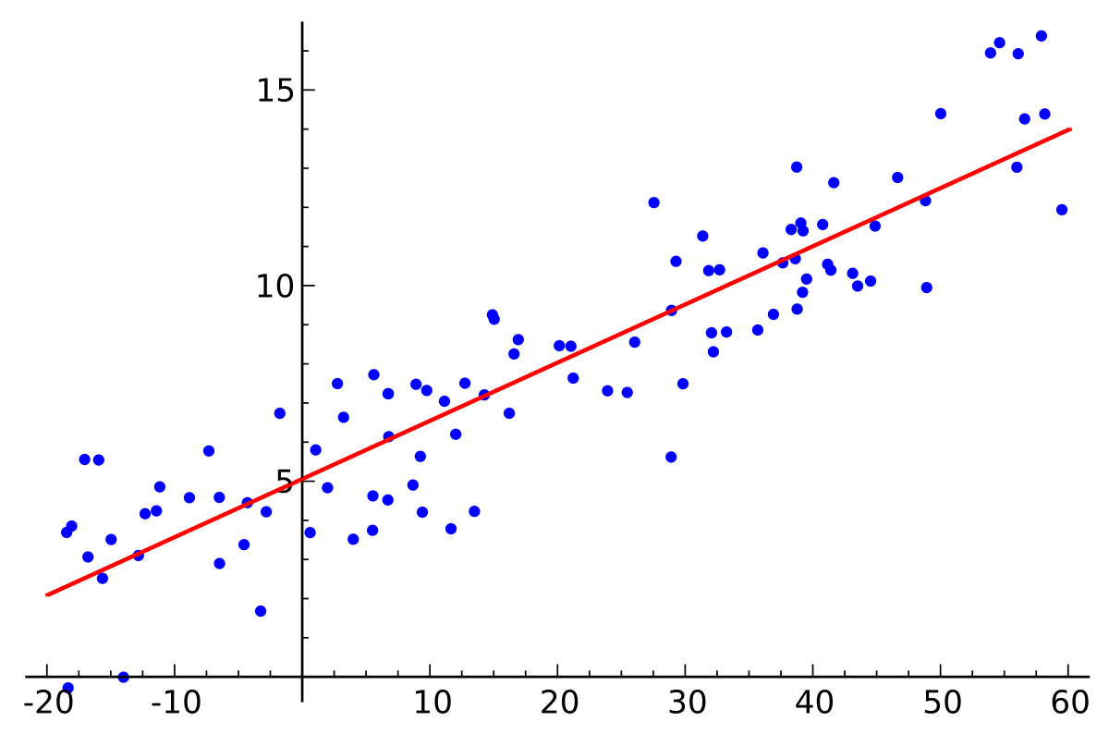

Regression | Image: Wikipedia

There are many types of regressions such as ‘Linear Regression’, ‘Polynomial Regression’, ‘Logistic regression’ and others but in this blog, we are going to study “Linear Regression” and “Polynomial Regression”.

**Linear Regression**

Linear regression is a basic and commonly used type of predictive analysis which usually works on continuous data. We will try to understand linear regression based on an example:

Aarav is a trying to buy a house and is collecting housing data so that he can estimate the “cost” of the house according to the “Living area” of the house in feet.

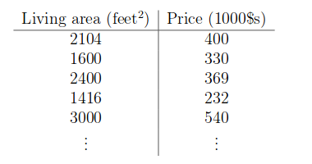

Housing data | Andrew Ng course

He observes the data and comes to the conclusion that the data is linear after he plots the scatter plot. For his first scatter plot, Aarav uses two variables: ‘Living area’ and ‘Price’.

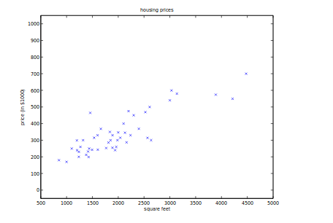

Scatter plot | Image: Andrew Ng course

As soon as he saw a pattern in the data, he planned to make a regression line on the graph so that he can use the line to predict the ‘price of the house’.  
Using the training data i.e ‘Price’ and ‘Living area’, a regression line is obtained which will give the minimum error. To do that he needs to make a line that is closest to as many points as possible. This ‘linear equation’ is then used for any new data so that he is able to predict the required output.

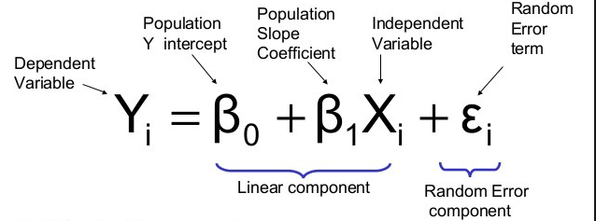

Here, the β1 it’s are the parameters (also called weights) βo is the y-intercept and Єi is the random error term whose role is to add bias. The above equation is the linear equation that needs to be obtained with the minimum error.

The above equation is a simple “*equation of a line*” that is

*Y(predicted) = (β1\*x + βo) + Error value*

Where ‘β1’ is the *slope* and ‘βo’ is the *y-intercept*similar to the equation of a line. The values ‘β1’ and ‘βo’ must be chosen so that they minimize the error. To check the error we have to calculate the sum of squared error and tune the parameters to try to reduce the error.

Error = Σ (actual output — predicted output)²

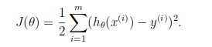

Cost function

Key:  
1. Y(predicted) is also called the *hypothesis function*.  
2. J(θ) is the cost function which can also be called the *error function*. Our main goal is to minimize the value of the cost.  
3. y(i) is the *predicted output*.  
4. hθ(x(i)) is called the *hypothesis function* which is basically the *Y(predicted)* value.

Now the question arises, how do we reduce the error value? Well, this can be done by using Gradient Descent. The main goal of Gradient descent is to minimize the cost value. i.e. min J(*θ*o, *θ1*)



Gradient Descent Visualization | Gif: mi-academy.com

Gradient descent has an analogy in which we have to imagine ourselves at the top of a mountain valley and left stranded and blindfolded, our objective is to reach the bottom of the hill. Feeling the slope of the terrain around you is what everyone would do. Well, this action is analogous to calculating the gradient descent, and taking a step is analogous to one iteration of the update to the parameters.

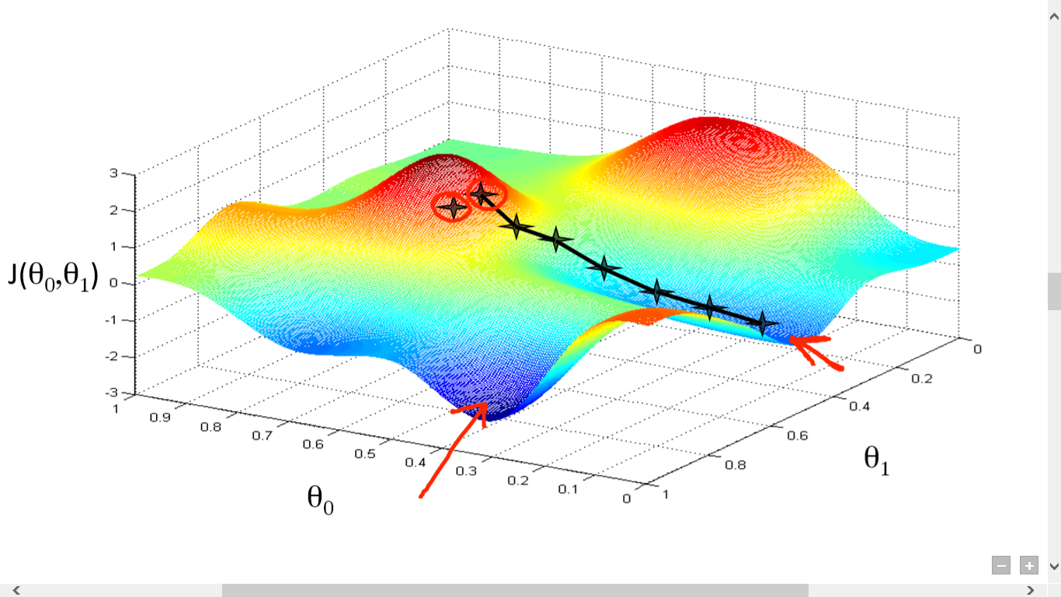

Gradient Decent Analogy | Image: Andrew Ng course

Choosing a perfect *learning rate* is a very important task as it depends on how large of a step we take downhill during each iteration. If we take too large of a step, we may step over the minimum. However, if we take small steps, it will require many iterations to arrive at the minimum.



# Gradient descent

Gradient descent algorithm is an iterative process that takes us to the minimum of a function(barring some caveats). The formula below sums up the entire Gradient Descent algorithm in a single line.

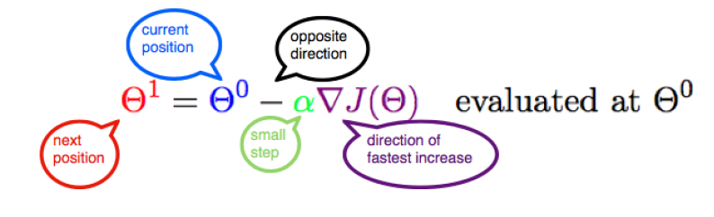

But how do we arrive at this formula? Well, It is actually very simple and just includes some high school maths. Through this article, we shall try to understand as well as recreate this formula in the context of a Linear Regression model. This article is an adaption of the video titled [**Mathematics of Gradient Descent — Intelligence and Learning by The Coding Train**](https://www.youtube.com/watch?v=jc2IthslyzM&vl=en)**.**If you do not like reading, you can watch the video too.

## A Machine Learning Model

* Consider a bunch of data points in a 2 D space. Assume that the data is related to the height and weight of a group of students. We are trying to predict some kind of relationship between these quantities so that we could predict the weight of some new students afterwards. This is essentially a simple example of a supervised Machine Learning technique.
* Let us now draw an arbitrary line in space that passes through some of these data points. The equation of this straight line would be **Y = mX + b** where **m** is the slope and **b** is its intercept on the Y-axis.

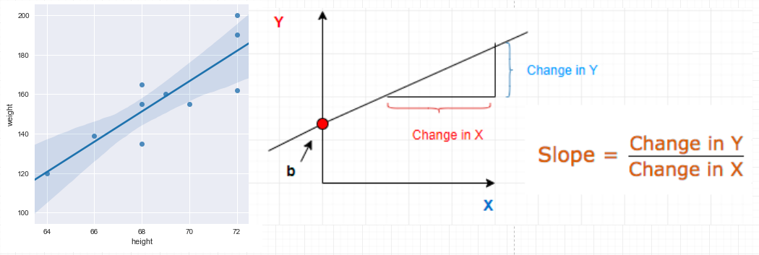

## Predictions

Given a known set of inputs and their corresponding outputs, A machine learning model tries to make some predictions for a new set of inputs.

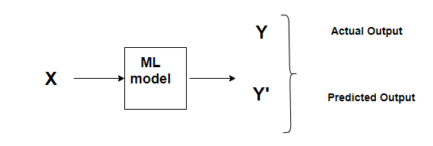

ML process

The Error would be the difference between the two predictions.

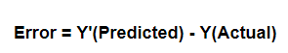

This relates to the idea of a **Cost function or Loss function.**

## Cost Function

A **Cost Function/Loss Function** evaluates the performance of our Machine Learning Algorithm. The**Loss function** computes the error for a single training example while the **Cost functi**on is the average of the loss functions for all the training examples. Henceforth, I shall be using both the terms interchangeably.

A Cost function basically tells us ‘ how good’ our model is at making predictions for a given value of m and b.

Let’s say, there are a total of ’N’ points in the dataset and for all those ’N’ data points we want to minimize the error. So the Cost function would be the total squared error i.e

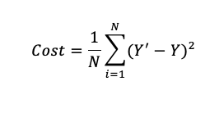

Cost function for N data points

*Why do we take the squared differences and simply not the absolute differences? Because the squared differences make it easier to derive a regression line. Indeed, to find that line we need to compute the first derivative of the Cost function, and it is much harder to compute the derivative of absolute values than squared values. Also, the squared differences increase the error distance, thus, making the bad predictions more pronounced than the good ones.*

## Minimizing the Cost Function

The goal of any Machine Learning Algorithm is to minimize the Cost Function.

This is because a lower error between the actual and the predicted values signifies that the algorithm has done a good job in learning. Since we want the lowest error value, we want those‘ **m’** and ‘**b’** values which give the smallest possible error.

## How do we actually minimize any function?

If we look carefully, our**Cost function** is of the form **Y = X²** . In a Cartesian coordinate system, this is an equation for a parabola and can be graphically represented as :

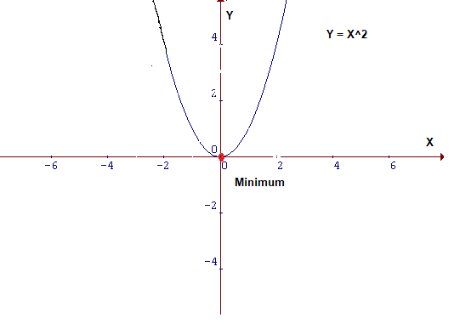

Parabola

To minimise the function above, we need to find **that value of X that produces the lowest value of Y**which is the**red dot.** It is quite easy to locate the minima here since it is a 2D graph but this may not always be the case especially in case of higher dimensions. For those cases, we need to devise an algorithm to locate the minima, and that algorithm is called**Gradient Descent.**

## Gradient Descent

**Gradient descent** is one of the most popular algorithms to perform optimization and by far the most common way to optimize neural networks. It is an iterative optimisation algorithm used to find the minimum value for a function.

## Intuition

Consider that you are walking along the graph below, and you are currently at the ‘**green**’ dot. Your aim is to reach the minimum i.e the ‘red’ dot, but from your position, you are unable to view it.

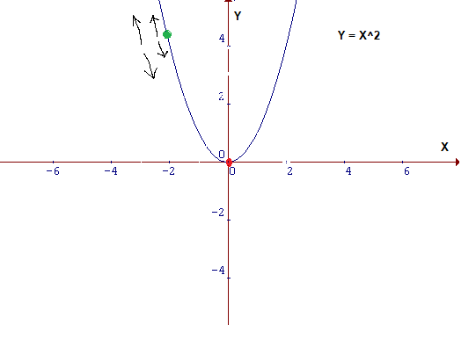

Figure 2

### **Possible actions would be:**

* You might go upward or downward
* If you decide on which way to go, you might take a bigger step or a little step to reach your destination.

Essentially, there are two things that you should know to reach the minima, i.e. which way to go and how big a step to take.

Gradient Descent Algorithm helps us to make these decisions efficiently and effectively with the use of derivatives. A **derivative** is a term that comes from calculus and is calculated as the slope of the graph at a particular point. The slope is described by drawing a tangent line to the graph at the point. So, if we are able to compute this tangent line, we might be able to compute the desired direction to reach the minima. We will talk about this in more detail in the later part of the article.

### The Minimum Value

In the same figure, if we draw a tangent at the green point, we know that if we are moving upwards, we are moving away from the minima and vice versa. Also, the tangent gives us a sense of the steepness of the slope.

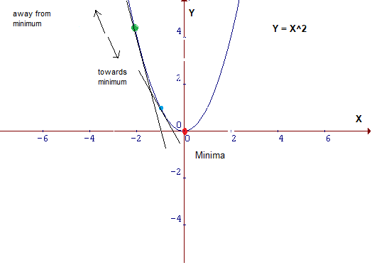

The slope at the blue point is less steep than that at the green point which means it will take much smaller **steps**to reach the minimum from the blue point than from the green point.

### Mathematical Interpretation of Cost Function

Let us now put all these learnings into a mathematical formula. In the equation, y = mX+b, ‘m’ and ‘b’ are its parameters. During the training process, there will be a small change in their values. Let that small change be denoted by δ**.**The value of parameters will be updated as **m=m-δm**and**b=b-δb**respectively. Our aim here is to find those values of m and b in y = mx+b , for which the error is minimum i.e values which minimize the cost function.

Rewriting the cost function:

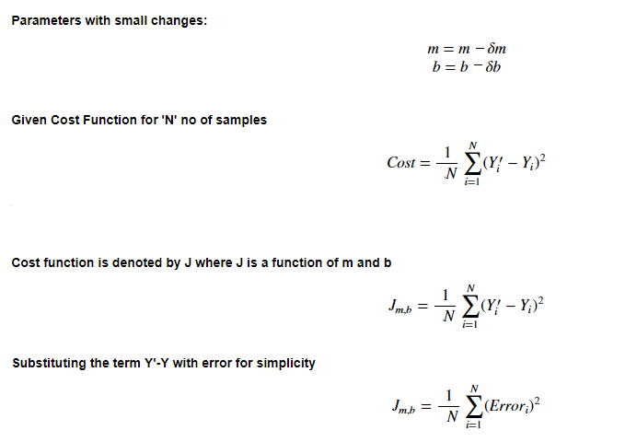

The idea is that by being able to compute the derivative/slope of the function, we can find the minimum of a function.

### The Learning rate

This size of steps taken to reach the minimum or bottom is called **Learning Rate**. We can cover more area with larger steps/higher learning rate but are at the risk of overshooting the minima. On the other hand, small steps/smaller learning rates will consume a lot of time to reach the lowest point.

The visualisations below give an idea about the Learning Rate concept. **See how in the third figure, we reach the minimum point with the minimum number of steps. This is the optimum learning rate for this problem.**

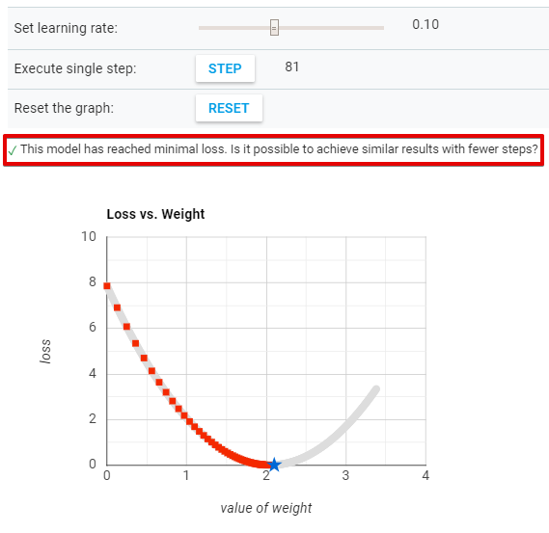

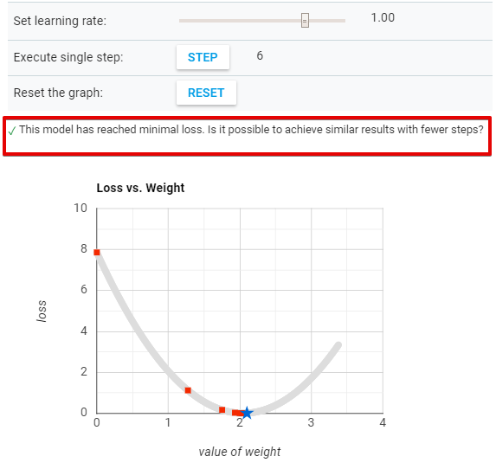

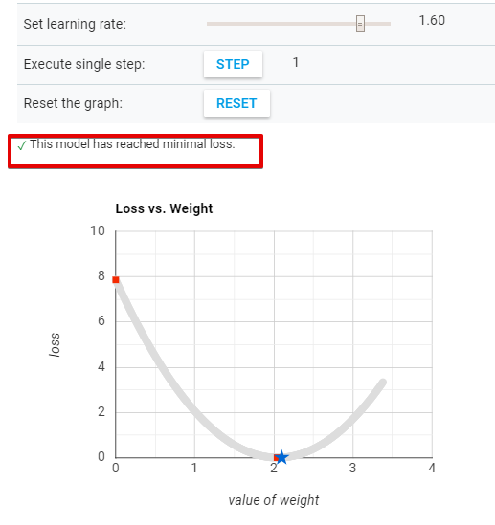

[Source](https://developers.google.com/machine-learning/crash-course/fitter/graph)

We saw that when the learning rate is too low, it takes a lot of steps to converge. On the other hand, when the learning rate is too high, Gradient Descent fails to reach the minimum as can be seen in the visualisation below.



[Source](https://developers.google.com/machine-learning/crash-course/fitter/graph)

Experiment with different learning rates by visiting the link below.

## [Optimizing Learning Rate | Machine Learning Crash Course | Google Developers](https://developers.google.com/machine-learning/crash-course/fitter/graph" \t "_blank)

### **[Can you reach the minimum more quickly with a higher learning rate? Set a learning rate of 1, and keep hitting STEP…](https://developers.google.com/machine-learning/crash-course/fitter/graph" \t "_blank)**

#### **[developers.google.com](https://developers.google.com/machine-learning/crash-course/fitter/graph" \t "_blank)**

### Derivatives

Machine learning uses derivatives in optimization problems. Optimization algorithms like gradient descent use derivates to actually decide whether to increase or decrease the weights in order to increase or decrease any objective function.

If we are able to compute the derivative of a function, we know in which direction to proceed to minimize it.

Primarily we shall be dealing with two concepts from calculus :

* **Power Rule**

Power rule calculates the derivative of a variable raised to a power.

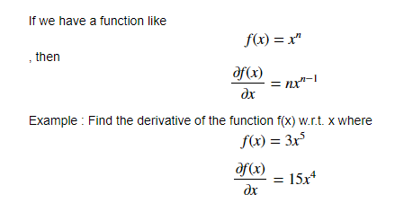

* **Chain Rule**

The **chain rule** is used for calculating the derivative of composite functions. The chain rule can also be expressed in [Leibniz’s notation](https://en.wikipedia.org/wiki/Leibniz%27s_notation) as follows:

If a variable **z** depends on the variable **y**, which itself depends on the variable **x**, so that y and z are dependent variables, then z, via the intermediate variable of y, depends on x as well. This is called the [chain rule](https://en.wikipedia.org/wiki/Chain_rule) and is mathematically written as,

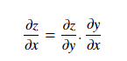

Let us understand it through an example:

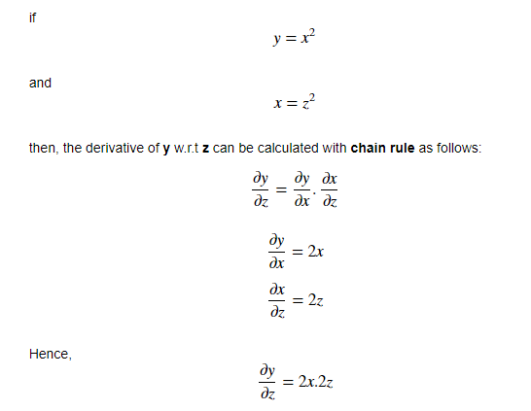

* Using the **Power** and **Chain** Rule for derivatives, let’s calculate how Cost function changes relative to m and c. This deals with the concept of **partial derivatives** which says that if there is a function of two variables, then to find the partial derivative of that function w.r.t to one variable, treat the other variable as constant. This will be more clear with an example:

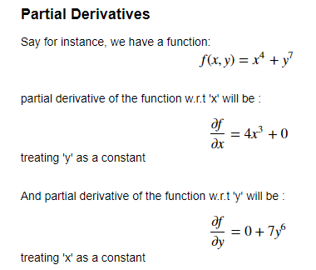

## Calculating Gradient Descent

Let us now apply the knowledge of these rules of calculus in our original equation and find the derivative of the Cost Function w.r.t to both **‘m’** and **‘b’**. Revising the Cost Function equation :

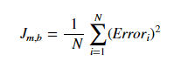

For simplicity, let us get rid of the summation sign. The summation part is important, especially with the concept of **Stochastic gradient descent (SGD )** vs **batch gradient descent**. During the **batch gradient descent**, we look at the error of all the training examples at once while in the **SGD** we look at each error at a time. However, just to keep things simple, we will assume that we are looking at each error one at a time.

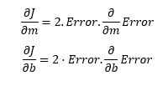

Now let’s calculate the gradient of Error w.r.t to both m and b :

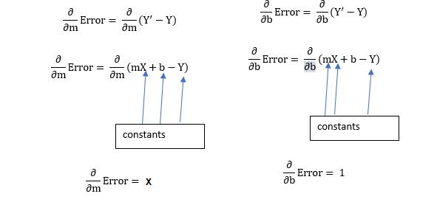

Plugging the values back in the cost function and multiplying it with the learning rate:

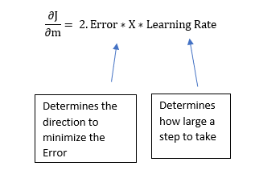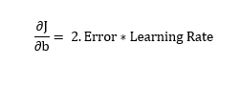

Now, this **2** in this equation isn’t that significant since it just says that we have a learning rate twice as big or half as big. So let’s just get rid of it too. So, Ultimately, this entire article boils down to two simple equations which represent the equations for Gradient Descen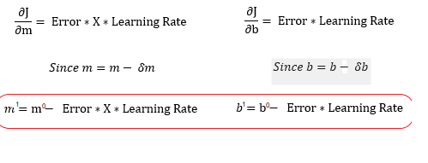

m¹,b¹ = next position parameters; m⁰,b⁰ = current position parameters

*Hence,to solve for the gradient, we iterate through our data points using our new m and b values and compute the partial derivatives. This new gradient tells us the slope of our cost function at our current position and the direction we should move to update our parameters. The size of our update is controlled by the learning rate.*

## Conclusion

The point of this article was to demonstrate the concept of gradient descent. We used gradient descent as our optimization strategy for linear regression. by drawing the line of best fit to measure the relationship between student heights and weights. However, it is important to note here that the linear regression example has been chosen for simplicity but can be used with other Machine Learning techniques too.

# Bias-Variance tradeoff, Overfitting & Under-fitting

Whenever we build a prediction model, even after all the adjustments and treatments, our predictions will generally be imperfect: there will be some nonzero difference between the predicted and the actual values. This difference is called prediction error. We can decompose prediction error into two components: Reducible and Irreducible error.

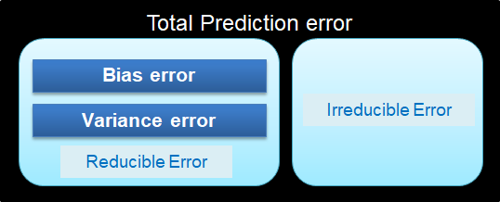

Let us understand it using a real life analogy. A train driver will be able to successfully lead the train to the desired destination or not, this is dependent on two factors, HIMSELF (reducible error, if he is alert and aware , he will not make any inadvertent mistakes) and EXTERNAL FACTORS (irreducible errors, what if a stray animal ventures on the rail track, what if another train driver coming from opposite direction loses control, what if a suicidal person throws himself in the front of his train etc.)

Have a look at the following equation to summarize it all:



Now, we will understand the two components (Bias error and Variance error) of this equation before discussing the trade-off situation between the two that plagues every model out there.

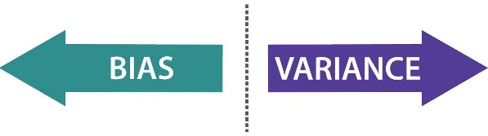

Consider a person Mr. X who is a freshman and an aspiring data scientist and is currently interviewing with various firms to get his first breakthrough in this industry. He appears for an interview one day and came back home really stressed and gloomy because it did not go well. His mother asked him all about it and he shared that the interviewer asked him way too advanced level questions and judged him critically at every point without mincing any words which broke his confidence. His mother then soothes him by pointing out that “this was just not your day, tomorrow will be better”.

Now, from this story we can see that the mother did not ask her son to prepare more zealously than before in order to increase his chances of success. The reason is that she will always have an emotional **BIAS** towards her son and will always try to downplay his failures. If you try predicting her response to a person who comes to her for comfort without considering if the person is her son (immediate family) or not, your prediction will have a bias error. Now, the following pointers will help you understand how Bias affects statistical models and the technical definition to fall back upon:

* Real life example for Bias- I will quote a stock market example here, let’s say I built a fairly simple model which predicts the share price of a stock based on only 3–4 predictors. The model predicted that on 3rd Feb 2019 share price per unit will be 4$ but the actual price turned out to be 3.4$ that day. Thus, the total error will be the difference between the two numbers, i.e. 0.6$ and the bias component is contributing majorly here because we took only few predictors.
* Define Bias- Bias error is the difference between the predicted data points and the actual data points which was caused because our model was oversimplified.
* A model with high bias is too simple and has low number of predictors. It is missing some other important predictors due to which it is unable to capture the underlying pattern of data. It misses how the features in the training data set relate to the expected output. It pays very little attention to the training data and oversimplifies the model. This leads to high error on training and test data.

Now, let’s go back to the story once again. We saw that the interviewer asked high difficulty level questions from a freshman i.e. he complicated the seemingly easy situation because the unnecessary complex questions dumbfounded Mr. X . Let’s throw two more facts here-

* Mr. X prepared only for the entry level questions, thus he couldn’t answer advanced questions.
* Interviewer had only interviewed people for positions requiring 5–6 years of experience, thus, he had never interviewed a fresher before.

In this situation, the interviewer is not comfortable outside of his comfort zone. Mr. X is an unseen input for him that he doesn’t know how to tackle so he flounders by asking way too complicated questions. This is the perfect case to understand **VARIANCE**. When exposed to situations in his comfort zone(training data), the interviewer performs excellently but a new experience(test data)threw him off track. Now you are ready to understand the technical definition of Variance and its effects on models as explained below:

* Any model which has very large number of predictors will end up being a very complex model which will deliver very accurate predictions for the training data that it has seen already but this complexity makes the generalization of this model to unseen data very difficult i.e a high variance model. Thus, this model will perform very poorly on test data.
* High variance error of a model implies that it is highly sensitive to small fluctuations. This model flounders outside of its comfort zone(training data)
* Variance also helps us to understand the spread of the data.

There are two more important terms related to bias and variance that we must understand now- Overfitting and Under fitting. I am again going to use a real life analogy here. I have referred to the blog of Machine learning@Berkeley for this example.

**There is a very delicate balancing act when machine learning algorithms try to predict things.**

**On the one hand, we want our algorithm to model the training data very closely, otherwise we’ll miss relevant features and interesting trends.**

**However, on the other hand we don’t want our model to fit too closely, and risk over-interpreting every outlier and irregularity.**

## The Fukushima power plant disaster

[The Fukushima power plant disaster](https://en.wikipedia.org/wiki/Fukushima_Daiichi_nuclear_disaster) is a devastating example of overfitting. When designing the power plant, engineers had to determine how often earthquakes would occur. They used a well-known law called the Gutenberg-Richter Law, which gives a way of predicting the probability of a very strong earthquake from the frequency that very weak earthquakes occur. This is useful because weak earthquakes–ones that are so weak that you can’t even feel them–happen almost all the time and are recorded by geologists, so the engineers had quite a large dataset to work with. Perhaps the most important result of this law is that the relationship between the magnitude of an earthquake and the logarithm of the probability that it happens is linear.

**The engineers of the nuclear power plant used earthquake data from the past 400 years to train a regression model.** Their prediction looked something like this:

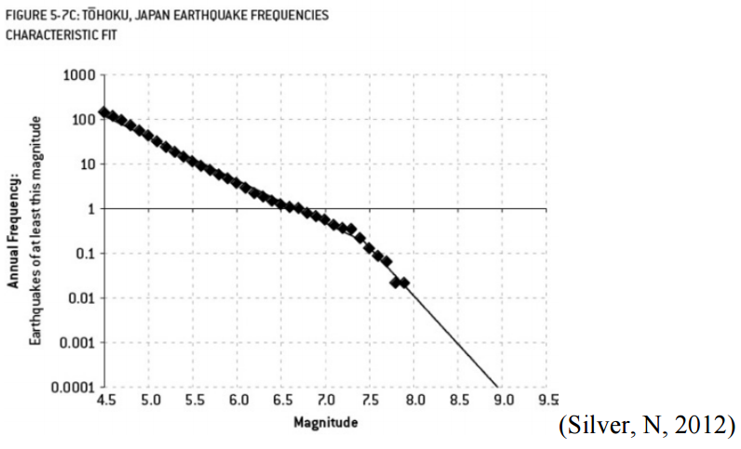

Source: [Brian Stacey, Fukushima: The Failure of Predictive Models](https://mpra.ub.uni-muenchen.de/69383/1/MPRA_paper_69383.pdf)

The diamonds represent actual data while the thin line shows the engineers’ regression. **Notice how their model hugs the data points very closely**. In fact, their model makes a kink at around a magnitude of 7.3 — decidedly not linear.

**In machine learning jargon, we call this overfitting**. As the name implies, overfitting is when we train a predictive model that “hugs” the training data too closely. In this case, the engineers knew the relationship should have been a straight line but they used a more complex model than they needed to.

If the engineers had used the correct linear model, their results would have looked something like this:

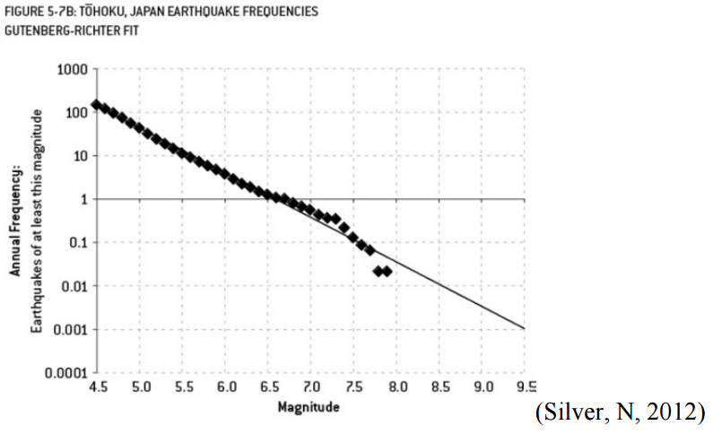

Notice there’s no kink this time, so the line isn’t as steeply sloped on the right.

**The difference between these two models? The overfitted model predicted one earthquake of at least magnitude 9 about every 13,000 years while the correct model predicted one earthquake of at least magnitude 9 just about every 300 years. And because of this, the Fukushima Nuclear Power Plant was built only to withstand an earthquake of magnitude 8.6. The 2011 earthquake that devastated the plant was of magnitude 9 (about 2.5 times stronger than a magnitude 8.6 earthquake).**

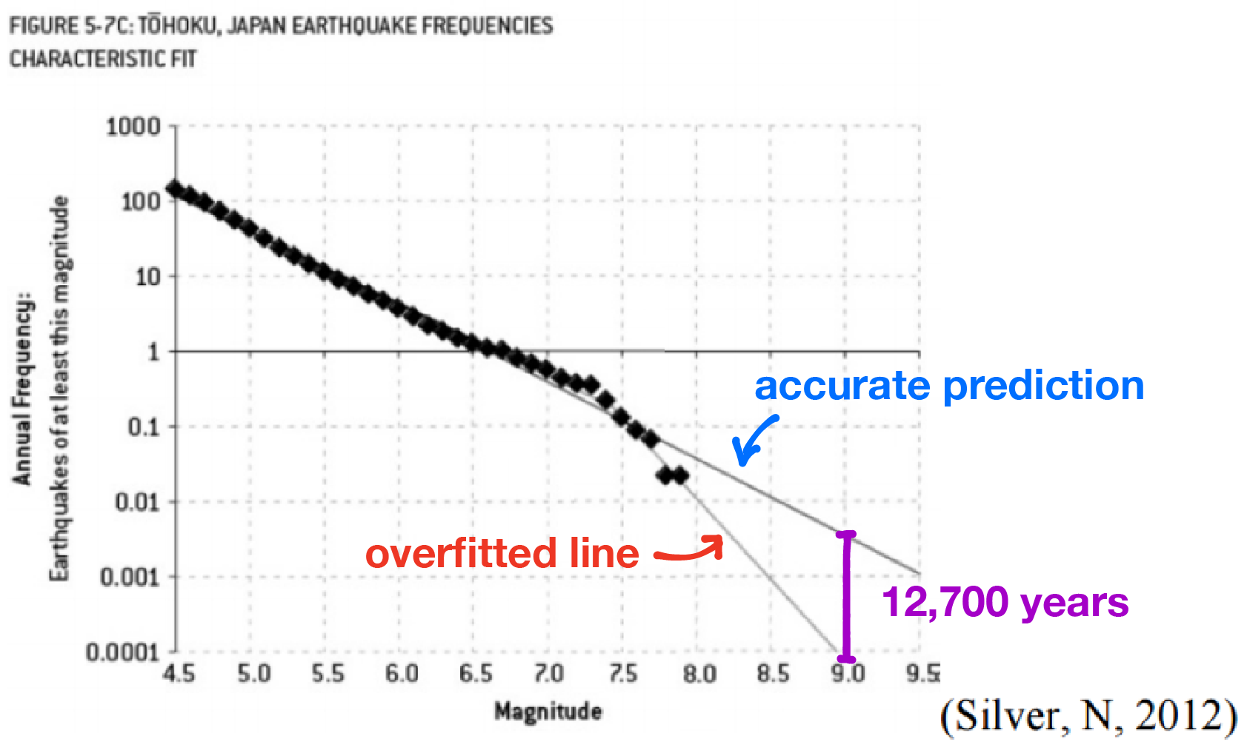

**There is actually a dual problem to overfitting, which is called Under-fitting**. In our attempt to reduce overfitting, we might actually begin to head to the other extreme and our model can start to ignore important features of our data set. This happens when we choose a model that is not complex enough to capture these important features, such as using a linear model when a quadratic is necessary.

Now, the important takeaways from this example that we have to remember are as following:

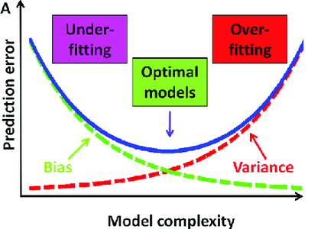

* **UNDER-FITTING**

1. When a model is unable to capture the essence of the training data properly because of low number of parameters then this phenomenon is known as Under-fitting.
2. High bias error, Low variance error
3. This can also happen in the cases where we have very less amount of data to build an accurate model.
4. This situation can also arise if we try to build linear model with non-linear data.
5. Example- Linear regression and logistic regression models might face this

* **OVERFITTING**

1. When a model is built using so many predictors that it captures noise along with the underlying pattern then it tries to fit the model too closely to the training data leaving very less scope for generalizability. This phenomenon is known as Overfitting.
2. Low bias error, High variance error
3. This is a case of complex representation of a simpler reality
4. Example- Decision tress are prime to Overfitting

## The Bias-variance tradeoff

**Bias-variance trade-off**is the sweet spot where our machine model performs between the errors introduced by the bias and the variance.

We have to avoid overfitting because it gives too much predictive power to even noise elements in our training data. But in our attempt to reduce overfitting we can also begin to underfit, ignoring important features in our training data. So how do we balance the two?

In the field of machine learning this incredibly important problem is known as **the bias-variance dilemma**. It’s entirely possible to have state-of-the-art algorithms, the fastest computers, and the most recent GPUs, but if your model overfits or underfits to the training data, its predictive powers are going to be terrible no matter how much money or technology you throw at it.

The name bias-variance dilemma comes from two terms in statistics: **bias**, which corresponds to Under-fitting, and **variance**, which corresponds to overfitting that you must have understood in its entirety if you have followed till here:)

### Explaining the Dilemma

So, why is there a trade-off between bias and variance anyways? How come we can’t have the best of both worlds and have a model that has both low bias and low variance? It turns out that bias and variance are actually side effects of one factor: the complexity of our model.

**Example-** For the case of high bias, we have a very simple model. In our example below, a linear model is used, possibly the most simple model there is. And for the case of high variance, the model we used was super complex (think squiggly).

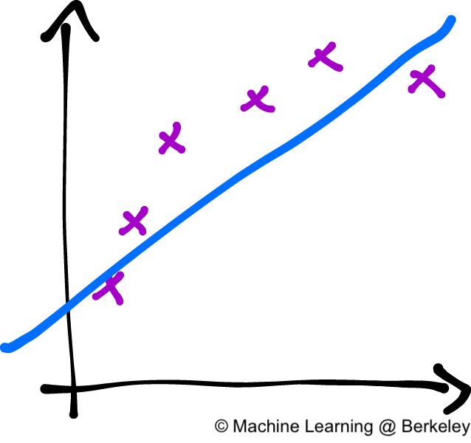

High bias- Under fitted model

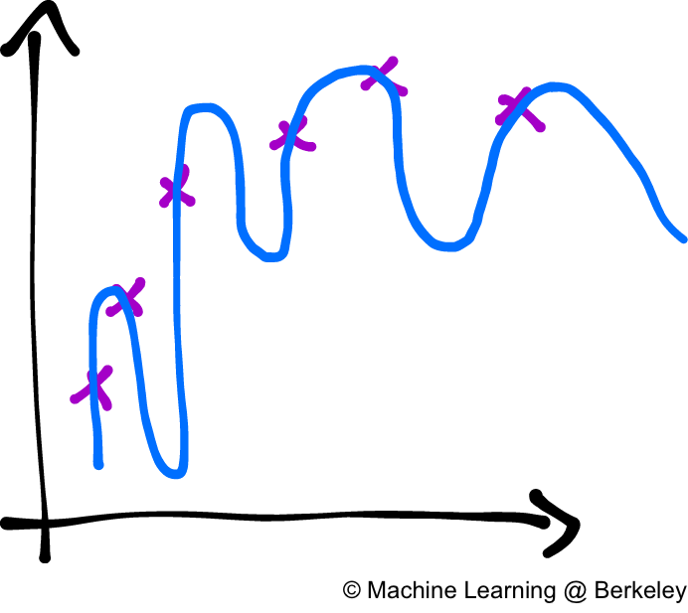

High variance- Overfitted model

This tradeoff is somewhat like the electron and the proton balance in an atom, both are equally important and their harmony is important for the universe as a whole. Similarly, bias and variance are two kinds of errors to be minimised during the model building. But, to minimize both at the same time poses a challenge because as shown in the image below:

* Any low complexity model- Will be prone to Under-fitting because of high bias and low variance
* Any high complexity model(Decision tress)- Will be prone to overfitting due to low bias and high variance

The best we can do is try to settle somewhere in the middle of the spectrum, where the purple pointer is.

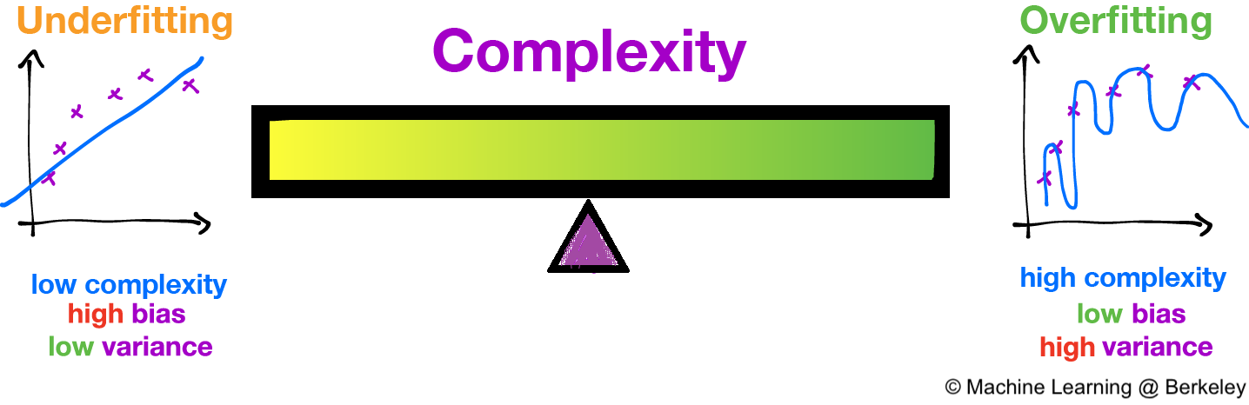

Lastly, have a look at the below diagram which you will notice being used everywhere in context of the bias-variance trade-off and we have covered all the concepts in detail for you to be able to understand it with ease now.

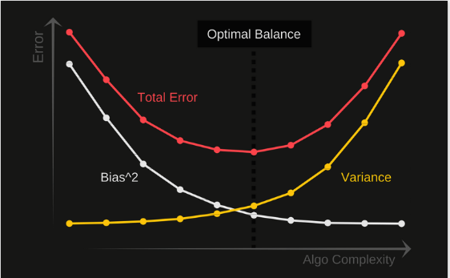

Thank you for reading:) I would love to hear your feedback/suggestions!

Reference:[https://ml.berkeley.edu/blog/2017/07/13/tutorial-4/](https://ml.berkeley.edu/blog/2017/07/13/tutorial-4/" \t "_blank)

# Polynomial Linear Regression

In the last section, we saw two variables in your data set were correlated but what happens if we know that our data is correlated, but the relationship doesn’t look linear? So hence depending on what the data looks like, we can do a polynomial regression on the data to fit a polynomial equation to it.





Left: Linear Regression, Right: Polynomial regression | GIF: Towards Data Science

Hence If we try to use a simple linear regression in the above graph then the linear regression line won’t fit very well. It is very difficult to fit a linear regression line in the above graph with a low value of error. Hence we can try to use the polynomial regression to fit a polynomial line so that we can achieve a minimum error or minimum cost function. The equation of the polynomial regression for the above graph data would be:

y = *θo + θ*₁*x*₁*+ θ*₂*x*₁²

This is the general equation of a polynomial regression is:

*Y*=θo + θ₁*X*+ θ₂*X*² + … + θₘXᵐ + **residual error**

## Advantages of using Polynomial Regression:

* Polynomial provides the best approximation of the relationship between the dependent and independent variable.
* A Broad range of function can be fit under it.
* Polynomial basically fits a wide range of curvature.

## Disadvantages of using Polynomial Regression

* The presence of one or two outliers in the data can seriously affect the results of the nonlinear analysis.
* These are too sensitive to the outliers.
* In addition, there are unfortunately fewer model validation tools for the detection of outliers in nonlinear regression than there are for linear regression.

# Residual Analysis

Randomness and unpredictability are the two main components of a regression model.

Prediction = Deterministic + Statistic

Deterministic part is covered by the predictor variable in the model. Stochastic part reveals the fact that the expected and observed value is unpredictable. There will always be some information that are missed to cover. This information can be obtained from the residual information.

Let’s explain the concept of residue through an example. Consider, we have a dataset which predicts sales of juice when given a temperature of place. Value predicted from regression equation will always have some difference with the actual value. Sales will not match exactly with the true output value. This difference is called as residue.

Residual plot helps in analysing the model using the values of residues. It is plotted between predicted values and residue. Their values are standardized. The distance of the point from 0 specifies how bad the prediction was for that value. If the value is positive, then the prediction is low. If the value is negative, then the prediction is high. 0 value indicates prefect prediction. Detecting residual pattern can improve the model.

Non-random pattern of the residual plot indicates that the model is,

* Missing a variable which has significant contribution to the model target
* Missing to capture non-linearity (using polynomial term)
* No interaction between terms in model

Characteristics of a residue

* Residuals do not exhibit any pattern
* Adjacent residuals should not be same as they indicate that there is some information missed by system.

Residual implementation and plot

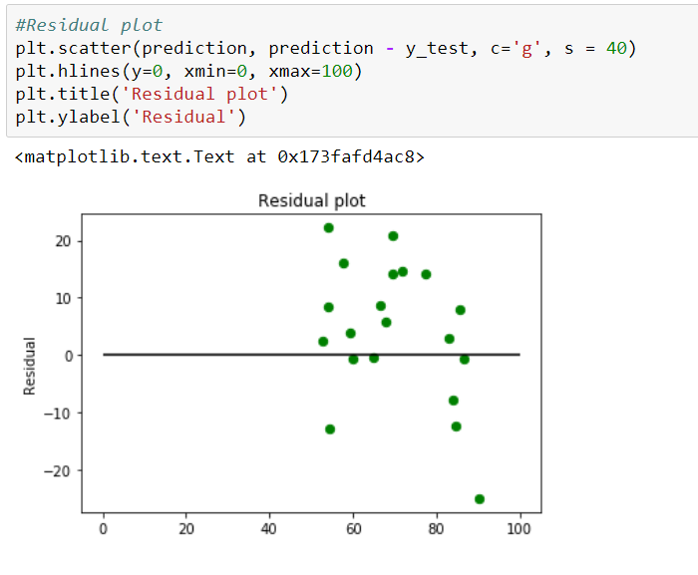

Figure 8: Residual Plot

[(Some other reference materials — 1](https://newonlinecourses.science.psu.edu/stat501/node/250/)) &([Reference material — 2)](http://blog.minitab.com/blog/adventures-in-statistics-2/why-you-need-to-check-your-residual-plots-for-regression-analysis" \t "_blank)

# Metrics for model evaluation

## R-Squared value

This value ranges from 0 to 1. Value ‘1’ indicates predictor perfectly accounts for all the variation in Y. Value ‘0’ indicates that predictor ‘x’ accounts for no variation in ‘y’.

1. Regression sum of squares (SSR)

This gives information about how far estimated regression line is from the horizontal ‘no relationship’ line (average of actual output).

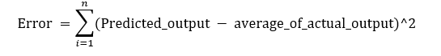

Figure 9: Regression Error Formula

2. Sum of Squared error (SSE)

How much the target value varies around the regression line (predicted value).

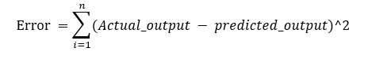

Figure 10: Sum of Square Formula

3. Total sum of squares (SSTO)

This tells how much the data point move around the mean.

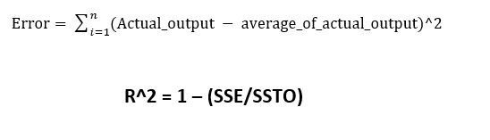

Figure 11: Total Error Formula

Python implementation

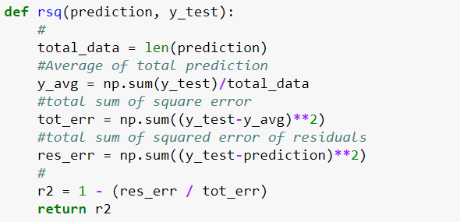

Figure 12: Python Implementation of R-Square

***Is the range of R-Square always between 0 to 1?***

Value of R2 may end up being negative if the regression line is made to pass through a point forcefully. This will lead to forcefully making regression line to pass through the origin (no intercept) giving an error higher than the error produced by the horizontal line. This will happen if the data is far away from the origin.

(For more details — <https://medium.com/@saishruthi.tn/is-r-sqaure-value-always-between-0-to-1-36a8d17807d1>)

***Correlation co-efficient (r)***

This is related to value of ‘r-squared’ which can be observed from the notation itself. It ranges from -1 to 1.

r = (+/-) sqrt(r²)

If the value of b1 is negative, then ‘r’ is negative whereas if the value of ‘b1’ is positive then, ‘r’ is positive. It is unitless.

***Null-Hypothesis and P-value***

Null hypothesis is the initial claim that researcher specify using previous research or knowledge.

Low P-value: Rejects null hypothesis indicating that the predictor value is related to the response

High P-value: Changes in predictor are not associated with change in target

Obtained Regression line

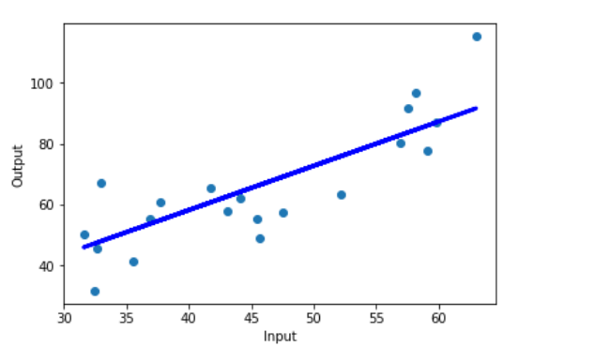

Figure 13: Final Regression line over test data

Full code: https://github.com/SSaishruthi/Linear\_Regression\_Detailed\_Implementation

Also read: Calculating R-squared from scratch (using python)

# Logistic Regression

## Introduction

In this blog, we will discuss the basic concepts of Logistic Regression and what kind of problems can it help us to solve.



GIF: University of Toronto

Logistic regression is a classification algorithm used to assign observations to a discrete set of classes. Some of the examples of classification problems are Email spam or not spam, Online transactions Fraud or not Fraud, Tumor Malignant or Benign. Logistic regression transforms its output using the logistic sigmoid function to return a probability value.

## **What are the types of logistic regression**

1. Binary (eg. Tumor Malignant or Benign)
2. Multi-linear functions failsClass (eg. Cats, dogs or Sheep's)

## Logistic Regression

Logistic Regression is a Machine Learning algorithm which is used for the classification problems, it is a predictive analysis algorithm and based on the concept of probability.

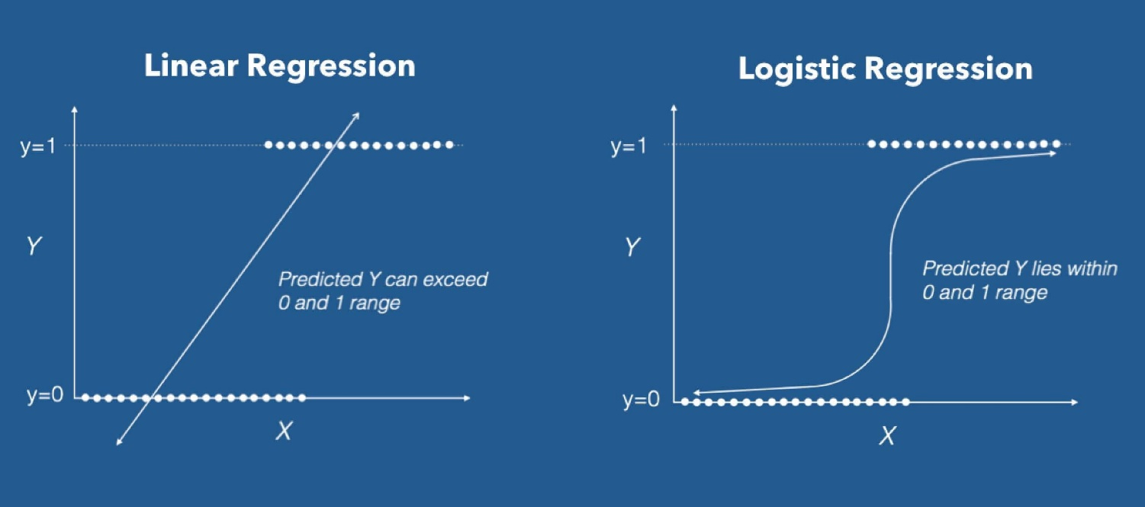

Linear Regression VS Logistic Regression Graph| Image: Data Camp

We can call a Logistic Regression a Linear Regression model but the Logistic Regression uses a more complex cost function, this cost function can be defined as the ‘**Sigmoid function**’ or also known as the ‘logistic function’ instead of a linear function.

The hypothesis of logistic regression tends it to limit the cost function between 0 and 1. Therefore linear functions fail to represent it as it can have a value greater than 1 or less than 0 which is not possible as per the hypothesis of logistic regression.

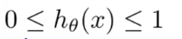

Logistic regression hypothesis expectation

## What is the Sigmoid Function?

In order to map predicted values to probabilities, we use the Sigmoid function. The function maps any real value into another value between 0 and 1. In machine learning, we use sigmoid to map predictions to probabilities.



### Sigmoid Function Graph

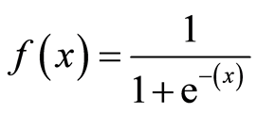

Formula of a sigmoid function | Image: Analytics India Magazine

## **Hypothesis Representation**

When using linear regression we used a formula of the hypothesis i.e.

*hΘ(x) = β₀ + β₁X*

For logistic regression we are going to modify it a little bit i.e.

*σ(Z) = σ(β₀ + β₁X)*

We have expected that our hypothesis will give values between 0 and 1.

Z = β₀ + β₁X

hΘ(x) = sigmoid(Z)

i.e. hΘ(x) = 1/(1 + e^-(β₀ + β₁X)

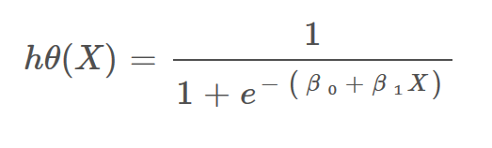

The Hypothesis of logistic regression

## Decision Boundary

We expect our classifier to give us a set of outputs or classes based on probability when we pass the inputs through a prediction function and returns a probability score between 0 and 1.

For Example, We have 2 classes, let’s take them like cats and dogs(1 — dog , 0 — cats). We basically decide with a threshold value above which we classify values into Class 1 and of the value goes below the threshold then we classify it in Class 2.

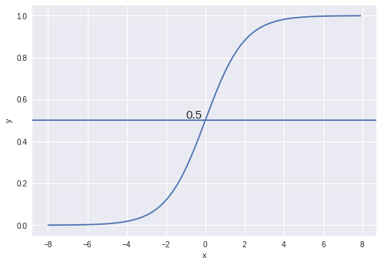

Example

As shown in the above graph we have chosen the threshold as 0.5, if the prediction function returned a value of 0.7 then we would classify this observation as Class 1(DOG). If our prediction returned a value of 0.2 then we would classify the observation as Class 2(CAT).

## Cost Function

We learnt about the cost function J(θ) in the [Linear regression](https://towardsdatascience.com/introduction-to-linear-regression-and-polynomial-regression-f8adc96f31cb), the cost function represents optimization objective i.e. we create a cost function and minimize it so that we can develop an accurate model with minimum error.



The Cost function of Linear regression

If we try to use the cost function of the linear regression in ‘Logistic Regression’ then it would be of no use as it would end up being a **non-convex** function with many local minimums, in which it would be very **difficult** to **minimize the cost value** and find the global minimum.

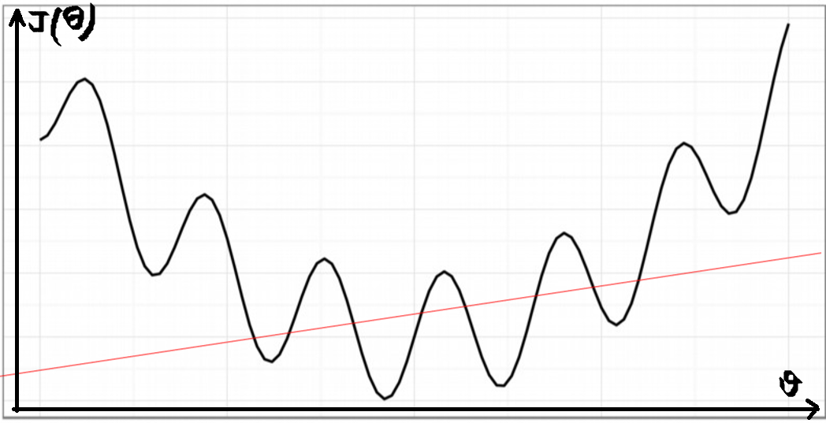

Non-convex function

For logistic regression, the Cost function is defined as:

*−log(*hθ*(*x*)) if y = 1*

*−log(1−*hθ*(*x*)) if y = 0*

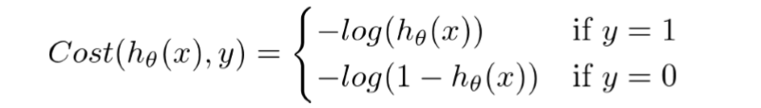

Cost function of Logistic Regression

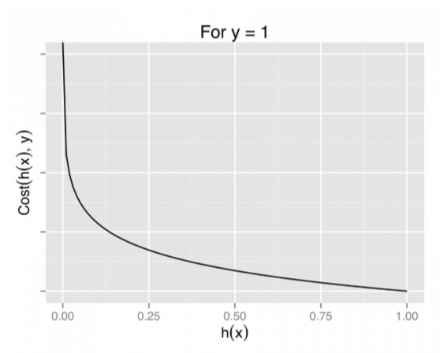

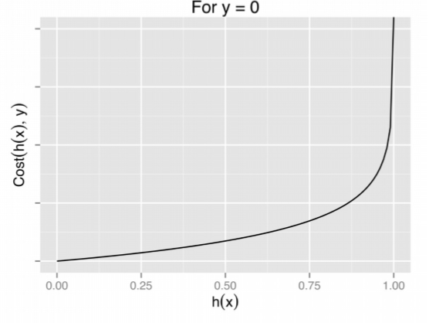

### **Cost function intuition**

If the actual class is 1 and the model predicts 0, we should highly penalize it and vice-versa. As you can see from the below picture, for the plot -log(h(x)) as h(x) approaches 1, the cost is 0 and as h(x) nears 0, the cost is infinity(that is we penalize the model heavily). Similarly for the plot -log(1-h(x)) when the actual value is 0 and the model predicts 0, the cost is 0 and the cost becomes infinity as h(x) approaches 1.

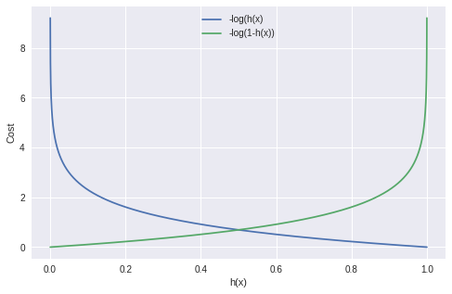

## Graph of logistic regression

The above two functions can be compressed into a single function i.e.

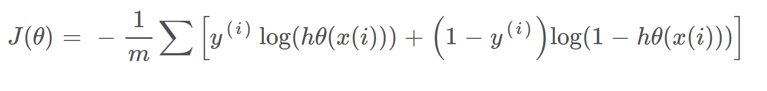

Above functions compressed into one cost function

## Gradient Descent

Now the question arises, how do we reduce the cost value? Well, this can be done by using **Gradient Descent.**The main goal of Gradient descent is to **minimize the cost value.** I.e. min J(**θ**).

Now to minimize our cost function we need to run the gradient descent function on each parameter i.e.

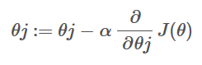

Objective: To minimize the cost function we have to run the gradient descent function on each parameter

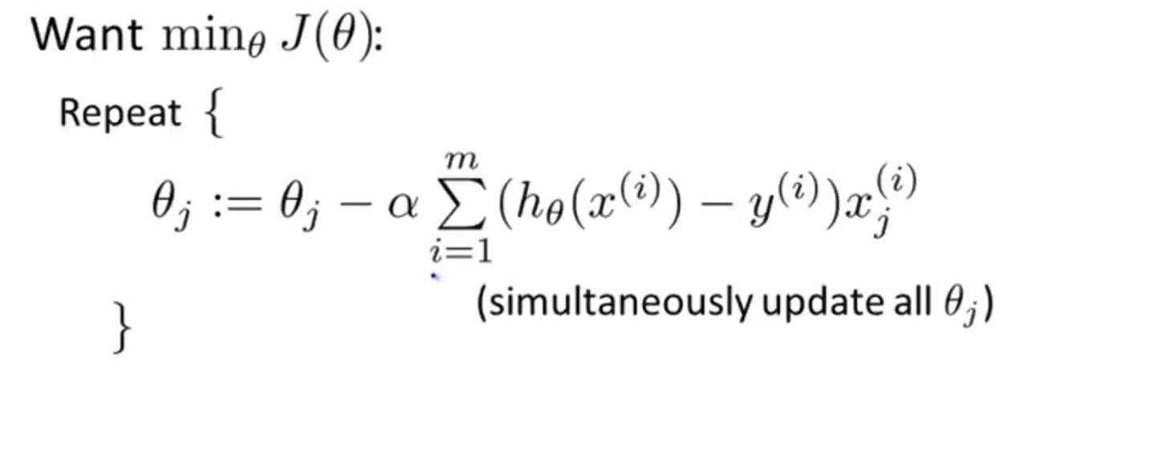

Gradient Descent Simplified | Image: Andrew Ng Course

Gradient descent has an analogy in which we have to imagine ourselves at the top of a mountain valley and left stranded and blindfolded, our objective is to reach the bottom of the hill. Feeling the slope of the terrain around you is what everyone would do. Well, this action is analogous to calculating the gradient descent, and taking a step is analogous to one iteration of the update to the parameters.

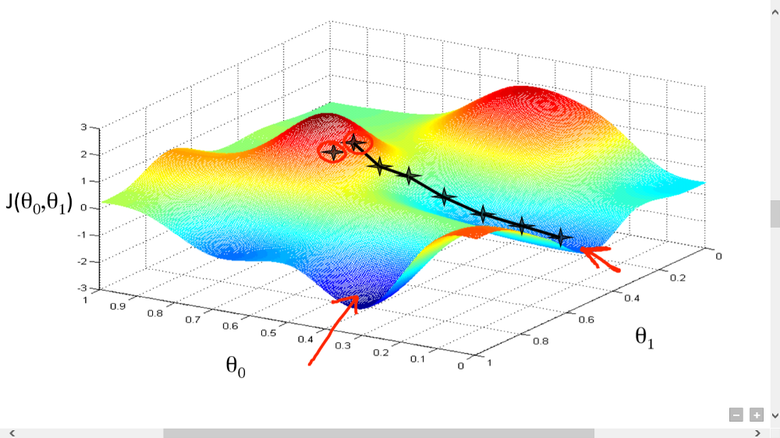

Gradient Descent analogy

# Introduction to k-Nearest Neighbours: A powerful Machine Learning Algorithm (with implementation in Python & R)

## **Overview**

* Understand k nearest neighbor (KNN) – one of the most popular [machine learning](https://www.analyticsvidhya.com/machine-learning/?utm_source=blog&utm_medium=k-nearest-neighbors) algorithms
* Learn the working of kNN in python
* Choose the right value of k in simple terms

## Introduction

[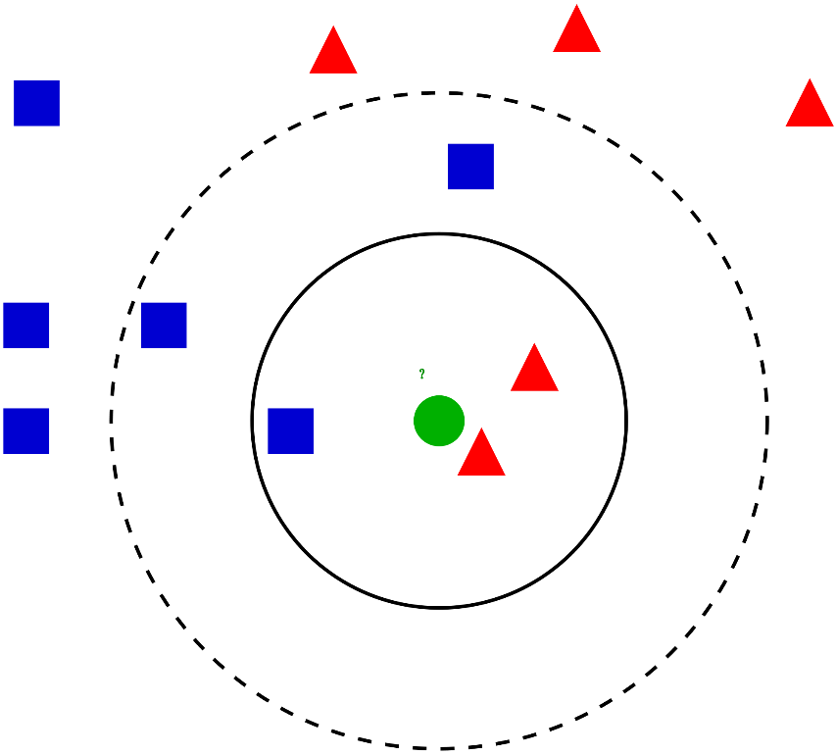](https://cdn.analyticsvidhya.com/wp-content/uploads/2018/03/knn3.png)

In this article, we will talk about another widely used [machine learning](https://www.analyticsvidhya.com/machine-learning/?utm_source=blog&utm_medium=k-nearest-neighbors) [**classification techniqu**](https://courses.analyticsvidhya.com/courses/introduction-to-data-science-2/?utm_source=blog&utm_medium=introknearestneighborarticle)**e** called K-nearest Neighbours (KNN). Our focus will be primarily on how the algorithm work does and how the input parameter does affects the output/prediction.

Note: People whoo prefer to learn through videos can learn the same through our free course – [K-Nearest Neighbours (KNN) Algorithm in Python and R](https://courses.analyticsvidhya.com/courses/K-Nearest-Neighbors-KNN-Algorithm?utm_source=blog&utm_medium=knn_in_python&R)

## Table of Contents

* When do we use KNN algorithm?
* How does the KNN algorithm work?
* How do we choose the factor K?
* Breaking it Down – Pseudo Code of KNN
* Implementation in Python from scratch
* Comparing our model with scikit-learn

## When do we use KNN algorithm?

KNN can be used for both classification and regression predictive problems. However, it is more widely used in classification problems in the industry. To evaluate any technique we generally look at 3 important aspects:

1. Ease to interpret output

2. Calculation time

3. Predictive Power

Let us take a few examples to place KNN in the scale:

[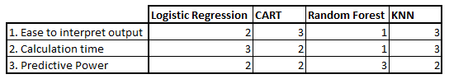](https://www.analyticsvidhya.com/wp-content/uploads/2014/10/Model-comparison.png)KNN algorithm fairs across all parameters of considerations. It is commonly used for its easy of interpretation and low calculation time.

## How does the KNN algorithm work?

Let’s take a simple case to understand this algorithm. Following is a spread of red circles (RC) and green squares (GS):

[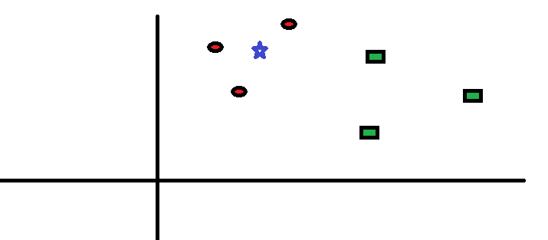](https://www.analyticsvidhya.com/wp-content/uploads/2014/10/scenario1.png)

You intend to find out the class of the blue star (BS). BS can either be RC or GS and nothing else. The “K” is KNN algorithm is the nearest neighbour we wish to take the vote from. Let’s say K = 3. Hence, we will now make a circle with BS as the centre just as big as to enclose only three data points on the plane. Refer to the following diagram for more details:

[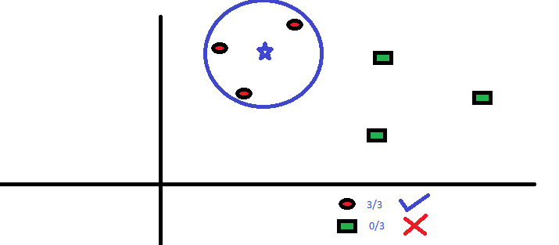](https://www.analyticsvidhya.com/wp-content/uploads/2014/10/scenario2.png)The three closest points to BS is all RC. Hence, with a good confidence level, we can say that the BS should belong to the class RC. Here, the choice became very obvious as all three votes from the closest neighbour went to RC. The choice of the parameter K is very crucial in this algorithm. Next, we will understand what are the factors to be considered to conclude the best “K”.

## How do we choose the factor K?

First let us try to understand what exactly K influences in the algorithm. If we see the last example, given that all the 6 training observation remain constant, with a given K value we can make boundaries of each class. These boundaries will segregate RC from GS. In the same way, let’s try to see the effect of value “K” on the class boundaries. The following are the different boundaries separating the two classes with different values of K.

[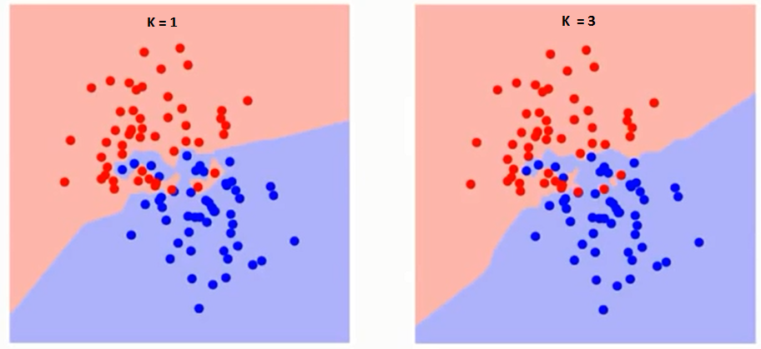](https://www.analyticsvidhya.com/wp-content/uploads/2014/10/K-judgement.png)

[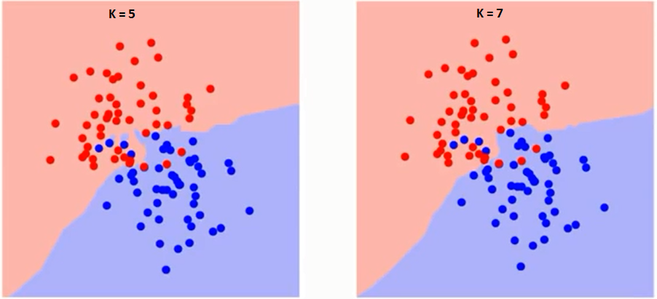](https://www.analyticsvidhya.com/wp-content/uploads/2014/10/K-judgement2.png)

If you watch carefully, you can see that the boundary becomes smoother with increasing value of K. With K increasing to infinity it finally becomes all blue or all red depending on the total majority.  The training error rate and the validation error rate are two parameters we need to access different K-value. Following is the curve for the training error rate with a varying value of K:

[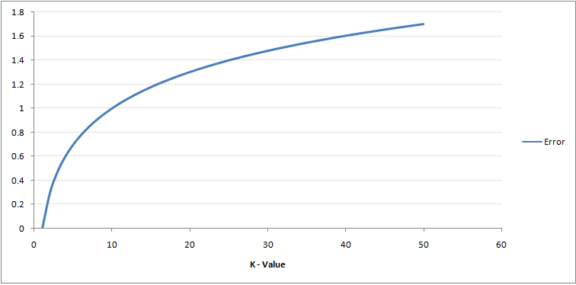](https://www.analyticsvidhya.com/wp-content/uploads/2014/10/training-error.png)As you can see, the error rate at K=1 is always zero for the training sample. This is because the closest point to any training data point is itself.Hence the prediction is always accurate with K=1. If validation error curve would have been similar, our choice of K would have been 1. Following is the validation error curve with varying value of K:

[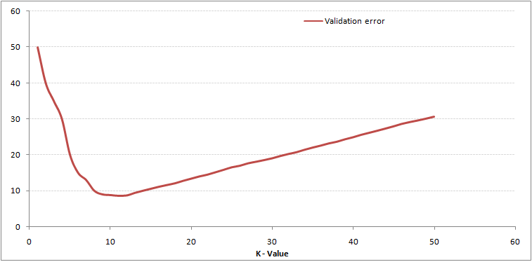](https://www.analyticsvidhya.com/wp-content/uploads/2014/10/training-error_11.png)This makes the story more clear. At K=1, we were overfitting the boundaries. Hence, error rate initially decreases and reaches a minima. After the minima point, it then increase with increasing K. To get the optimal value of K, you can segregate the training and validation from the initial dataset. Now plot the validation error curve to get the optimal value of K. This value of K should be used for all predictions.

The above content can be understood more intuitively using our free course – [K-Nearest Neighbours (KNN) Algorithm in Python and R](https://courses.analyticsvidhya.com/courses/K-Nearest-Neighbors-KNN-Algorithm?utm_source=blog&utm_medium=knn_in_python&R)

## End Notes

KNN algorithm is one of the simplest classification algorithm. Even with such simplicity, it can give highly competitive results. KNN algorithm can also be used for regression problems. The only difference from the discussed methodology will be using averages of nearest Neighbours rather than voting from nearest Neighbours. KNN can be coded in a single line on R. I am yet to explore how can we use KNN algorithm on SAS

# Understanding Support Vector Machine (SVM) algorithm from examples (along with code)

## What is Support Vector Machine?

“Support Vector Machine” (SVM) is a supervised [machine learning algorithm](https://courses.analyticsvidhya.com/courses/introduction-to-data-science-2?utm_source=blog&utm_medium=understandingsupportvectormachinearticle) which can be used for both classification and regression challenges. However, it is mostly used in classification problems. In the SVM algorithm, we plot each data item as a point in n-dimensional space (where n is number of features you have) with the value of each feature being the value of a particular coordinate. Then, we perform classification by finding the hyper-plane that differentiates the two classes very well (look at the below snapshot).

[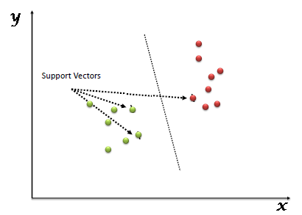](https://www.analyticsvidhya.com/wp-content/uploads/2015/10/SVM_1.png)

Support Vectors are simply the co-ordinates of individual observation. The SVM classifier is a frontier which best segregates the two classes (hyper-plane/ line).

You can look at [support vector machines](https://www.analyticsvidhya.com/blog/2014/10/support-vector-machine-simplified/?utm_source=blog&utm_medium=understandingsupportvectormachinearticle) and a few examples of its working here.

## How does it work?

Above, we got accustomed to the process of segregating the two classes with a hyper-plane. Now the burning question is “How can we identify the right hyper-plane?”. Don’t worry, it’s not as hard as you think!

Let’s understand:

* **Identify the right hyper-plane (Scenario-1):**Here, we have three hyper-planes (A, B and C). Now, identify the right hyper-plane to classify star and circle.  
  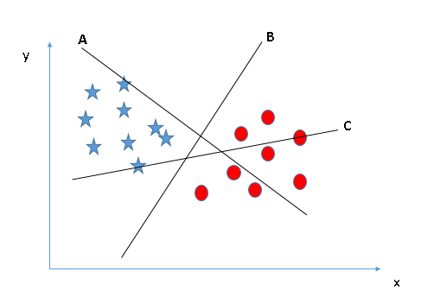You need to remember a thumb rule to identify the right hyper-plane: “Select the hyper-plane which segregates the two classes better”. In this scenario, hyper-plane “B” has excellently performed this job.
* **Identify the right hyper-plane (Scenario-2):**Here, we have three hyper-planes (A, B and C) and all are segregating the classes well. Now, How can we identify the right hyper-plane?

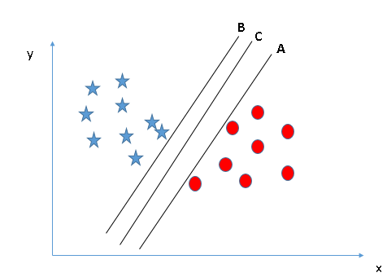

Here, maximizing the distances between nearest data point (either class) and hyper-plane will help us to decide the right hyper-plane. This distance is called as **Margin**.

[[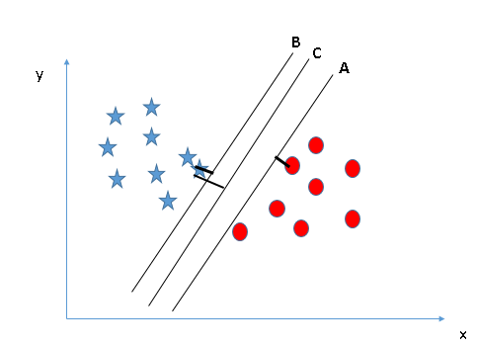](https://www.analyticsvidhya.com/wp-content/uploads/2015/10/SVM_4.png)](https://www.analyticsvidhya.com/wp-content/uploads/2015/10/SVM_4.png)Above, you can see that the margin for hyper-plane C is high as compared to both A and B. Hence, we name the right hyper-plane as C. Another lightning reason for selecting the hyper-plane with higher margin is robustness. If we select a hyper-plane having low margin then there is high chance of miss-classification.

* **Identify the right hyper-plane (Scenario-3):**Hint:Use the rules as discussed in previous section to identify the right hyper-plane

**[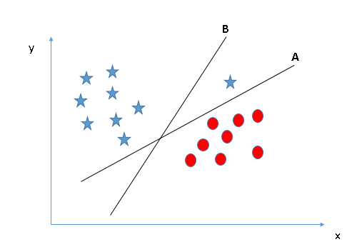](https://www.analyticsvidhya.com/wp-content/uploads/2015/10/SVM_5.png)**

Some of you may have selected the hyper-plane **B**as it has higher margin compared to **A.**But, here is the catch, SVM selects the hyper-plane which classifies the classes accurately prior to maximizing margin. Here, hyper-plane B has a classification error and A has classified all correctly. Therefore, the right hyper-plane is **A.**

* **Can we classify two classes (Scenario-4)?:**Below, I am unable to segregate the two classes using a straight line, as one of the stars lies in the territory of other(circle) as outlier.

**[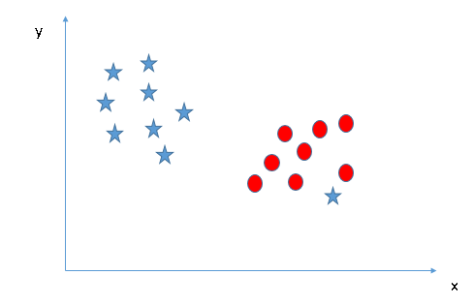](https://www.analyticsvidhya.com/wp-content/uploads/2015/10/SVM_61.png)**

* As I have already mentioned, one star at other end is like an outlier for star class. The SVM algorithm has a feature to ignore outliers and find the hyper-plane that has the maximum margin. Hence, we can say, SVM classification is robust to outliers.  
  **[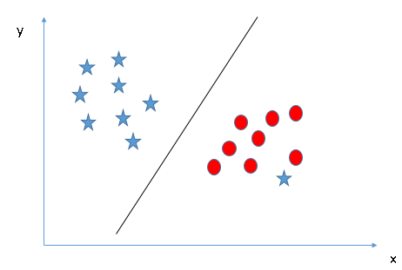](https://www.analyticsvidhya.com/wp-content/uploads/2015/10/SVM_71.png)**
* **Find the hyper-plane to segregate to classes (Scenario-5):**In the scenario below, we can’t have linear hyper-plane between the two classes, so how does SVM classify these two classes? Till now, we have only looked at the linear hyper-plane.**[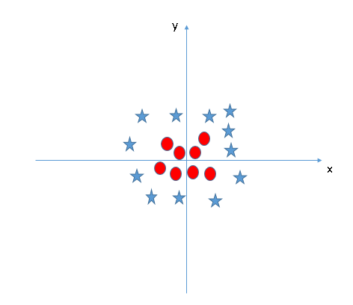](https://www.analyticsvidhya.com/wp-content/uploads/2015/10/SVM_8.png)**
* SVM can solve this problem. Easily! It solves this problem by introducing additional feature. Here, we will add a new feature z=x^2+y^2. Now, let’s plot the data points on axis x and z:  
  [[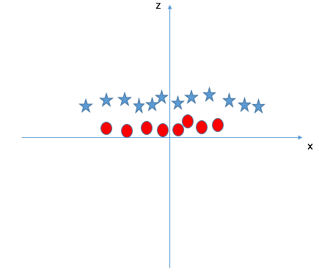](https://www.analyticsvidhya.com/wp-content/uploads/2015/10/SVM_9.png)](https://www.analyticsvidhya.com/wp-content/uploads/2015/10/SVM_9.png)In above plot, points to consider are:
  + All values for z would be positive always because z is the squared sum of both x and y
  + In the original plot, red circles appear close to the origin of x and y axes, leading to lower value of z and star relatively away from the origin result to higher value of z.

In the SVM classifier, it is easy to have a linear hyper-plane between these two classes. But, another burning question which arises is, should we need to add this feature manually to have a hyper-plane. No, the SVM  algorithm has a technique called the [**kernel**](https://en.wikipedia.org/wiki/Kernel_method)**trick**. The SVM kernel is a function that takes low dimensional input space and transforms it to a higher dimensional space i.e. it converts not separable problem to separable problem. It is mostly useful in non-linear separation problem. Simply put, it does some extremely complex data transformations, then finds out the process to separate the data based on the labels or outputs you’ve defined.

When we look at the hyper-plane in original input space it looks like a circle:  
[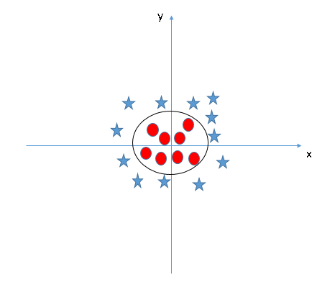](https://www.analyticsvidhya.com/wp-content/uploads/2015/10/SVM_10.png)

Now, let’s look at the methods to apply SVM classifier algorithm in a data science challenge.

## How to implement SVM in Python and R?

In Python, scikit-learn is a widely used library for implementing [machine learning](https://www.analyticsvidhya.com/machine-learning/?utm_source=blog&utm_medium=support-vector-machine) algorithms. SVM is also available in the scikit-learn library and we follow the same structure for using it(Import library, object creation, fitting model and prediction).

Now, let us have a look at a real-life problem statement and dataset to understand how to apply SVM for classification

## Problem Statement

Dream Housing Finance company deals in all home loans. They have a presence across all urban, semi-urban and rural areas. A customer first applies for a home loan, after that the company validates the customer’s eligibility for a loan.

Company wants to automate the loan eligibility process (real-time) based on customer details provided while filling an online application form. These details are Gender, Marital Status, Education, Number of Dependents, Income, Loan Amount, Credit History and others. To automate this process, they have given a problem to identify the customers’ segments, those are eligible for loan amount so that they can specifically target these customers. Here they have provided a partial data set.

Use the coding window below to predict the loan eligibility on the test set. **Try changing the hyper parameters for the linear SVM to improve the accuracy.**

## How to tune Parameters of SVM?

Tuning the parameters’ values for machine learning algorithms effectively improves model performance. Let’s look at the list of parameters available with SVM.

sklearn.svm.SVC(C=1.0, kernel='rbf', degree=3, gamma=0.0, coef0=0.0, shrinking=True, probability=False,tol=0.001, cache\_size=200, class\_weight=None, verbose=False, max\_iter=-1, random\_state=None)

I am going to discuss about some important parameters having higher impact on model performance, “kernel”, “gamma” and “C”.

kernel:

We have already discussed about it. Here, we have various options available with kernel like, “linear”, “rbf”,”poly” and others (default value is “rbf”).  Here “rbf” and “poly” are useful for non-linear hyper-plane. Let’s look at the example, where we’ve used linear kernel on two feature of iris data set to classify their class.

## Support Vector Machine(SVM) code in Python

**Example:**Have a linear SVM kernel

import numpy as np

import matplotlib.pyplot as plt

from sklearn import svm, datasets

# import some data to play with

iris = datasets.load\_iris()

X = iris.data[:,:2] # we only take the first two features. We could

# avoid this ugly slicing by using a two-dim dataset

y = iris.target

# we create an instance of SVM and fit out data. We do not scale our

# data since we want to plot the support vectors

C = 1.0 # SVM regularization parameter

svc = svm.SVC(kernel='linear', C=1,gamma=0).fit(X, y)

# create a mesh to plot in

x\_min, x\_max = X[:, 0].min() - 1, X[:, 0].max() + 1

y\_min, y\_max = X[:, 1].min() - 1, X[:, 1].max() + 1

h = (x\_max / x\_min)/100

xx, yy = np.meshgrid(np.arange(x\_min, x\_max, h),

np.arange(y\_min, y\_max, h))

plt.subplot(1, 1, 1)

Z = svc.predict(np.c\_[xx.ravel(), yy.ravel()])

Z = Z.reshape(xx.shape)

plt.contourf(xx, yy, Z, cmap=plt.cm.Paired, alpha=0.8)

plt.scatter(X[:, 0], X[:, 1], c=y, cmap=plt.cm.Paired)

plt.xlabel('Sepal length')

plt.ylabel('Sepal width')

plt.xlim(xx.min(), xx.max())

plt.title('SVC with linear kernel')

plt.show()[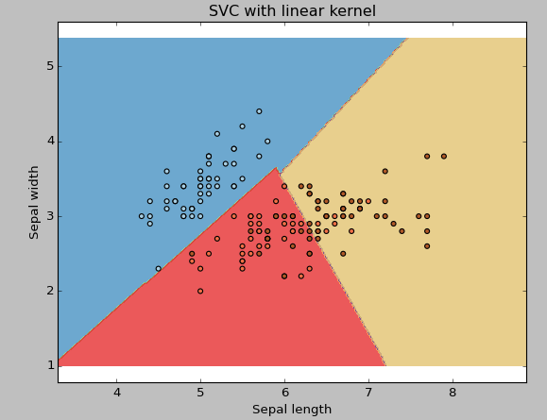](https://www.analyticsvidhya.com/wp-content/uploads/2015/10/SVM_111.png)

## **Example:**Use SVM rbf kernel

Change the kernel type to rbf in below line and look at the impact.

svc = svm.SVC(kernel='rbf', C=1,gamma=0).fit(X, y)

[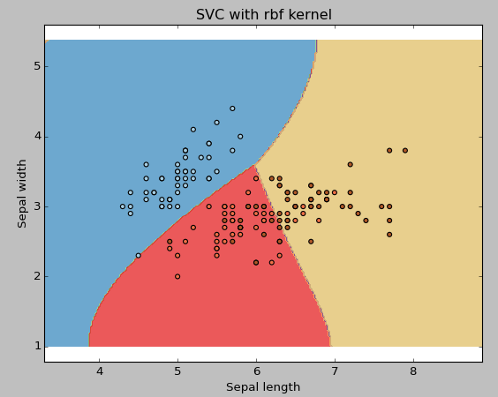](https://www.analyticsvidhya.com/wp-content/uploads/2015/10/SVM_12.png)

I would suggest you go for linear SVM kernel if you have a large number of features (>1000) because it is more likely that the data is linearly separable in high dimensional space. Also, you can use RBF but do not forget to cross-validate for its parameters to avoid over-fitting.

## Gamma:

Kernel coefficient for ‘rbf’, ‘poly’ and ‘sigmoid’. Higher the value of gamma, will try to exact fit the as per training data set i.e. generalization error and cause over-fitting problem.

**Example:**Let’s difference if we have gamma different gamma values like 0, 10 or 100.

svc = svm.SVC(kernel='rbf', C=1,gamma=0).fit(X, y)

[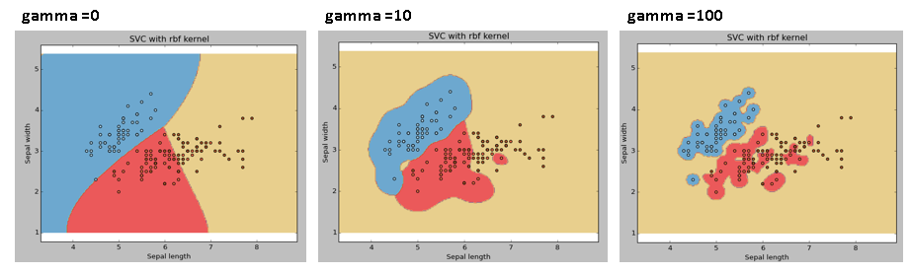](https://www.analyticsvidhya.com/wp-content/uploads/2015/10/SVM_15.png)

## **C:**

Penalty parameter C of the error term. It also controls the trade-off between smooth decision boundaries and classifying the training points correctly.

[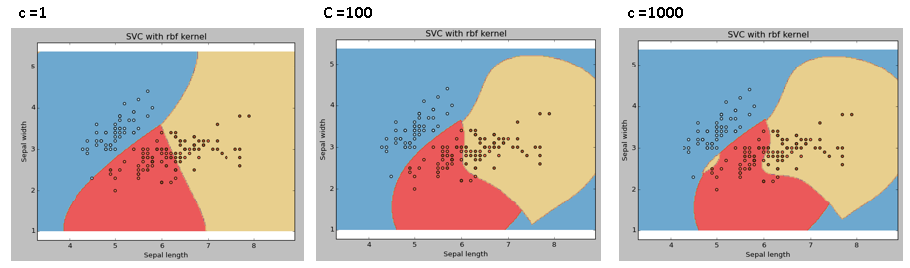](https://www.analyticsvidhya.com/wp-content/uploads/2015/10/SVM_18.png)

We should always look at the cross-validation score to have effective combination of these parameters and avoid over-fitting.

In R, SVMs can be tuned in a similar fashion as they are in Python. Mentioned below are the respective parameters for e1071 package:

* The kernel parameter can be tuned to take “Linear”,”Poly”,”rbf” etc.
* The gamma value can be tuned by setting the “Gamma” parameter.
* The C value in Python is tuned by the “Cost” parameter in R.

## Pros and Cons associated with SVM

* **Pros:**
  + It works really well with a clear margin of separation
  + It is effective in high dimensional spaces.
  + It is effective in cases where the number of dimensions is greater than the number of samples.
  + It uses a subset of training points in the decision function (called support vectors), so it is also memory efficient.
* **Cons:**
  + It doesn’t perform well when we have large data set because the required training time is higher
  + It also doesn’t perform very well, when the data set has more noise i.e. target classes are overlapping
  + SVM doesn’t directly provide probability estimates, these are calculated using an expensive five-fold cross-validation. It is included in the related SVC method of Python scikit-learn library.

# The Kernel Trick in Support Vector Classification

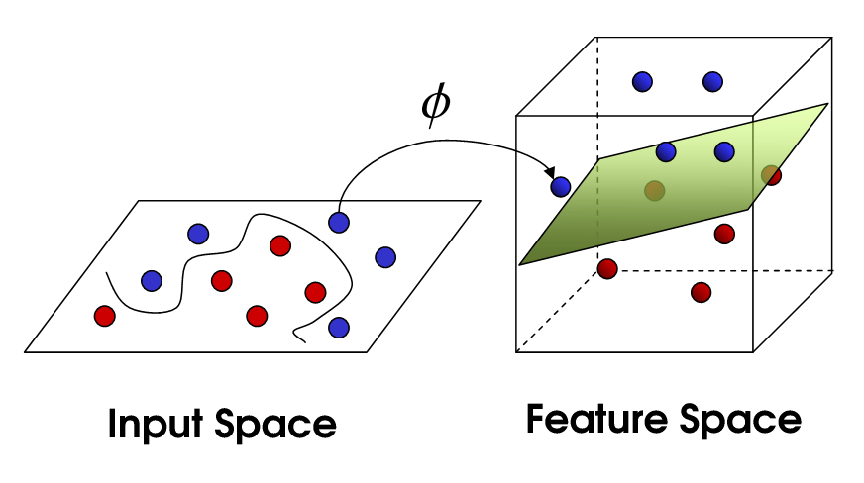

The kernel trick seems to be one of the most confusing concepts in statistics and machine learning; it first appears to be genuine mathematical sorcery, not to mention the problem of lexical ambiguity (does kernel refer to: a non-parametric way to estimate a probability density (statistics), the set of vectors **v**for which a linear transformation T maps to the zero vector — i.e. T(**v**) = 0 (linear algebra), the set of elements in a group G that are mapped to the identity element by a homomorphism between groups (group theory), the core of a computer operating system (computer science), or something to do with the seeds of nuts or fruit?).

Although there are some obstacles to understanding the kernel trick, it is highly important to understand how kernels are used in support vector classification. For practical reasons, it is important to understand because implementing support vector classifiers requires specifying a kernel function, and there are not established, general rules to know what kernel will work best for your particular data.

More conceptually, the kernel trick also illustrates some fundamental ideas about different ways to represent data and how machine learning algorithms “see” these different data representations. And finally, the seeming mathematical sleight of hand in the kernel trick just begs one to further explore what it actually means.

I will certainly not be able to fully explain the kernel trick in this post. I believe a truly deep understanding of the kernel trick requires a rigorous mathematical treatment, and this can’t be done in what is labeled as a seven minute read, let alone by someone who realistically has only been learning about the kernel trick and SVMs for a short period of time. However, I will attempt to do the following:

* briefly introduce support vector classification
* visualize some non-linear transformations in the context of support vector classification
* introduce the idea that the benefit of the kernel trick in training support vector classifiers lies in a unique data representation

## Intro to Support Vector Classification

Support vector classification is based on a very natural way that one might attempt to classify data points into various target classes. If the classes in our training data can be separated by a line or some boundary, then we can just classify the data depending on what side of this decision boundary the data lies on.

In the following 2-d example, we can separate the data with any of the three lines, and then just assign classes based on whether the observation lies above or below the line. The data are 2-dimensional vectors specified by the features X1 and X2 with class labels as either y =1 (blue) or y = 0 (red).

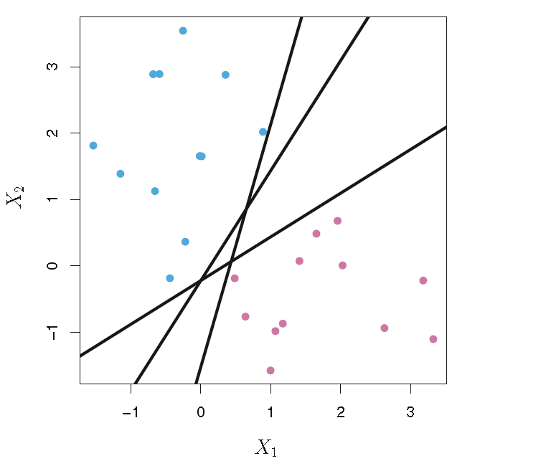

An example dataset showing classes that can be linearly separated.

Training a linear support vector classifier, like nearly every problem in machine learning, and in life, is an optimization problem. We maximize the *margin* — the distance separating the closest pair of data points belonging to opposite classes. These points are called the support vectors, because they are the data observations that “support”, or determine, the decision boundary. To train a support vector classifier, we find the *maximal margin hyperplane*, or *optimal separating hyperplane*, which optimally separates the two classes in order to generalize to new data and make accurate classification predictions.

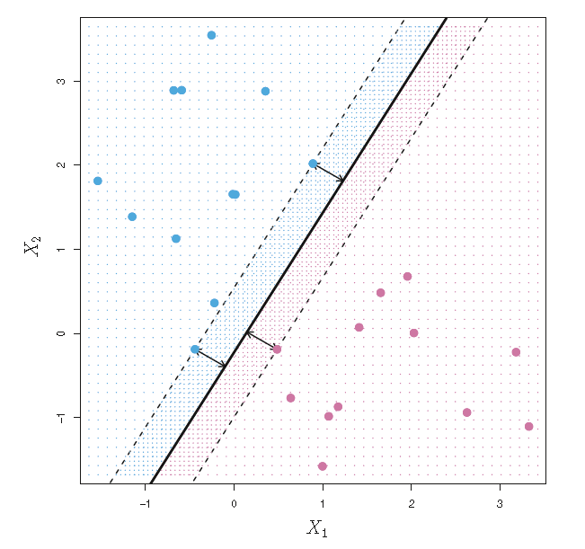

The support vectors are the points on the dashed lines. The distance from the dashed line to the solid line is the margin, represented by the arrows.

Support vector machines are much harder to interpret in higher dimensions. It is much harder to visualize how the data can be linearly separable, and what the decision boundary will look like. A hyperplane in p-dimensions is a p-1 dimensional “flat” subspace that lies inside the larger p-dimensional space. In 2 dimensions, the hyperplane is just a line. In 3 dimensions, the hyperplane is a regular 2-d plane. Mathematically, we have the following:

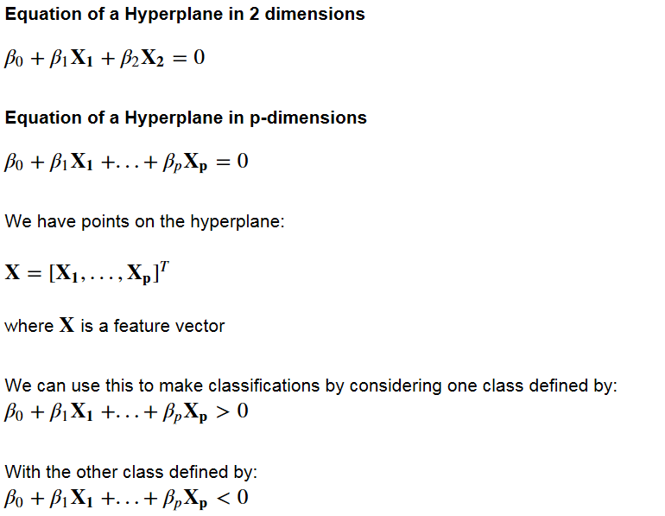

Equations defining a hyperplane and the classification rules defined by the decision boundary.

Support vector classification relies on this notion of linearly separable data. “Soft margin” classification can accommodate some classification errors on the training data, in the case where data is not perfectly linearly separable. However, in practice data is often very far from being linearly separable, and we need to transform the data into a higher dimensional space in order to fit a support vector classifier.

## Non-linear transformations

If the data is not linearly separable in the original, or input, space then we apply transformations to the data, which map the data from the original space into a higher dimensional feature space. The goal is that after the transformation to the higher dimensional space, the classes are now linearly separable *in this higher dimensional feature space*. We can then fit a decision boundary to separate the classes and make predictions. The decision boundary will be a hyperplane in this higher dimensional space.

It is obviously hard to visualize higher dimensional data, and so we first focus on some transformations applied to 1-dimensional data. In this example, the picture on the left shows our original data points. In 1-dimension, this data is not linearly separable, but after applying the transformation *ϕ*(x) = x² and adding this second dimension to our feature space, the classes become linearly separable.

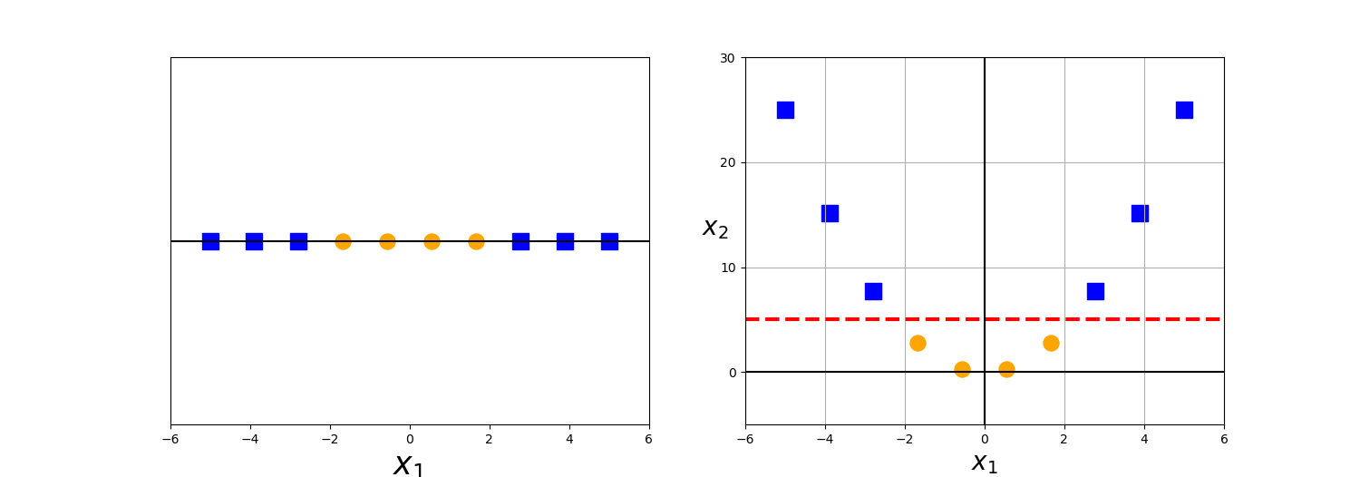

This data becomes linearly separable after a quadratic transformation to 2-dimensions.

For now, we are just examining transformations of the original data to higher dimensions that allow the data to be linearly separated. These are just functions, and there are many possible functions that can map the data to any number of higher dimensions.

Here we apply the transformation *ϕ*(x) = x mod 2

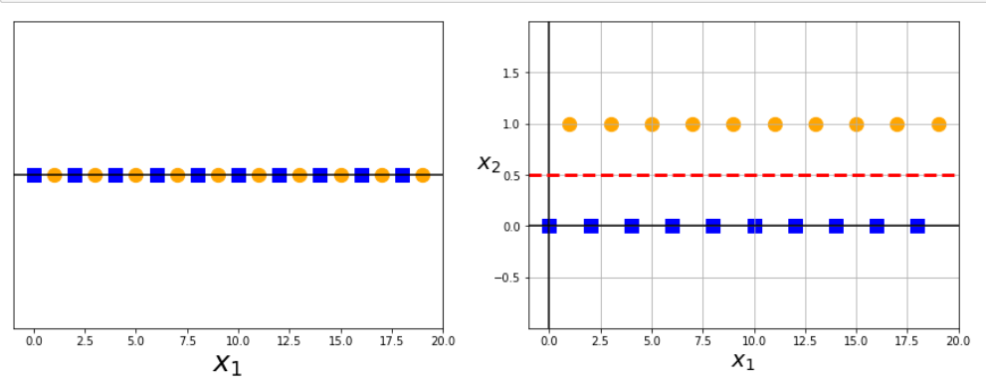

This transformation allows us to linearly separate the even and odd X1 values in 2 dimensions.

Now let’s look at an example where our original data is not linearly separable in two dimensions. Here is our original data, which cannot be linearly separated.

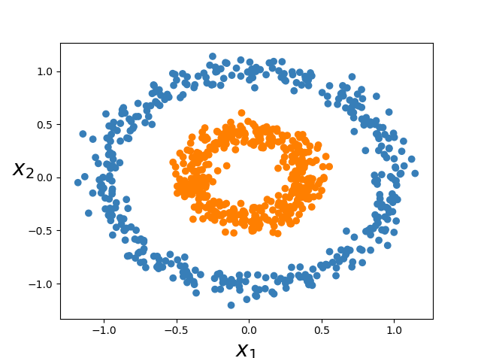

After the following transformation:

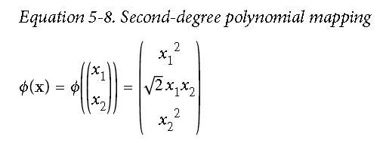

Our data becomes linearly separable (by a 2-d plane) in 3-dimensions.

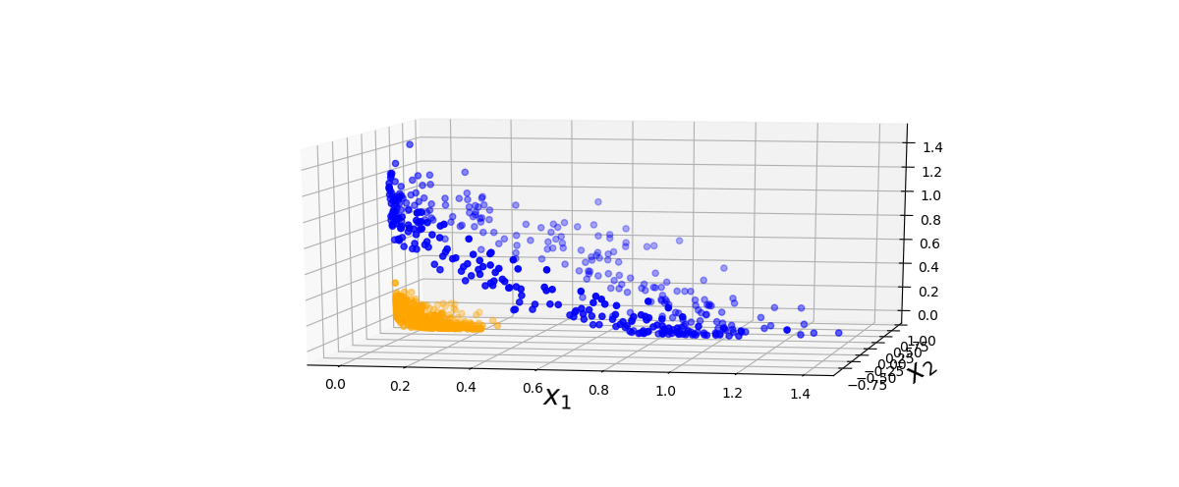

Linearly separable data in 3-d after applying the 2nd-degree polynomial transformation

There can be many transformations that allow the data to be linearly separated in higher dimensions, but not all of these functions are actually kernels. The kernel function has a special property that makes it particularly useful in training support vector models, and the use of this property in optimizing non-linear support vector classifiers is often called the kernel trick.

## The Kernel Trick

We have seen how higher dimensional transformations can allow us to separate data in order to make classification predictions. It seems that in order to train a support vector classifier and optimize our objective function, we would have to perform operations with the higher dimensional vectors in the transformed feature space. In real applications, there might be many features in the data and applying transformations that involve many polynomial combinations of these features will lead to extremely high and impractical computational costs.

The **kernel trick** provides a solution to this problem. The “trick” is that kernel methods represent the data only through a set of pairwise similarity comparisons between the original data observations **x**(with the original coordinates in the lower dimensional space), instead of explicitly applying the transformations *ϕ*(**x**) and representing the data by these transformed coordinates in the higher dimensional feature space.

In kernel methods, the data set **X** is represented by an n x n kernel matrix of pairwise similarity comparisons where the entries (i, j) are defined by the **kernel function:** k(xi, xj). This kernel function has a special mathematical property. The kernel function acts as a modified dot product. We have:

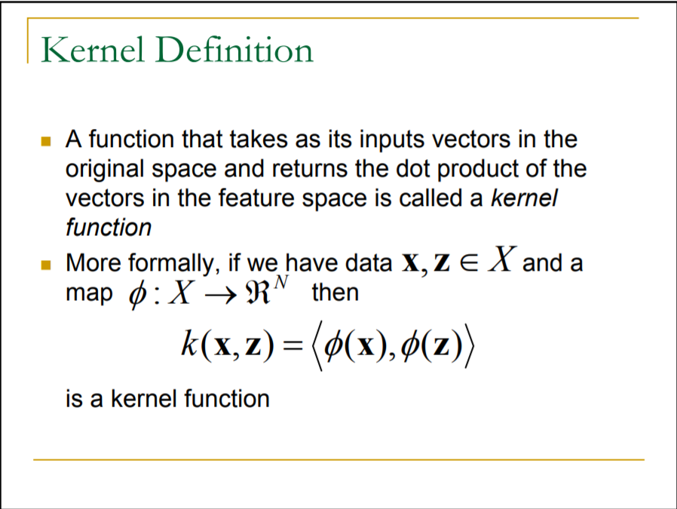

Our kernel function accepts inputs in the original lower dimensional space and returns the dot product of the transformed vectors in the higher dimensional space. There are also theorems which guarantee the existence of such kernel functions under certain conditions.

It can somewhat help to understand how the kernel function is equal to the dot product of the transformed vectors by considering that each coordinate of the transformed vector *ϕ*(**x**) is just some function of the coordinates in the corresponding lower dimensional vector **x**.

For example, the kernel trick for the 2nd-degree polynomial is illustrated below, and we visualized this transformation in 3-d in a previous figure. The transformed vectors have coordinates that are functions of the two components x1 and x2. so the dot product will only involve components x1 and x2 as well. The kernel function will also take inputs x1, x2 and return a real number. The dot product always returns a real number too.

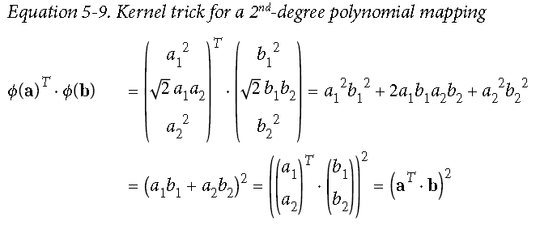

On the left-hand side, we have the dot product of the transformed feature vectors, which is equal to our 2nd-degree polynomial kernel function.

The kernel function here is the polynomial kernel k(a,b) = (a^T \* b)²

The ultimate benefit of the kernel trick is that the objective function we are optimizing to fit the higher dimensional decision boundary only includes the dot product of the transformed feature vectors. Therefore, we can just substitute these dot product terms with the kernel function, and we don’t even use *ϕ*(**x**).

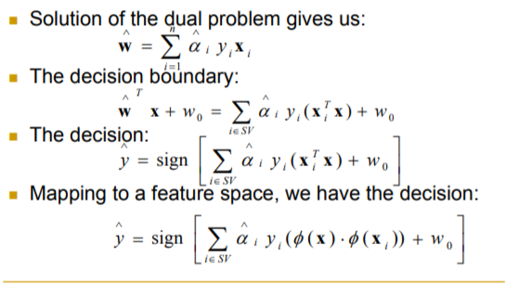

In the bottom equation, we replace the dot product of the transformed vectors with the kernel function.

Remember, our data is only linearly separable as the vectors *ϕ*(**x**) in the higher dimensional space, and we are finding the optimal separating hyperplane in this higher dimensional space *without having to calculate or in reality even know anything about ϕ(x).*

# Naive Bayes Classifier

## What is a classifier?

A classifier is a machine learning model that is used to discriminate different objects based on certain features.

## Principle of Naive Bayes Classifier:

A Naive Bayes classifier is a probabilistic machine learning model that’s used for classification task. The crux of the classifier is based on the Bayes theorem.

## Bayes Theorem:

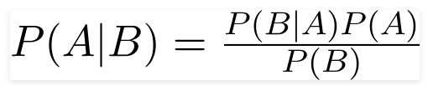

Using Bayes theorem, we can find the probability of **A** happening, given that **B** has occurred. Here, **B** is the evidence and **A** is the hypothesis. The assumption made here is that the predictors/features are independent. That is presence of one particular feature does not affect the other. Hence it is called naive.

### Example

let’s say we have data on 1000 pieces of fruit. The fruit being a Banana, Orange or some other fruit and imagine we know 3 features of each fruit, whether it’s long or not, sweet or not and yellow or not, as displayed in the table below.

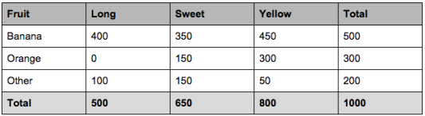

So from the table what do we already know?

50% of the fruits are bananas

30% are oranges

20% are other fruits

Based on our training set we can also say the following:

From 500 bananas 400 (0.8) are Long, 350 (0.7) are Sweet and 450 (0.9) are Yellow

Out of 300 oranges, 0 are Long, 150 (0.5) are Sweet and 300 (1) are Yellow

From the remaining 200 fruits, 100 (0.5) are Long, 150 (0.75) are Sweet and 50 (0.25) are Yellow

Which should provide enough evidence to predict the class of another fruit as it’s introduced.

So let’s say we’re given the features of a piece of fruit and we need to predict the class. If we’re told that the additional fruit is Long, Sweet and Yellow, we can classify it using the following formula and subbing in the values for each outcome, whether it’s a Banana, an Orange or Other Fruit. The one with the highest probability (score) being the winner.

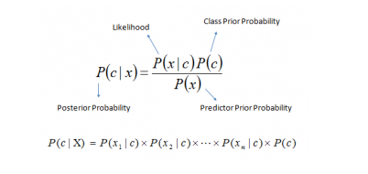

Formula for reference

Banana:

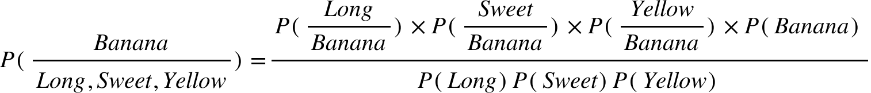

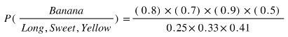

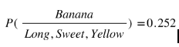

Orange:

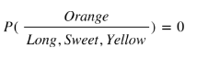

Other Fruit:

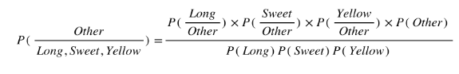

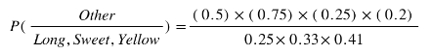

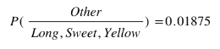

In this case, based on the higher score ( 0.252 for banana ) we can assume this Long, Sweet and Yellow fruit is in fact, a Banana.

## Types of Naive Bayes Classifier:

### Multinomial Naive Bayes:

This is mostly used for document classification problem, i.e whether a document belongs to the category of sports, politics, technology etc. The features/predictors used by the classifier are the frequency of the words present in the document.

### Bernoulli Naive Bayes:

This is similar to the multinomial naive bayes but the predictors are boolean variables. The parameters that we use to predict the class variable take up only values yes or no, for example if a word occurs in the text or not.

### Gaussian Naive Bayes:

When the predictors take up a continuous value and are not discrete, we assume that these values are sampled from a gaussian distribution.

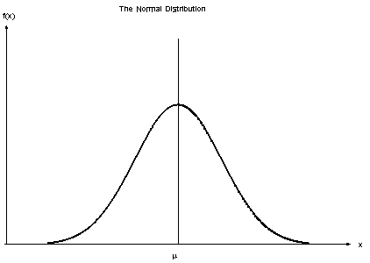

Gaussian Distribution (Normal Distribution)

Since the way the values are present in the dataset changes, the formula for conditional probability changes to,

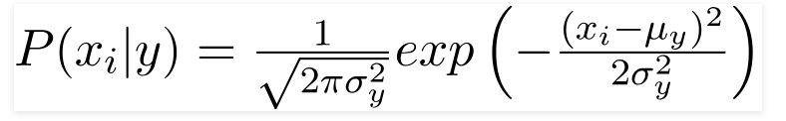

## How Naive Bayes algorithm works?

Let’s understand it using an example. Below I have a training data set of weather and corresponding target variable ‘Play’ (suggesting possibilities of playing). Now, we need to classify whether players will play or not based on weather condition. Let’s follow the below steps to perform it.

Step 1: Convert the data set into a frequency table

Step 2: Create Likelihood table by finding the probabilities like Overcast probability = 0.29 and probability of playing is 0.64.

[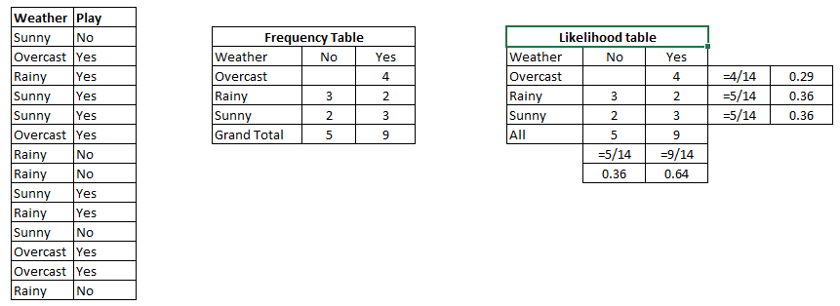](https://www.analyticsvidhya.com/wp-content/uploads/2015/08/Bayes_41.png)

Step 3: Now, use [Naive Bayesian](https://courses.analyticsvidhya.com/courses/naive-bayes?utm_source=blog&utm_medium=naive-bayes-explained) equation to calculate the posterior probability for each class. The class with the highest posterior probability is the outcome of prediction.

**Problem:**Players will play if weather is sunny. Is this statement is correct?

We can solve it using above discussed method of posterior probability.

P(Yes | Sunny) = P( Sunny | Yes) \* P(Yes) / P (Sunny)

Here we have P (Sunny |Yes) = 3/9 = 0.33, P(Sunny) = 5/14 = 0.36, P( Yes)= 9/14 = 0.64

Now, P (Yes | Sunny) = 0.33 \* 0.64 / 0.36 = 0.60, which has higher probability.

Naive Bayes uses a similar method to predict the probability of different class based on various attributes. This algorithm is mostly used in text classification and with problems having multiple classes.

## What are the Pros and Cons of Naive Bayes?

***Pros:***

* It is easy and fast to predict class of test data set. It also perform well in multi class prediction
* When assumption of independence holds, a Naive Bayes classifier performs better compare to other models like logistic regression and you need less training data.
* It perform well in case of categorical input variables compared to numerical variable(s). For numerical variable, normal distribution is assumed (bell curve, which is a strong assumption).

***Cons:***

* If categorical variable has a category (in test data set), which was not observed in training data set, then model will assign a 0 (zero) probability and will be unable to make a prediction. This is often known as “Zero Frequency”. To solve this, we can use the smoothing technique. One of the simplest smoothing techniques is called Laplace estimation.
* On the other side naive Bayes is also known as a bad estimator, so the probability outputs from predict\_proba are not to be taken too seriously.
* Another limitation of [Naive Bayes](https://courses.analyticsvidhya.com/courses/naive-bayes?utm_source=blog&utm_medium=naive-bayes-explained) is the assumption of independent predictors. In real life, it is almost impossible that we get a set of predictors which are completely independent.

## 4 Applications of Naive Bayes Algorithms

* **Real time Prediction:**Naive Bayes is an eager learning classifier and it is sure fast. Thus, it could be used for making predictions in real time.
* **Multi class Prediction:**This algorithm is also well known for multi class prediction feature. Here we can predict the probability of multiple classes of target variable.
* **Text classification/ Spam Filtering/ Sentiment Analysis:** Naive Bayes classifiers mostly used in text classification (due to better result in multi class problems and independence rule) have higher success rate as compared to other algorithms. As a result, it is widely used in Spam filtering (identify spam e-mail) and Sentiment Analysis (in social media analysis, to identify positive and negative customer sentiments)
* **Recommendation System:**Naive Bayes Classifier and [Collaborative Filtering](https://en.wikipedia.org/wiki/Collaborative_filtering) together builds a Recommendation System that uses machine learning and data mining techniques to filter unseen information and predict whether a user would like a given resource or not

## Tips to improve the power of Naive Bayes Model

Here are some tips for improving power of [Naive Bayes](https://courses.analyticsvidhya.com/courses/naive-bayes?utm_source=blog&utm_medium=naive-bayes-explained) Model:

* If continuous features do not have normal distribution, we should use transformation or different methods to convert it in normal distribution.
* If test data set has zero frequency issue, apply smoothing techniques “Laplace Correction” to predict the class of test data set.
* Remove correlated features, as the highly correlated features are voted twice in the model and it can lead to over inflating importance.
* Naive Bayes classifiers has limited options for parameter tuning like alpha=1 for smoothing, fit\_prior=[True|False] to learn class prior probabilities or not and some other options (look at detail [here](http://scikit-learn.org/stable/modules/generated/sklearn.naive_bayes.MultinomialNB.html#sklearn.naive_bayes.MultinomialNB)). I would recommend to focus on your pre-processing of data and the feature selection.
* You might think to apply some classifier combination technique like ensemble, bagging and boosting but these methods would not help. Actually, “ensemble, boosting, bagging” won’t help since their purpose is to reduce variance. Naive Bayes has no variance to minimize.

## Conclusion:

Naive Bayes algorithms are mostly used in sentiment analysis, spam filtering, and recommendation systems etc. They are fast and easy to implement but their biggest disadvantage is that the requirement of predictors to be independent. In most of the real life cases, the predictors are dependent, this hinders the performance of the classifier.

**ID3**

The algorithm creates a multi-way tree — each node can have two or more edges — finding the categorical feature that will maximize the *information gain* using the impurity criterion *entropy*. Not only can it not handle numerical features, it is only appropriate for classification problems.

Advantages

* Understandable prediction rules are created from the training data
* Builds the fastest tree
* Builds a short tree
* Only need enough attributes until all data is classified
* Finding leaf nodes enable test data to be pruned, reducing number of tests
* Whole dataset is searched to create tree

Disadvantages

* Data may be over-fitted or over-classified, if a small sample is tested
* Only one attribute at a time is tested for making a decision
* Does not handle numeric attributes and missing values

**CART**

CART stands for Classification and Regression Trees. The algorithm creates a binary tree — each node has exactly two outgoing edges — finding the best numerical or categorical feature to split using an appropriate impurity criterion. For classification, *Gini impurity* or *twoing criterion* can be used. For regression, CART introduced *variance reduction* using least squares (mean square error).

Advantages

* CART can easily handle both numerical and categorical variables
* CART algorithm will itself identify the most significant variables and eliminate non-significant ones
* CART can easily handle outliers

Disadvantages

* CART may have unstable decision tree
* CART splits by one by one variable

# Tree Based Algorithms: A Complete Tutorial from Scratch (in R & Python)

## Overview

* Explanation of tree based algorithms from scratch in R and python
* Learn machine learning concepts like decision trees, random forest, boosting, bagging, ensemble methods
* Implementation of these tree based algorithms in R and Python

## Introduction to Tree Based Algorithms

Tree based algorithms are considered to be one of the best and mostly used supervised learning methods. Tree based algorithms empower predictive models with high accuracy, stability and ease of interpretation. Unlike linear models, they map non-linear relationships quite well. They are adaptable at solving any kind of problem at hand (classification or regression).

Methods like decision trees, random forest, gradient boosting are being popularly used in all kinds of data science problems. Hence, for every analyst (fresher also), it’s important to learn these algorithms and use them for modelling.

This tutorial is meant to help beginners learn tree based algorithms from scratch. After the successful completion of this tutorial, one is expected to become proficient at using tree based algorithms and build predictive models.

Note: This tutorial requires no prior knowledge of machine learning. However, elementary knowledge of R or Python will be helpful. To get started you can follow [*full tutorial in R*](https://www.analyticsvidhya.com/blog/2016/02/complete-tutorial-learn-data-science-scratch/) and [*full tutorial in Python*](https://www.analyticsvidhya.com/blog/2016/01/complete-tutorial-learn-data-science-python-scratch-2/). You can also check out the ‘[*Introduction to Data Science*](https://trainings.analyticsvidhya.com/courses/course-v1:AnalyticsVidhya+DS101+2018T2/about?utm_source=treebasedarticle&utm_medium=blog)‘course covering Python, Statistics and Predictive Modelling.

We will also cover some ensemble techniques using tree-based models below. To learn more about them and other ensemble learning techniques in a comprehensive manner, you can enrol in this free course: [*Ensemble Learning Course: Ensemble Learning and Ensemble Learning Techniques*](https://courses.analyticsvidhya.com/courses/ensemble-learning-and-ensemble-learning-techniques?utm_source=blog&utm_medium=tree-based-algorithms-complete-tutorial-scratch-in-python)

## Table of Contents

* 1. [What is a Decision Tree? How does it work?](https://www.analyticsvidhya.com/blog/2016/04/tree-based-algorithms-complete-tutorial-scratch-in-python/#one)
  2. [Regression Trees vs Classification Trees](https://www.analyticsvidhya.com/blog/2016/04/tree-based-algorithms-complete-tutorial-scratch-in-python/#two)
  3. [How does a tree based algorithms decide where to split?](https://www.analyticsvidhya.com/blog/2016/04/tree-based-algorithms-complete-tutorial-scratch-in-python/#three)
  4. [What are the key parameters of model building and how can we avoid over-fitting in tree based algorithms?](https://www.analyticsvidhya.com/blog/2016/04/tree-based-algorithms-complete-tutorial-scratch-in-python/#four)
  5. [Are tree based algorithms better than linear models?](https://www.analyticsvidhya.com/blog/2016/04/tree-based-algorithms-complete-tutorial-scratch-in-python/#five)
  6. [Working with Decision Trees in R and Python](https://www.analyticsvidhya.com/blog/2016/04/tree-based-algorithms-complete-tutorial-scratch-in-python/#six)
  7. [What are the ensemble methods of tree based algorithms?](https://www.analyticsvidhya.com/blog/2016/04/tree-based-algorithms-complete-tutorial-scratch-in-python/#seven)
  8. [What is Bagging? How does it work?](https://www.analyticsvidhya.com/blog/2016/04/tree-based-algorithms-complete-tutorial-scratch-in-python/#eight)
  9. [What is Random Forest ? How does it work?](https://www.analyticsvidhya.com/blog/2016/04/tree-based-algorithms-complete-tutorial-scratch-in-python/#nine)
  10. [What is Boosting ? How does it work?](https://www.analyticsvidhya.com/blog/2016/04/tree-based-algorithms-complete-tutorial-scratch-in-python/#ten)
  11. [Which is more powerful: GBM or Xgboost?](https://www.analyticsvidhya.com/blog/2016/04/tree-based-algorithms-complete-tutorial-scratch-in-python/#eleven)
  12. [Working with GBM in R and Python](https://www.analyticsvidhya.com/blog/2016/04/tree-based-algorithms-complete-tutorial-scratch-in-python/#twelve)
  13. [Working with Xgboost in R and Python](https://www.analyticsvidhya.com/blog/2016/04/tree-based-algorithms-complete-tutorial-scratch-in-python/#thirteen)
  14. [Where to Practice?](https://www.analyticsvidhya.com/blog/2016/04/tree-based-algorithms-complete-tutorial-scratch-in-python/#fourteen)

## 1. What is a Decision Tree? How does it work?

Decision tree is a type of supervised learning algorithm (having a predefined target variable) that is mostly used in classification problems. It works for both categorical and continuous input and output variables. In this technique, we split the population or sample into two or more homogeneous sets (or sub-populations) based on most significant splitter / differentiator in input variables.

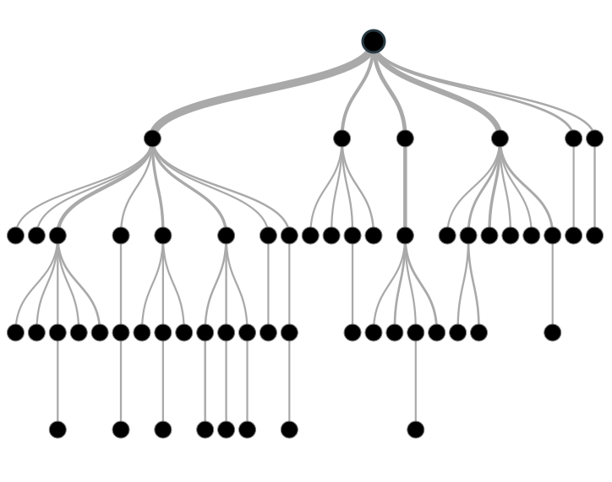

Tree based modelling in R and Python

**Example:-**

Let’s say we have a sample of 30 students with three variables Gender (Boy/ Girl), Class ( IX/ X) and Height (5 to 6 ft). 15 out of these 30 play cricket in leisure time. Now, I want to create a model to predict who will play cricket during leisure period? In this problem, we need to segregate students who play cricket in their leisure time based on highly significant input variable among all three.

This is where decision tree helps, it will segregate the students based on all values of three variable and identify the variable, which creates the best homogeneous sets of students (which are heterogeneous to each other). In the snapshot below, you can see that variable Gender is able to identify best homogeneous sets compared to the other two variables.

[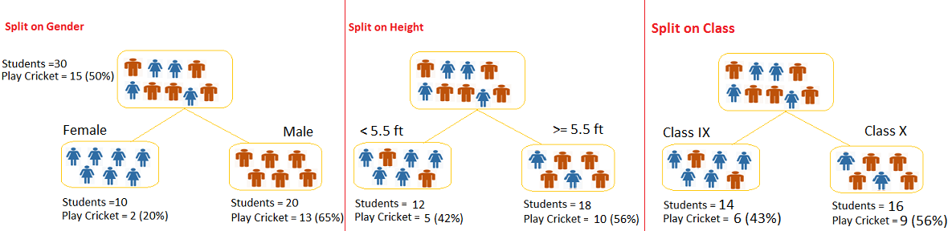](https://www.analyticsvidhya.com/wp-content/uploads/2015/01/Test.png)

As mentioned above, decision tree identifies the most significant variable and it’s value that gives best homogeneous sets of population. Now the question which arises is, how does it identify the variable and the split? To do this, decision tree uses various algorithms, which we will discuss in the following section.

## Types of Decision Trees

Types of decision tree is based on the type of target variable we have. It can be of two types:

1. **Categorical Variable Decision Tree:**Decision Tree which has categorical target variable then it called as categorical variable decision tree. Example:- In above scenario of student problem, where the target variable was “Student will play cricket or not” i.e. YES or NO.
2. **Continuous Variable Decision Tree:**Decision Tree has continuous target variable then it is called as Continuous Variable Decision Tree.

**Example:-** Let’s say we have a problem to predict whether a customer will pay his renewal premium with an insurance company (yes/ no). Here we know that income of customer is a significant variable but insurance company does not have income details for all customers. Now, as we know this is an important variable, then we can build a decision tree to predict customer income based on occupation, product and various other variables. In this case, we are predicting values for continuous variable.

## Important Terminology related to Tree based Algorithms

Let’s look at the basic terminology used with Decision trees:

1. **Root Node:**It represents entire population or sample and this further gets divided into two or more homogeneous sets.
2. **Splitting:**It is a process of dividing a node into two or more sub-nodes.
3. **Decision Node:**When a sub-node splits into further sub-nodes, then it is called decision node.
4. **Leaf/ Terminal Node:**Nodes do not split is called Leaf or Terminal node.

[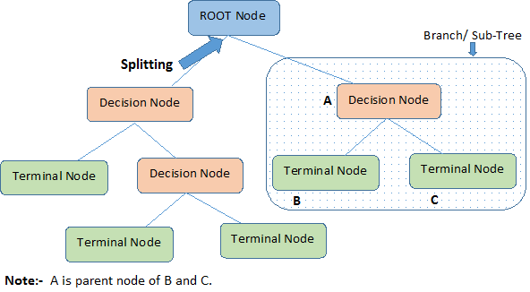](https://www.analyticsvidhya.com/wp-content/uploads/2015/01/Decision_Tree_2.png)

1. **Pruning:**When we remove sub-nodes of a decision node, this process is called pruning. You can say opposite process of splitting.
2. **Branch / Sub-Tree:**A sub section of entire tree is called branch or sub-tree.
3. **Parent and Child Node:**A node, which is divided into sub-nodes is called parent node of sub-nodes whereas sub-nodes are the child of parent node.

These are the terms commonly used for decision trees. As we know that every algorithm has advantages and disadvantages, below are the important factors which one should know.

## Pros and Cons associated with SVM

Pros

1. **Easy to Understand**: Decision tree output is very easy to understand even for people from non-analytical background. It does not require any statistical knowledge to read and interpret them. Its graphical representation is very intuitive and users can easily relate their hypothesis.
2. **Useful in Data exploration:**Decision tree is one of the fastest way to identify most significant variables and relation between two or more variables. With the help of decision trees, we can create new variables / features that has better power to predict target variable. You can refer article ([Trick to enhance power of regression model](https://www.analyticsvidhya.com/blog/2013/10/trick-enhance-power-regression-model-2/)) for one such trick.  It can also be used in data exploration stage. For example, we are working on a problem where we have information available in hundreds of variables, there decision tree will help to identify most significant variable.
3. **Less data cleaning required:**It requires less data cleaning compared to some other modelling techniques. It is not influenced by outliers and missing values to a fair degree.
4. **Data type is not a constraint:**It can handle both numerical and categorical variables.
5. **Non Parametric Method:**Decision tree is considered to be a non-parametric method. This means that decision trees have no assumptions about the space distribution and the classifier structure.

Cons:

1. **Over fitting:** Over fitting is one of the most practical difficulty for decision tree models. This problem gets solved by setting constraints on model parameters and pruning (discussed in detailed below).
2. **Not fit for continuous variables**: While working with continuous numerical variables, decision tree loses information when it categorizes variables in different categories.

## 2. Regression Trees vs Classification Trees

We all know that the terminal nodes (or leaves) lies at the bottom of the decision tree. This means that decision trees are typically drawn upside down such that leaves are the the bottom & roots are the tops (shown below).



Both the trees work almost similar to each other, let’s look at the primary differences & similarity between classification and regression trees:

1. Regression trees are used when dependent variable is continuous. Classification trees are used when dependent variable is categorical.
2. In case of regression tree, the value obtained by terminal nodes in the training data is the mean response of observation falling in that region. Thus, if an unseen data observation falls in that region, we’ll make its prediction with mean value.
3. In case of classification tree, the value (class) obtained by terminal node in the training data is the mode of observations falling in that region. Thus, if an unseen data observation falls in that region, we’ll make its prediction with mode value.
4. Both the trees divide the predictor space (independent variables) into distinct and non-overlapping regions. For the sake of simplicity, you can think of these regions as high dimensional boxes or boxes.
5. Both the trees follow a top-down greedy approach known as recursive binary splitting. We call it as ‘top-down’ because it begins from the top of tree when all the observations are available in a single region and successively splits the predictor space into two new branches down the tree. It is known as ‘greedy’ because, the algorithm cares (looks for best variable available) about only the current split, and not about future splits which will lead to a better tree.
6. This splitting process is continued until a user defined stopping criteria is reached. For example: we can tell the the algorithm to stop once the number of observations per node becomes less than 50.
7. In both the cases, the splitting process results in fully grown trees until the stopping criteria is reached. But, the fully grown tree is likely to overfit data, leading to poor accuracy on unseen data. This bring ‘pruning’. Pruning is one of the technique used tackle overfitting. We’ll learn more about it in following section.

## 3. How does a tree based algorithms decide where to split?

The decision of making strategic splits heavily affects a tree’s accuracy. The decision criteria is different for classification and regression trees.

Decision trees use multiple algorithms to decide to split a node in two or more sub-nodes. The creation of sub-nodes increases the homogeneity of resultant sub-nodes. In other words, we can say that purity of the node increases with respect to the target variable. Decision tree splits the nodes on all available variables and then selects the split which results in most homogeneous sub-nodes.

The algorithm selection is also based on type of target variables. Let’s look at the four most commonly used algorithms in decision tree:

### Gini

Gini says, if we select two items from a population at random then they must be of same class and probability for this is 1 if population is pure.

1. It works with categorical target variable “Success” or “Failure”.
2. It performs only Binary splits
3. Higher the value of Gini higher the homogeneity.
4. CART (Classification and Regression Tree) uses Gini method to create binary splits.

#### **Steps to Calculate Gini for a split**

1. Calculate Gini for sub-nodes, using formula sum of square of probability for success and failure (p^2+q^2).
2. Calculate Gini for split using weighted Gini score of each node of that split

**Example: –**Referring to example used above, where we want to segregate the students based on target variable (playing cricket or not ). In the snapshot below, we split the population using two input variables Gender and Class. Now, I want to identify which split is producing more homogeneous sub-nodes using Gini .

[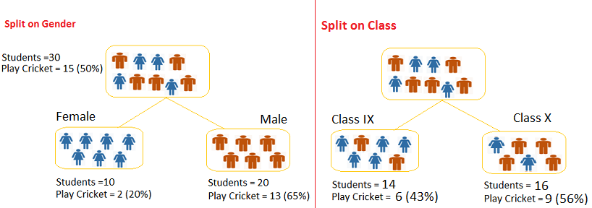](https://www.analyticsvidhya.com/wp-content/uploads/2015/01/Decision_Tree_Algorithm1.png)**Split on Gender:**

1. Calculate, Gini for sub-node Female = (0.2)\*(0.2)+(0.8)\*(0.8)=0.68
2. Gini for sub-node Male = (0.65)\*(0.65)+(0.35)\*(0.35)=0.55
3. Calculate weighted Gini for Split Gender = (10/30)\*0.68+(20/30)\*0.55 = **0.59**

**Similar for Split on Class:**

1. Gini for sub-node Class IX = (0.43)\*(0.43)+(0.57)\*(0.57)=0.51
2. Gini for sub-node Class X = (0.56)\*(0.56)+(0.44)\*(0.44)=0.51
3. Calculate weighted Gini for Split Class = (14/30)\*0.51+(16/30)\*0.51 = **0.51**

Above, you can see that Gini score for Split on Gender is higher than Split on Class, hence, the node split will take place on Gender.

You might often come across the term ‘Gini Impurity’ which is determined by subtracting the gini value from 1. So mathematically we can say,

Gini Impurity = 1-Gini

### Chi-Square

It is an algorithm to find out the statistical significance between the differences between sub-nodes and parent node. We measure it by sum of squares of standardized differences between observed and expected frequencies of target variable.

1. It works with categorical target variable “Success” or “Failure”.
2. It can perform two or more splits.
3. Higher the value of Chi-Square higher the statistical significance of differences between sub-node and Parent node.
4. Chi-Square of each node is calculated using formula,
5. Chi-square = ((Actual – Expected)^2 / Expected)^1/2
6. It generates tree called CHAID (Chi-square Automatic Interaction Detector)

#### **Steps to Calculate Chi-square for a split:**

1. Calculate Chi-square for individual node by calculating the deviation for Success and Failure both
2. Calculated Chi-square of Split using Sum of all Chi-square of success and Failure of each node of the split

**Example:**Let’s work with above example that we have used to calculate Gini.

**Split on Gender:**

1. First we are populating for node Female, Populate the actual value for “**Play Cricket”** and**“Not Play Cricket”**, here these are 2 and 8 respectively.
2. Calculate expected value for “**Play Cricket”** and “**Not Play Cricket”**, here it would be 5 for both because parent node has probability of 50% and we have applied same probability on Female count(10).
3. Calculate deviations by using formula, Actual – Expected. It is for “**Play Cricket”** (2 – 5 = -3) and for “**Not play cricket”** ( 8 – 5 = 3).
4. Calculate Chi-square of node for “**Play Cricket**” and “**Not Play Cricket**” using formula with formula, **= ((Actual – Expected)^2 / Expected)^1/2**. You can refer below table for calculation.
5. Follow similar steps for calculating Chi-square value for Male node.
6. Now add all Chi-square values to calculate Chi-square for split Gender.

[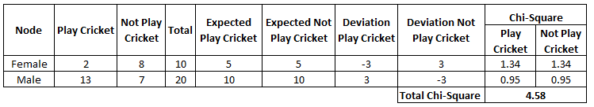](https://www.analyticsvidhya.com/wp-content/uploads/2015/01/Decision_Tree_Chi_Square1.png)

**Split on Class:**

Perform similar steps of calculation for split on Class and you will come up with below table.

[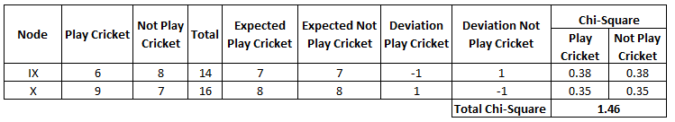](https://www.analyticsvidhya.com/wp-content/uploads/2015/01/Decision_Tree_Chi_Square_2.png)Above, you can see that Chi-square also identify the Gender split is more significant compare to Class.

### Information Gain:

Look at the image below and think which node can be described easily. I am sure, your answer is C because it requires less information as all values are similar. On the other hand, B requires more information to describe it and A requires the maximum information. In other words, we can say that C is a pure node, B is less Impure and A is more impure.

[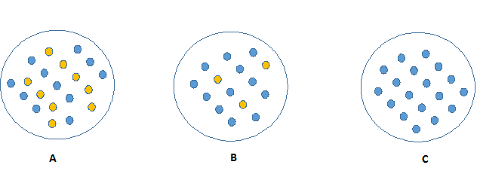](https://www.analyticsvidhya.com/wp-content/uploads/2015/01/Information_Gain_Decision_Tree2.png)

Now, we can build a conclusion that less impure node requires less information to describe it. And, more impure node requires more information. Information theory is a measure to define this degree of disorganization in a system known as Entropy. If the sample is completely homogeneous, then the entropy is zero and if the sample is an equally divided (50% – 50%), it has entropy of one.

Entropy can be calculated using formula:-

Here p and q is probability of success and failure respectively in that node. Entropy is also used with categorical target variable. It chooses the split which has lowest entropy compared to parent node and other splits. The lesser the entropy, the better it is.

#### **Steps to calculate entropy for a split:**

1. Calculate entropy of parent node
2. Calculate entropy of each individual node of split and calculate weighted average of all sub-nodes available in split.

**Example:**Let’s use this method to identify best split for student example.

1. Entropy for parent node = -(15/30) log2 (15/30) – (15/30) log2 (15/30) = **1**. Here 1 shows that it is a impure node.
2. Entropy for Female node = -(2/10) log2 (2/10) – (8/10) log2 (8/10) = 0.72 and for male node,  -(13/20) log2 (13/20) – (7/20) log2 (7/20) = **0.93**
3. Entropy for split Gender = Weighted entropy of sub-nodes = (10/30)\*0.72 + (20/30)\*0.93 = **0.86**
4. Entropy for Class IX node, -(6/14) log2 (6/14) – (8/14) log2 (8/14) = 0.99 and for Class X node,  -(9/16) log2 (9/16) – (7/16) log2 (7/16) = 0.99.
5. Entropy for split Class =  (14/30)\*0.99 + (16/30)\*0.99 = **0.99**

Above, you can see that entropy for Split on Gender is the lowest among all, so the tree will split on Gender. We can derive information gain from entropy as **1- Entropy.**

### Reduction in Variance

Till now, we have discussed the algorithms for categorical target variable. Reduction in variance is an algorithm used for continuous target variables (regression problems). This algorithm uses the standard formula of variance to choose the best split. The split with lower variance is selected as the criteria to split the population:

[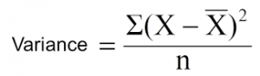](https://www.analyticsvidhya.com/wp-content/uploads/2015/01/Varince.png)

Above X-bar is mean of the values, X is actual and n is number of values.

#### **Steps to calculate Variance:**

1. Calculate variance for each node.
2. Calculate variance for each split as weighted average of each node variance.

**Example: -** Let’s assign numerical value 1 for play cricket and 0 for not playing cricket. Now follow the steps to identify the right split:

1. Variance for Root node, here mean value is (15\*1 + 15\*0)/30 = 0.5 and we have 15 one and 15 zero. Now variance would be ((1-0.5)^2+(1-0.5)^2+….15 times+(0-0.5)^2+(0-0.5)^2+…15 times) / 30, this can be written as (15\*(1-0.5)^2+15\*(0-0.5)^2) / 30 = **0.25**
2. Mean of Female node =  (2\*1+8\*0)/10=0.2 and Variance = (2\*(1-0.2)^2+8\*(0-0.2)^2) / 10 = 0.16
3. Mean of Male Node = (13\*1+7\*0)/20=0.65 and Variance = (13\*(1-0.65)^2+7\*(0-0.65)^2) / 20 = 0.23
4. Variance for Split Gender = Weighted Variance of Sub-nodes = (10/30)\*0.16 + (20/30) \*0.23 = **0.21**
5. Mean of Class IX node =  (6\*1+8\*0)/14=0.43 and Variance = (6\*(1-0.43)^2+8\*(0-0.43)^2) / 14= 0.24
6. Mean of Class X node =  (9\*1+7\*0)/16=0.56 and Variance = (9\*(1-0.56)^2+7\*(0-0.56)^2) / 16 = 0.25
7. Variance for Split Gender = (14/30)\*0.24 + (16/30) \*0.25 = **0.25**

Above, you can see that Gender split has lower variance compare to parent node, so the split would take place on Gender variable.

Until here, we learnt about the basics of decision trees and the decision making process involved to choose the best splits in building a tree model. As I said, decision tree can be applied both on regression and classification problems. Let’s understand these aspects in detail.

## 4. What are the key parameters of tree based algorithms and how can we avoid over-fitting in decision trees?

Overfitting is one of the key challenges faced while using tree based algorithms. If there is no limit set of a decision tree, it will give you 100% accuracy on training set because in the worst case it will end up making 1 leaf for each observation. Thus, preventing overfitting is pivotal while modelling a decision tree and it can be done in 2 ways:

1. Setting constraints on tree size
2. Tree pruning

Let’s discuss both of these briefly.

### Setting Constraints on tree based algorithms

This can be done by using various parameters which are used to define a tree. First, let’s look at the general structure of a decision tree:

[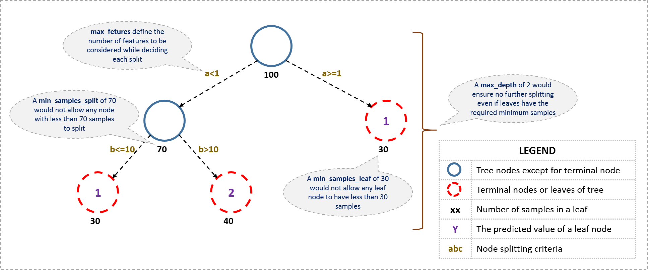](https://www.analyticsvidhya.com/wp-content/uploads/2016/02/tree-infographic.png)

The parameters used for defining a tree are further explained below. The parameters described below are irrespective of tool. It is important to understand the role of parameters used in tree modelling. These parameters are available in R & Python.

1. **Minimum samples for a node split**
   * Defines the minimum number of samples (or observations) which are required in a node to be considered for splitting.
   * Used to control over-fitting. Higher values prevent a model from learning relations which might be highly specific to the particular sample selected for a tree.
   * Too high values can lead to under-fitting hence, it should be tuned using CV.
2. **Minimum samples for a terminal node (leaf)**
   * Defines the minimum samples (or observations) required in a terminal node or leaf.
   * Used to control over-fitting similar to min\_samples\_split.
   * Generally lower values should be chosen for imbalanced class problems because the regions in which the minority class will be in majority will be very small.
3. **Maximum depth of tree (vertical depth)**
   * The maximum depth of a tree.
   * Used to control over-fitting as higher depth will allow model to learn relations very specific to a particular sample.
   * Should be tuned using CV.
4. **Maximum number of terminal nodes**
   * The maximum number of terminal nodes or leaves in a tree.
   * Can be defined in place of max\_depth. Since binary trees are created, a depth of ‘n’ would produce a maximum of 2^n leaves.
5. **Maximum features to consider for split**
   * The number of features to consider while searching for a best split. These will be randomly selected.
   * As a thumb-rule, square root of the total number of features works great but we should check upto 30-40% of the total number of features.
   * Higher values can lead to over-fitting but depends on case to case.

## Pruning in tree based algorithms

As discussed earlier, the technique of setting constraint is a greedy-approach. In other words, it will check for the best split instantaneously and move forward until one of the specified stopping condition is reached. Let’s consider the following case when you’re driving:

[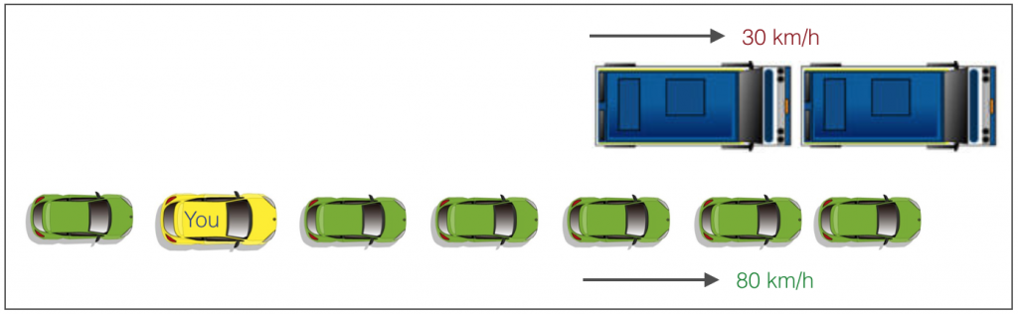](https://www.analyticsvidhya.com/wp-content/uploads/2016/04/graphic.png)

There are 2 lanes:

1. A lane with cars moving at 80km/h
2. A lane with trucks moving at 30km/h

At this instant, you are the yellow car and you have 2 choices:

1. Take a left and overtake the other 2 cars quickly
2. Keep moving in the present lane

Let’s analyse these choice. In the former choice, you’ll immediately overtake the car ahead and reach behind the truck and start moving at 30 km/h, looking for an opportunity to move back right. All cars originally behind you move ahead in the meanwhile. This would be the optimum choice if your objective is to maximize the distance covered in next say 10 seconds. In the later choice, you sale through at same speed, cross trucks and then overtake maybe depending on situation ahead. Greedy you!

This is exactly the difference between normal decision tree & pruning. A decision tree with constraints won’t see the truck ahead and adopt a greedy approach by taking a left. On the other hand if we use pruning, we in effect look at a few steps ahead and make a choice.

So we know pruning is better. But how to implement it in decision tree? The idea is simple.

1. We first make the decision tree to a large depth.
2. Then we start at the bottom and start removing leaves which are giving us negative returns when compared from the top.
3. Suppose a split is giving us a gain of say -10 (loss of 10) and then the next split on that gives us a gain of 20. A simple decision tree will stop at step 1 but in pruning, we will see that the overall gain is +10 and keep both leaves.

Note that sklearn’s decision tree classifier does not currently support pruning. Advanced packages like xgboost have adopted tree pruning in their implementation. But the library rpart in R, provides a function to prune. Good for R users!

## 5. Are tree based algorithms better than linear models?

“If I can use logistic regression for classification problems and linear regression for regression problems, why is there a need to use trees”? Many of us have this question. And, this is a valid one too.

Actually, you can use any algorithm. It is dependent on the type of problem you are solving. Let’s look at some key factors which will help you to decide which algorithm to use:

1. If the relationship between dependent & independent variable is well approximated by a linear model, linear regression will outperform tree based model.
2. If there is a high non-linearity & complex relationship between dependent & independent variables, a tree model will outperform a classical regression method.
3. If you need to build a model which is easy to explain to people, a decision tree model will always do better than a linear model. Decision tree models are even simpler to interpret than linear regression!

## 6. Working with tree based algorithms Trees in R and Python

For R users and Python users, decision tree is quite easy to implement. Let’s quickly look at the set of codes that can get you started with this algorithm. For ease of use, I’ve shared standard codes where you’ll need to replace your data set name and variables to get started.

In fact, you can build the decision tree in Python right here! Here’s a live coding window for you to play around the code and generate results:

 In the code above:

* y\_train – represents dependent variable.
* x\_train – represents independent variable
* x – represents training data.

For Python users, below is the code:

#Import Library

#Import other necessary libraries like pandas, numpy...

from sklearn import tree

#Assumed you have, X (predictor) and Y (target) for training data set and x\_test(predictor) of test\_dataset

# create tree object

model = tree.DecisionTreeClassifier(criterion='gini') # for classification, here you can change the algorithm as gini or entropy (information gain) by default it is gini

# model = tree.DecisionTreeRegressor() for regression

# Train the model using the training sets and check score

model.fit(X, y)

model.score(X, y)

#Predict Output

predicted= model.predict(x\_test)

## 7. What are ensemble methods in tree based algorithms?

The literary meaning of word ‘ensemble’ is group. [Ensemble methods](https://courses.analyticsvidhya.com/courses/ensemble-learning-and-ensemble-learning-techniques?utm_source=blog&utm_medium=tree-based-algorithms-complete-tutorial-scratch-in-python) involve group of predictive models to achieve a better accuracy and model stability. Ensemble methods are known to impart supreme boost to tree based models.

Like every other model, a tree based algorithm also suffers from the plague of bias and variance. Bias means, ‘how much on an average are the predicted values different from the actual value.’ Variance means, ‘how different will the predictions of the model be at the same point if different samples are taken from the same population’.

You build a small tree and you will get a model with low variance and high bias. How do you manage to balance the trade-off between bias and variance?

Normally, as you increase the complexity of your model, you will see a reduction in prediction error due to lower bias in the model. As you continue to make your model more complex, you end up over-fitting your model and your model will start suffering from high variance.

A champion model should maintain a balance between these two types of errors. This is known as the **trade-off management** of bias-variance errors. Ensemble learning is one way to execute this trade off analysis.

[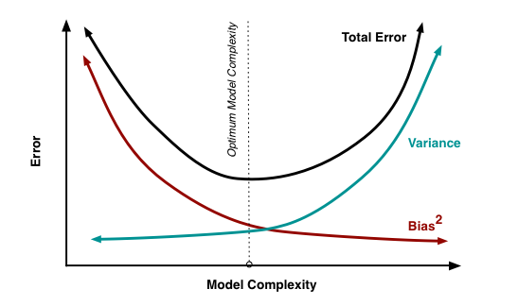](https://www.analyticsvidhya.com/wp-content/uploads/2015/07/model_complexity.png)Some of the commonly used ensemble methods include: Bagging, Boosting and Stacking. In this tutorial, we’ll focus on Bagging and Boosting in detail.

## 8. What is bagging? How does it work?

Bagging is an [ensemble technique](https://courses.analyticsvidhya.com/courses/ensemble-learning-and-ensemble-learning-techniques?utm_source=blog&utm_medium=tree-based-algorithms-complete-tutorial-scratch-in-python) used to reduce the variance of our predictions by combining the result of multiple classifiers modelled on different sub-samples of the same data set. The following figure will make it clearer:

[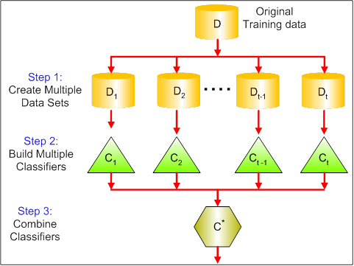](https://www.analyticsvidhya.com/wp-content/uploads/2015/07/bagging.png)

### The steps followed in bagging are:

1. **Create Multiple Datasets**:
   * Sampling is done with replacement on the original data and new datasets are formed.
   * The new data sets can have a fraction of the columns as well as rows, which are generally hyper-parameters in a bagging model
   * Taking row and column fractions less than 1 helps in making robust models, less prone to overfitting
2. **Build Multiple Classifiers:**
   * Classifiers are built on each data set.
   * Generally the same classifier is modelled on each data set and predictions are made.
3. **Combine Classifiers:**
   * The predictions of all the classifiers are combined using a mean, median or mode value depending on the problem at hand.
   * The combined values are generally more robust than a single model.

Note that, here the number of models built is not a hyper-parameters. Higher number of models are always better or may give similar performance than lower numbers. It can be theoretically shown that the variance of the combined predictions are reduced to 1/n (n: number of classifiers) of the original variance, under some assumptions.

There are various implementations of bagging models. Random forest is one of them and we’ll discuss it next.

## 9. What is Random Forest? How does it work?

Random Forest is considered to be a panacea of all data science problems. On a funny note, when you can’t think of any algorithm (irrespective of situation), use random forest!

Random Forest is a versatile machine learning method capable of performing both regression and classification tasks. It also undertakes dimensional reduction methods, treats missing values, outlier values and other essential [steps of data exploration](https://www.analyticsvidhya.com/blog/2015/02/data-exploration-preparation-model/), and does a fairly good job. It is a type of [ensemble learning](https://courses.analyticsvidhya.com/courses/ensemble-learning-and-ensemble-learning-techniques?utm_source=blog&utm_medium=tree-based-algorithms-complete-tutorial-scratch-in-python) method, where a group of weak models combine to form a powerful model.

### How does it work?

In Random Forest, we grow multiple trees as opposed to a single tree in CART model (see comparison between CART and Random Forest here, [part1](https://www.analyticsvidhya.com/blog/2014/06/comparing-cart-random-forest-1/) and [part2](https://www.analyticsvidhya.com/blog/2014/06/comparing-random-forest-simple-cart-model/)). To classify a new object based on attributes, each tree gives a classification and we say the tree “votes” for that class. The forest chooses the classification having the most votes (over all the trees in the forest) and in case of regression, it takes the average of outputs by different trees.

It works in the following manner. Each tree is planted & grown as follows:

1. Assume number of cases in the training set is N. Then, sample of these N cases is taken at random but with replacement. This sample will be the training set for growing the tree.
2. If there are M input variables, a number m<M is specified such that at each node, m variables are selected at random out of the M. The best split on these m is used to split the node. The value of m is held constant while we grow the forest.
3. Each tree is grown to the largest extent possible and  there is no pruning.
4. Predict new data by aggregating the predictions of the ntree trees (i.e., majority votes for classification, average for regression).

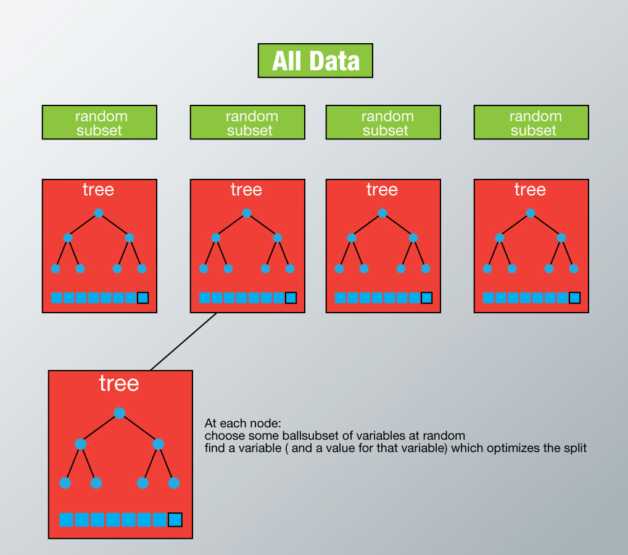

To understand more in detail about this algorithm using a case study, please read this article “[Introduction to Random forest – Simplified](https://www.analyticsvidhya.com/blog/2014/06/introduction-random-forest-simplified/)“.

## Advantages of Random Forest

* This algorithm can solve both type of problems i.e. classification and regression and does a decent estimation at both fronts.
* One of benefits of Random forest which excites me most is, the power of handle large data set with higher dimensionality. It can handle thousands of input variables and identify most significant variables so it is considered as one of the dimensionality reduction methods. Further, the model outputs **Importance of variable,**which can be a very handy feature (on some random data set).  
  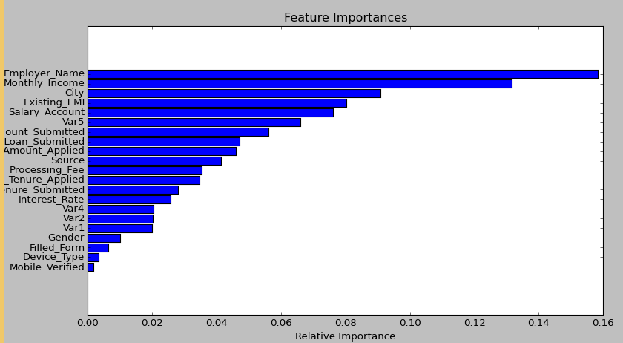
* It has an effective method for estimating missing data and maintains accuracy when a large proportion of the data are missing.
* It has methods for balancing errors in data sets where classes are imbalanced.
* The capabilities of the above can be extended to unlabeled data, leading to unsupervised clustering, data views and outlier detection.
* Random Forest involves sampling of the input data with replacement called as bootstrap sampling. Here one third of the data is not used for training and can be used to testing. These are called the **out of bag** samples. Error estimated on these out of bag samples is known as out of bag error. Study of error estimates by Out of bag, gives evidence to show that the out-of-bag estimate is as accurate as using a test set of the same size as the training set. Therefore, using the out-of-bag error estimate removes the need for a set aside test set.

## Disadvantages of Random Forest

* It surely does a good job at classification but not as good as for regression problem as it does not give precise continuous nature predictions. In case of regression, it doesn’t predict beyond the range in the training data, and that they may over-fit data sets that are particularly noisy.
* Random Forest can feel like a black box approach for statistical modelers – you have very little control on what the model does. You can at best – try different parameters and random seeds!

## 10. What is Boosting? How does it work?

Definition: The term ‘Boosting’ refers to a family of algorithms which converts weak learner to strong learners.

Let’s understand this definition in detail by solving a problem of spam email identification:

How would you classify an email as SPAM or not? Like everyone else, our initial approach would be to identify ‘spam’ and ‘not spam’ emails using following criteria. If:

1. Email has only one image file (promotional image), It’s a SPAM
2. Email has only link(s), It’s a SPAM
3. Email body consist of sentence like “You won a prize money of $ xxxxxx”, It’s a SPAM
4. Email from our official domain “[Analyticsvidhya.com](http://analyticsvidhya.com/)” , Not a SPAM
5. Email from known source, Not a SPAM

Above, we’ve defined multiple rules to classify an email into ‘spam’ or ‘not spam’. But, do you think these rules individually are strong enough to successfully classify an email? No.

Individually, these rules are not powerful enough to classify an email into ‘spam’ or ‘not spam’. Therefore, these rules are called as **weak learner**.

To convert weak learner to strong learner, we’ll combine the prediction of each weak learner using methods like:

* Using average/ weighted average
* Considering prediction has higher vote

For example:  Above, we have defined 5 weak learners. Out of these 5, 3 are voted as ‘SPAM’ and 2 are voted as ‘Not a SPAM’. In this case, by default, we’ll consider an email as SPAM because we have higher(3) vote for ‘SPAM’.

### How does it work?

Now we know that, boosting combines weak learner a.k.a. base learner to form a strong rule. An immediate question which should pop in your mind is, ‘How boosting identify weak rules?‘

To find weak rule, we apply base learning (ML) algorithms with a different distribution. Each time base learning algorithm is applied, it generates a new weak prediction rule. This is an iterative process. After many iterations, the boosting algorithm combines these weak rules into a single strong prediction rule. This is how the [ensemble model](https://courses.analyticsvidhya.com/courses/ensemble-learning-and-ensemble-learning-techniques?utm_source=blog&utm_medium=tree-based-algorithms-complete-tutorial-scratch-in-python) is built.

Here’s another question which might haunt you, ‘How do we choose different distribution for each round?’

For choosing the right distribution, here are the following steps:

Step 1:  The base learner takes all the distributions and assign equal weight or attention to each observation.

Step 2: If there is any prediction error caused by first base learning algorithm, then we pay higher attention to observations having prediction error. Then, we apply the next base learning algorithm.

Step 3: Iterate Step 2 till the limit of base learning algorithm is reached or higher accuracy is achieved.

Finally, it combines the outputs from weak learner and creates a strong learner which eventually improves the prediction power of the model. Boosting pays higher focus on examples which are mis-classiﬁed or have higher errors by preceding weak rules.  
There are many boosting algorithms which impart additional boost to model’s accuracy. In this tutorial, we’ll learn about the two most commonly used algorithms i.e. Gradient Boosting (GBM) and XGboost.

## 11. Which is more powerful: GBM or Xgboost?

I’ve always admired the boosting capabilities that xgboost algorithm. At times, I’ve found that it provides better result compared to GBM implementation, but at times you might find that the gains are just marginal. When I explored more about its performance and science behind its high accuracy, I discovered many advantages of Xgboost over GBM:

1. **Regularization:**
   * Standard GBM implementation has no [regularization](https://www.analyticsvidhya.com/blog/2015/02/avoid-over-fitting-regularization/) like XGBoost, therefore it also helps to reduce overfitting.
   * In fact, XGBoost is also known as ‘**regularized boosting**‘ technique.
2. **Parallel Processing:**
   * XGBoost implements parallel processing and is **blazingly faster** as compared to GBM.
   * But hang on, we know that [boosting](https://www.analyticsvidhya.com/blog/2015/11/quick-introduction-boosting-algorithms-machine-learning/) is sequential process so how can it be parallelized? We know that each tree can be built only after the previous one, so what stops us from making a tree using all cores? I hope you get where I’m coming from. Check [this link](http://zhanpengfang.github.io/418home.html) out to explore further.
   * XGBoost also supports implementation on Hadoop.
3. **High Flexibility**
   * XGBoost allow users to define **custom optimization objectives and evaluation criteria**.
   * This adds a whole new dimension to the model and there is no limit to what we can do.
4. **Handling Missing Values**
   * XGBoost has an in-built routine to handle missing values.
   * User is required to supply a different value than other observations and pass that as a parameter. XGBoost tries different things as it encounters a missing value on each node and learns which path to take for missing values in future.
5. **Tree Pruning:**
   * A GBM would stop splitting a node when it encounters a negative loss in the split. Thus it is more of a **greedy algorithm**.
   * XGBoost on the other hand make **splits upto the max\_depth** specified and then start **pruning** the tree backwards and remove splits beyond which there is no positive gain.
   * Another advantage is that sometimes a split of negative loss say -2 may be followed by a split of positive loss +10. GBM would stop as it encounters -2. But XGBoost will go deeper and it will see a combined effect of +8 of the split and keep both.
6. **Built-in Cross-Validation**
   * XGBoost allows user to run a **cross-validation at each iteration** of the boosting process and thus it is easy to get the exact optimum number of boosting iterations in a single run.
   * This is unlike GBM where we have to run a grid-search and only a limited values can be tested.
7. **Continue on Existing Model**
   * User can start training an XGBoost model from its last iteration of previous run. This can be of significant advantage in certain specific applications.
   * GBM implementation of sklearn also has this feature so they are even on this point.

## 12. Working with GBM in R and Python

Before we start working, let’s quickly understand the important parameters and the working of this algorithm. This will be helpful for both R and Python users. Below is the overall pseudo-code of GBM algorithm for 2 classes:

1. Initialize the outcome

2. Iterate from 1 to total number of trees

2.1 Update the weights for targets based on previous run (higher for the ones mis-classified)

2.2 Fit the model on selected subsample of data

2.3 Make predictions on the full set of observations

2.4 Update the output with current results taking into account the learning rate

3. Return the final output.

This is an extremely simplified (probably naive) explanation of GBM’s working. But, it will help every beginners to understand this algorithm.

Let’s consider the important GBM parameters used to improve model performance in Python:

1. **learning\_rate**
   * This determines the impact of each tree on the final outcome (step 2.4). GBM works by starting with an initial estimate which is updated using the output of each tree. The learning parameter controls the magnitude of this change in the estimates.
   * Lower values are generally preferred as they make the model robust to the specific characteristics of tree and thus allowing it to generalize well.
   * Lower values would require higher number of trees to model all the relations and will be computationally expensive.
2. **n\_estimators**
   * The number of sequential trees to be modelled (step 2)
   * Though GBM is fairly robust at higher number of trees but it can still over fit at a point. Hence, this should be tuned using CV for a particular learning rate.
3. **subsample**
   * The fraction of observations to be selected for each tree. Selection is done by random sampling.
   * Values slightly less than 1 make the model robust by reducing the variance.
   * Typical values ~0.8 generally work fine but can be fine-tuned further.

Apart from these, there are certain miscellaneous parameters which affect overall functionality:

1. **loss**
   * It refers to the loss function to be minimized in each split.
   * It can have various values for classification and regression case. Generally the default values work fine. Other values should be chosen only if you understand their impact on the model.
2. **init**
   * This affects initialization of the output.
   * This can be used if we have made another model whose outcome is to be used as the initial estimates for GBM.
3. **random\_state**
   * The random number seed so that same random numbers are generated every time.
   * This is important for parameter tuning. If we don’t fix the random number, then we’ll have different outcomes for subsequent runs on the same parameters and it becomes difficult to compare models.
   * It can potentially result in overfitting to a particular random sample selected. We can try running models for different random samples, which is computationally expensive and generally not used.
4. **verbose**
   * The type of output to be printed when the model fits. The different values can be:
     + 0: no output generated (default)
     + 1: output generated for trees in certain intervals
     + >1: output generated for all trees
5. **warm\_start**
   * This parameter has an interesting application and can help a lot if used judicially.
   * Using this, we can fit additional trees on previous fits of a model. It can save a lot of time and you should explore this option for advanced applications
6. **presort**
   * Select whether to presort data for faster splits.
   * It makes the selection automatically by default but it can be changed if needed.

I know its a long list of parameters but I have simplified it for you in an excel file which you can download from this [GitHub repository](https://github.com/aarshayj/Analytics_Vidhya/tree/master/Articles/Parameter_Tuning_GBM_with_Example).

For R users, using caret package, there are 3 main tuning parameters:

1. n.trees – It refers to number of iterations i.e. tree which will be taken to grow the trees
2. interaction.depth – It determines the complexity of the tree i.e. total number of splits it has to perform on a tree (starting from a single node)
3. shrinkage – It refers to the learning rate. This is similar to learning\_rate in python (shown above).
4. n.minobsinnode – It refers to minimum number of training samples required in a node to perform splitting

### GBM in Python

## 13. Working with XGBoost in R and Python

**XGBoost (eXtreme Gradient Boosting)** is an advanced implementation of gradient boosting algorithm. It’s feature to implement parallel computing makes it at least **10 times faster** than existing gradient boosting implementations. It supports various objective functions, including regression, classification and ranking.

R Tutorial: For R users, this is a complete tutorial on XGboost which explains the parameters along with codes in R. [Check Tutorial](https://www.analyticsvidhya.com/blog/2016/01/xgboost-algorithm-easy-steps/).

Python Tutorial: For Python users, this is a comprehensive tutorial on XGBoost, good to get you started. [Check Tutorial](https://www.analyticsvidhya.com/blog/2016/03/complete-guide-parameter-tuning-xgboost-with-codes-python/).

## 14. Where to practice?

Practice is the one and true method of mastering any concept. Hence, you need to start practicing if you wish to master these algorithms.

|  |  |  |
| --- | --- | --- |
| [https://cdn.analyticsvidhya.com/wp-content/uploads/2016/01/food_500x250-300x150.jpg](https://datahack.analyticsvidhya.com/contest/genpact-machine-learning-hackathon-1/?utm_source=complete-tutorial-learn-data-science-python-scratch-2&utm_medium=blog) | [Practice Problem: Food Demand Forecasting Challenge](https://datahack.analyticsvidhya.com/contest/genpact-machine-learning-hackathon-1/?utm_source=complete-tutorial-learn-data-science-python-scratch-2&utm_medium=blog) | Predict the demand of meals for a meal delivery company |
| [https://cdn.analyticsvidhya.com/wp-content/uploads/2016/01/hr_500x250-300x150.jpg](https://datahack.analyticsvidhya.com/contest/wns-analytics-hackathon-2018-1/?utm_source=complete-tutorial-learn-data-science-python-scratch-2&utm_medium=blog) | [Practice Problem: HR Analytics Challenge](https://datahack.analyticsvidhya.com/contest/wns-analytics-hackathon-2018-1/?utm_source=complete-tutorial-learn-data-science-python-scratch-2&utm_medium=blog) | Identify the employees most likely to get promoted |
| [https://cdn.analyticsvidhya.com/wp-content/uploads/2016/01/upvote_500x250-300x150.jpg](https://datahack.analyticsvidhya.com/contest/enigma-codefest-machine-learning-1/?utm_source=complete-tutorial-learn-data-science-python-scratch-2&utm_medium=blog) | [Practice Problem: Predict Number of Upvotes](https://datahack.analyticsvidhya.com/contest/enigma-codefest-machine-learning-1/?utm_source=complete-tutorial-learn-data-science-python-scratch-2&utm_medium=blog) | Predict number of upvotes on a query asked at an online question & answer platform |

## End Notes

Tree based algorithms are important for every data scientist to learn. In fact, tree models are known to provide the best model performance in the family of whole machine learning algorithms. In this tutorial, we learnt until GBM and XGBoost. And with this, we come to the end of this tutorial.

We discussed about tree based algorithms from scratch. We learnt the important of decision tree and how that simplistic concept is being used in boosting algorithms. For better understanding, I would suggest you to continue practicing these algorithms practically. Also, do keep note of the parameters associated with boosting algorithms. I’m hoping that this tutorial would enrich you with complete knowledge on tree based modelling.

# Entropy: How Decision Trees Make Decisions

You’re a Data Scientist in training. You’ve come a long way from writing your first line of Python or R code. You know your way around Scikit-Learn like the back of your hand. You spend more time on Kaggle than Facebook now. You’re no stranger to building awesome random forests and other tree based ensemble models that get the job done. However, you’re nothing if not thorough. You want to dig deeper and understand some of the intricacies and concepts behind popular machine learning models. Well, so do I.

In this blog post, I will introduce the concept of Entropy as a general topic in statistics which will allow me to further introduce the concept of Information Gain and subsequently explain why both these fundamental concepts form the basis of how decision trees build themselves on the data we supply them.

Right. Let’s get on with it then.

What is Entropy? In the most layman terms, Entropy is nothing but the **measure of disorder.**(You can think of it as a measure of purity as well. You’ll see. I like disorder because it sounds cooler.)

The Mathematical formula for Entropy is as follows -

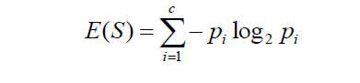

Entropy. Sometimes also denoted using the letter ‘H’

Where ‘Pi’ is simply the frequentist probability of an element/class ‘i’ in our data. For simplicity’s sake let’s say we only have two classes, a positive class and a negative class. Therefore ‘i’ here could be either + or (-). So if we had a total of 100 data points in our dataset with 30 belonging to the positive class and 70 belonging to the negative class then ‘P+’ would be 3/10 and ‘P-’ would be 7/10. Pretty straightforward.

If I was to calculate the entropy of my classes in this example using the formula above. Here’s what I would get.

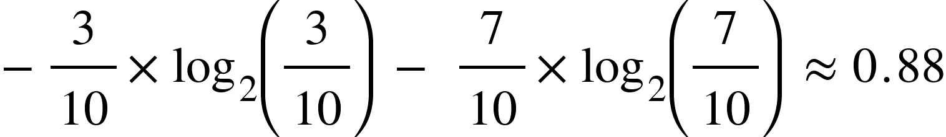

The entropy here is approximately 0.88. This is considered a high entropy, a high level of disorder (meaning low level of purity). Entropy is measured between 0 and 1.(Depending on the number of classes in your dataset, entropy can be greater than 1 but it means the same thing , a very high level of disorder. For the sake of simplicity, the examples in this blog will have entropy between 0 and 1).

Take a look at this graph below.

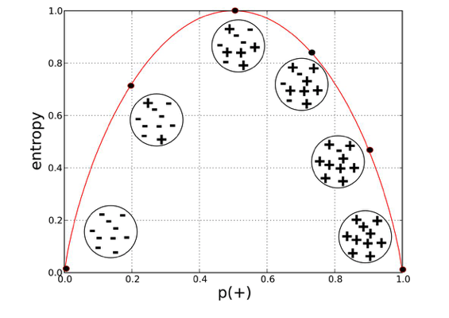

Provost, Foster; Fawcett, Tom. Data Science for Business: What You Need to Know about Data Mining and Data-Analytic Thinking

The x-axis measures the proportion of data points belonging to the positive class in each bubble and the y-axis axis measures their respective entropies. Right away, you can see the inverted ‘U’ shape of the graph. Entropy is lowest at the extremes, when the bubble either contains no positive instances or only positive instances. That is, when the bubble is pure the disorder is 0. Entropy is highest in the middle when the bubble is evenly split between positive and negative instances. Extreme disorder, because there is no majority.

Does it matter why entropy is measured using log base 2 or why entropy is measured between 0 and 1 and not some other range? No. It’s just a metric. It’s not important to know how it came to be. It’s important to know how to read it and what it tells us, which we just did above. Entropy is a measure of disorder or uncertainty and the goal of machine learning models and Data Scientists in general is to reduce uncertainty.

Now we know how to measure disorder. Next we need a metric to measure the reduction of this disorder in our target variable/class given additional information (features/independent variables) about it. This is where Information Gain comes in. Mathematically it can be written as:



Information Gain from X on Y

We simply subtract the entropy of Y given X from the entropy of just Y to calculate the reduction of uncertainty about Y given an additional piece of information X about Y. This is called Information Gain. The greater the reduction in this uncertainty, the more information is gained about Y from X.

Let me illustrate with an example using a simple contingency table and then I’ll bring all of it together with how decisions trees use entropy and information gain to decide what feature to split their nodes on as they are being trained on a data set.

**Example: Contingency Table**

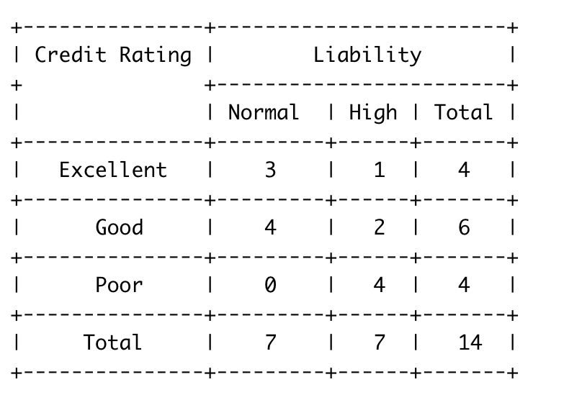

Contingency Table

Here our target variable is Liability which can take on two values “Normal” and “High” and we only have one feature called Credit Rating which can take on values “Excellent”, “Good” and “Poor”. There are a total of 14 observations. 7 of them belong to the Normal Liability class and 7 belong to High Liability Class. So it’s an even split by itself. Summing across the top row we can see there are 4 observations that have value Excellent for the feature credit rating. Furthermore, I can also see how my target variable is split for “Excellent” Credit Rating. For observations that take have value “Excellent” for their credit rating there are 3 that belong to the Normal Liability class and only 1 that belongs to the High Liability class. I can similarly figure out such values for other values of Credit Rating from the contingency table.

For this illustration, I will use this contingency table to calculate the entropy of our target variable by itself and then calculate the entropy of our target variable given additional information about the feature, credit rating. This will allow me to calculate how much additional information does “Credit Rating” provide for my target variable “Liability”.

Let’s get to it then.

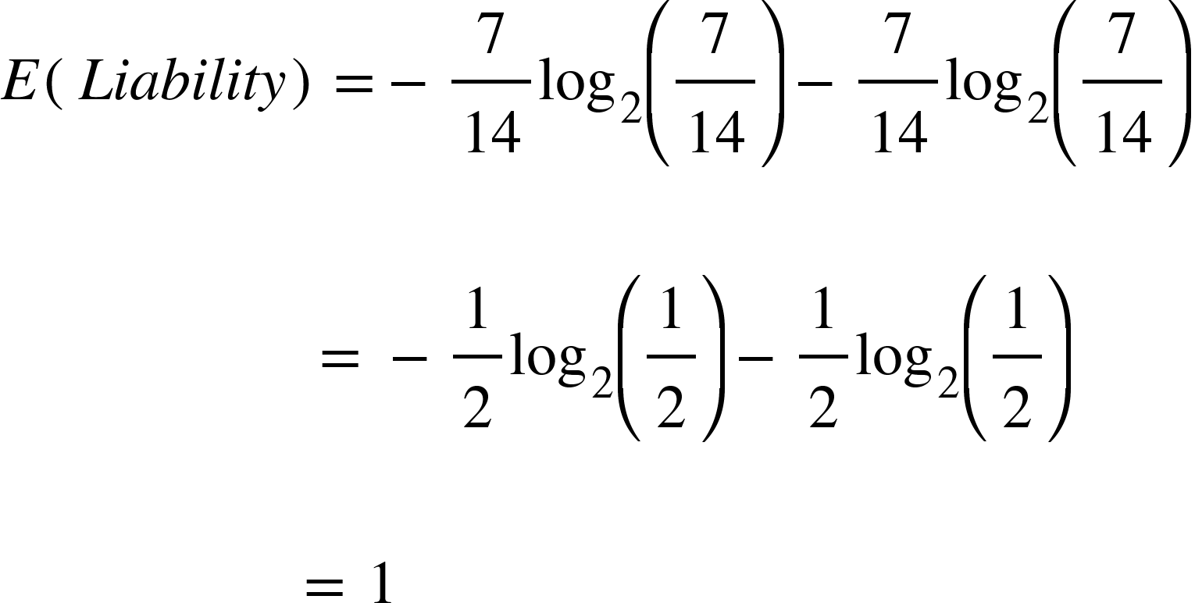

The entropy of our target variable is 1, at maximum disorder due to the even split between class label “Normal” and “High”. Our next step is to calculate the entropy of our target variable Liability given additional information about credit score. For this we will calculate the entropy for Liability for each value of Credit Score and add them using a weighted average of the proportion of observations that end up in each value. Why we use a weighted average will become clearer when we discuss this in the context of decision trees.

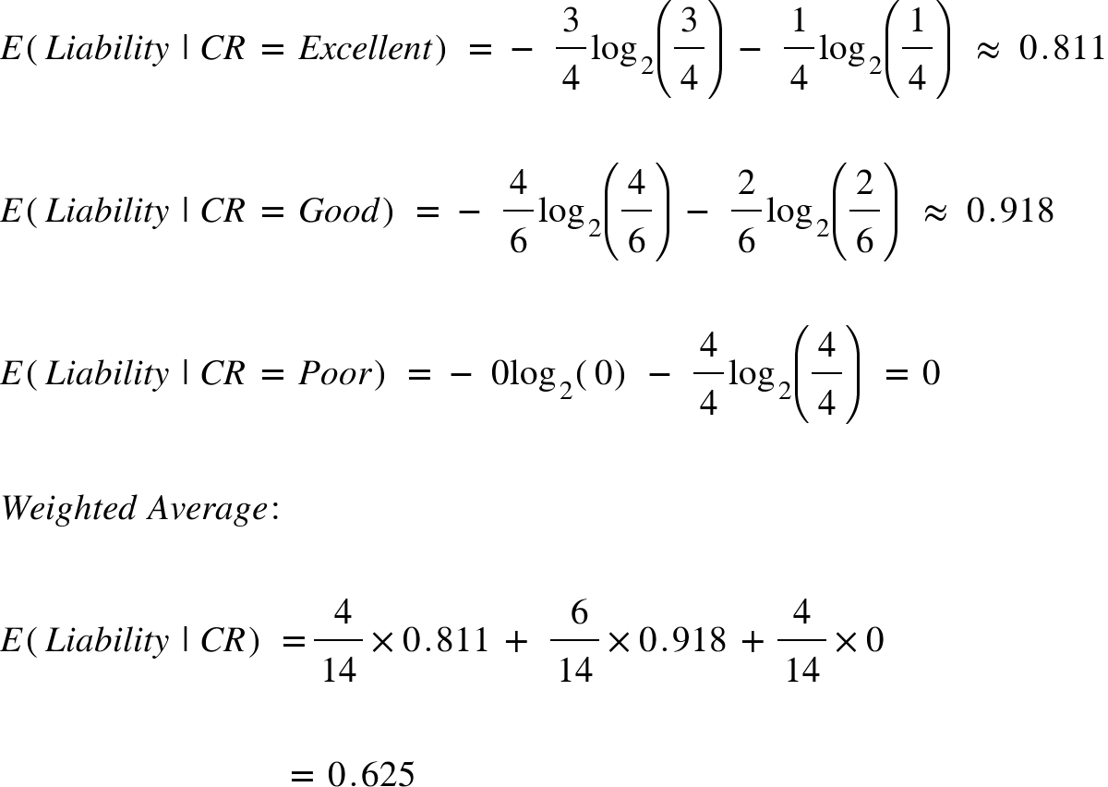

We got the entropy for our target variable given the feature Credit Rating. Now we can compute the Information Gain on Liability from Credit Rating to see how informative this feature is.

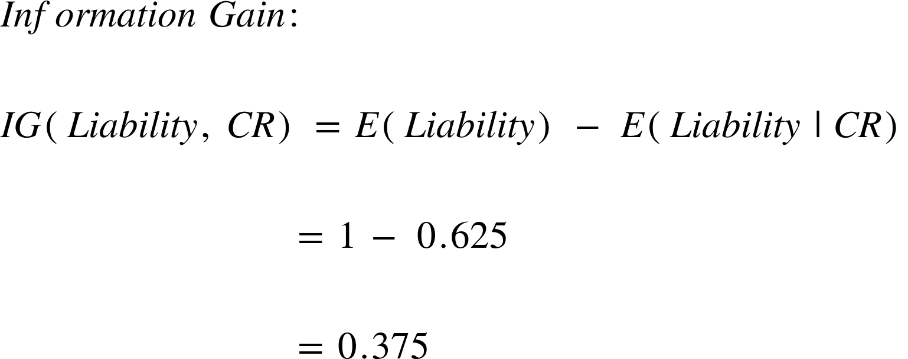

Knowing the Credit Rating helped us reduce the uncertainty around our target variable, Liability! Isn’t that what a good feature is supposed to do? Provide us information about our target variable? Well that’s exactly how and why decision trees use entropy and information gain to determine which feature to split their nodes on to get closer to predicting the target variable with each split and also to determine when to stop splitting the tree! (in addition to hyper-parameters like max depth of course). Let’s see this in action with another example using decision trees.

# Example: Decision Tree

Consider an example where we are building a decision tree to predict whether a loan given to a person would result in a write-off or not. Our entire population consists of 30 instances. 16 belong to the write-off class and the other 14 belong to the non-write-off class. We have two features, namely “Balance” that can take on two values -> “< 50K” or “>50K” and “Residence” that can take on three values -> “OWN”, “RENT” or “OTHER”. I’m going to show you how a decision tree algorithm would decide what attribute to split on first and what feature provides more information, or reduces more uncertainty about our target variable out of the two using the concepts of Entropy and Information Gain.

**Feature 1: Balance**

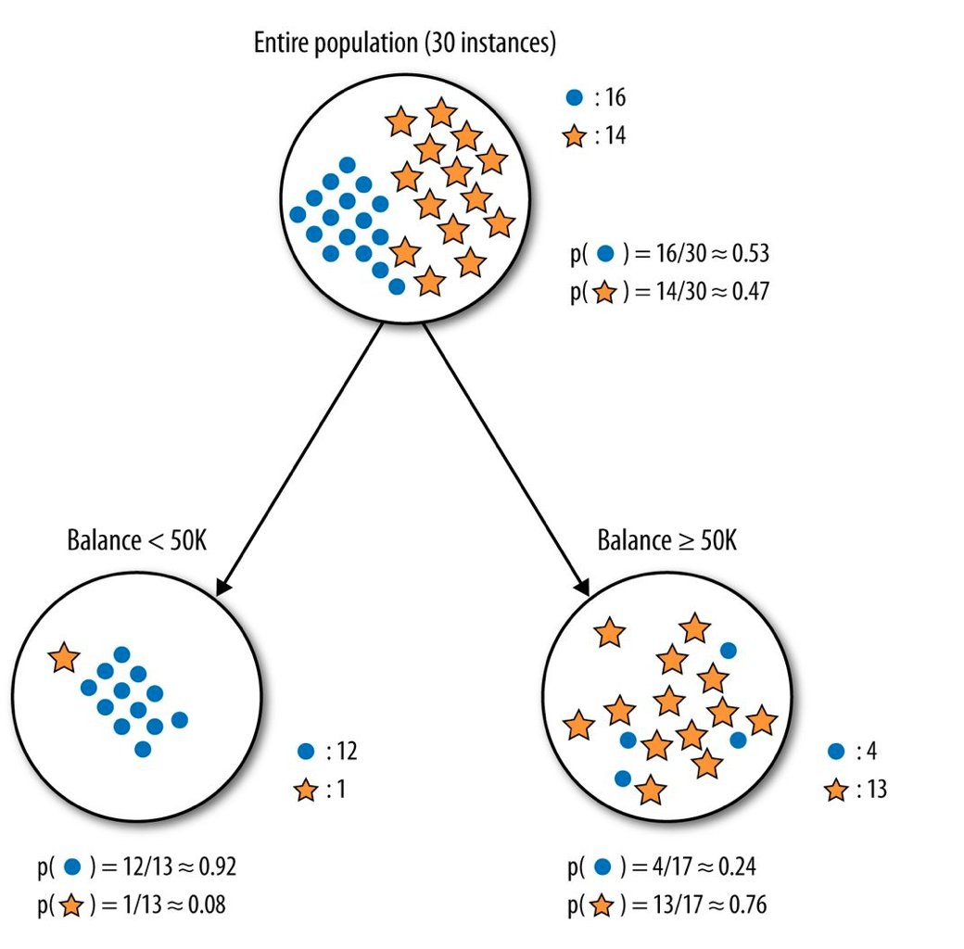

Provost, Foster; Fawcett, Tom. Data Science for Business: What You Need to Know about Data Mining and Data-Analytic Thinking

The dots are the data points with class right-off and the stars are the non-write-offs. Splitting the parent node on attribute balance gives us 2 child nodes. The left node gets 13 of the total observations with 12/13 (0.92 probability) observations from the write-off class and only 1/13(0.08 probability) observations from the non-write of class. The right node gets 17 of the total observation with 13/17(0.76 probability) observations from the non-write-off class and 4/17 (0.24 probability) from the write-off class.

Let’s calculate the entropy for the parent node and see how much uncertainty the tree can reduce by splitting on Balance.

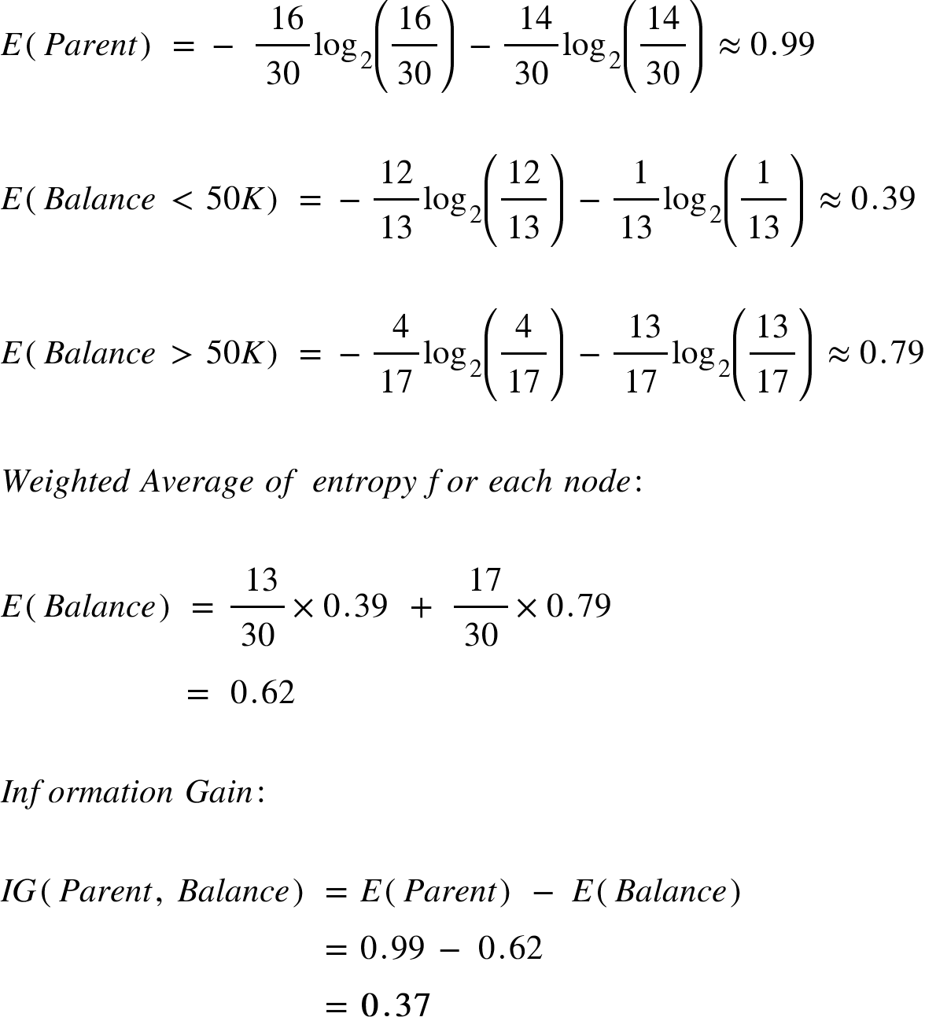

Splitting on feature, “Balance” leads to an information gain of 0.37 on our target variable. Let’s do the same thing for feature, “Residence” to see how it compares.

**Feature 2: Residence**

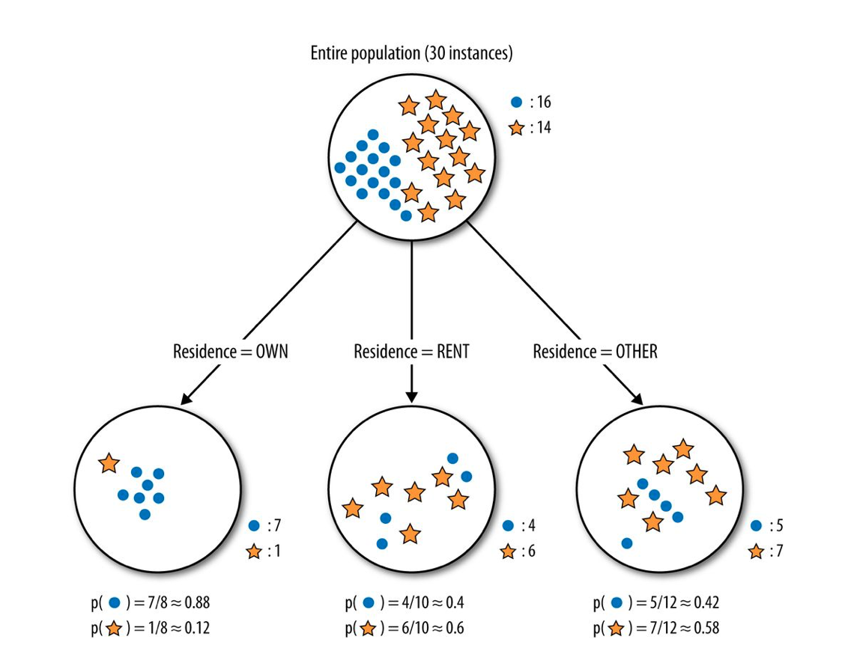

Provost, Foster; Fawcett, Tom. Data Science for Business: What You Need to Know about Data Mining and Data-Analytic Thinking

Splitting the tree on Residence gives us 3 child nodes. The left child node gets 8 of the total observations with 7/8 (0.88 probability) observations from the write-off class and only 1/8 (0.12 probability) observations from the non-write-off class. The middle child nodes gets 10 of the total observations with 4/10 (0.4 probability) observations of the write-off class and 6/10(0.6 probability) observations from the non-write-off class. The right child node gets 12 of the total observations with 5/12 (0.42 probability) observations from the write-off class and 7/12 (0.58) observations from the non-write-off class. We already know the entropy for the parent node. We simply need to calculate the entropy after the split to compute the information gain from “Residence”

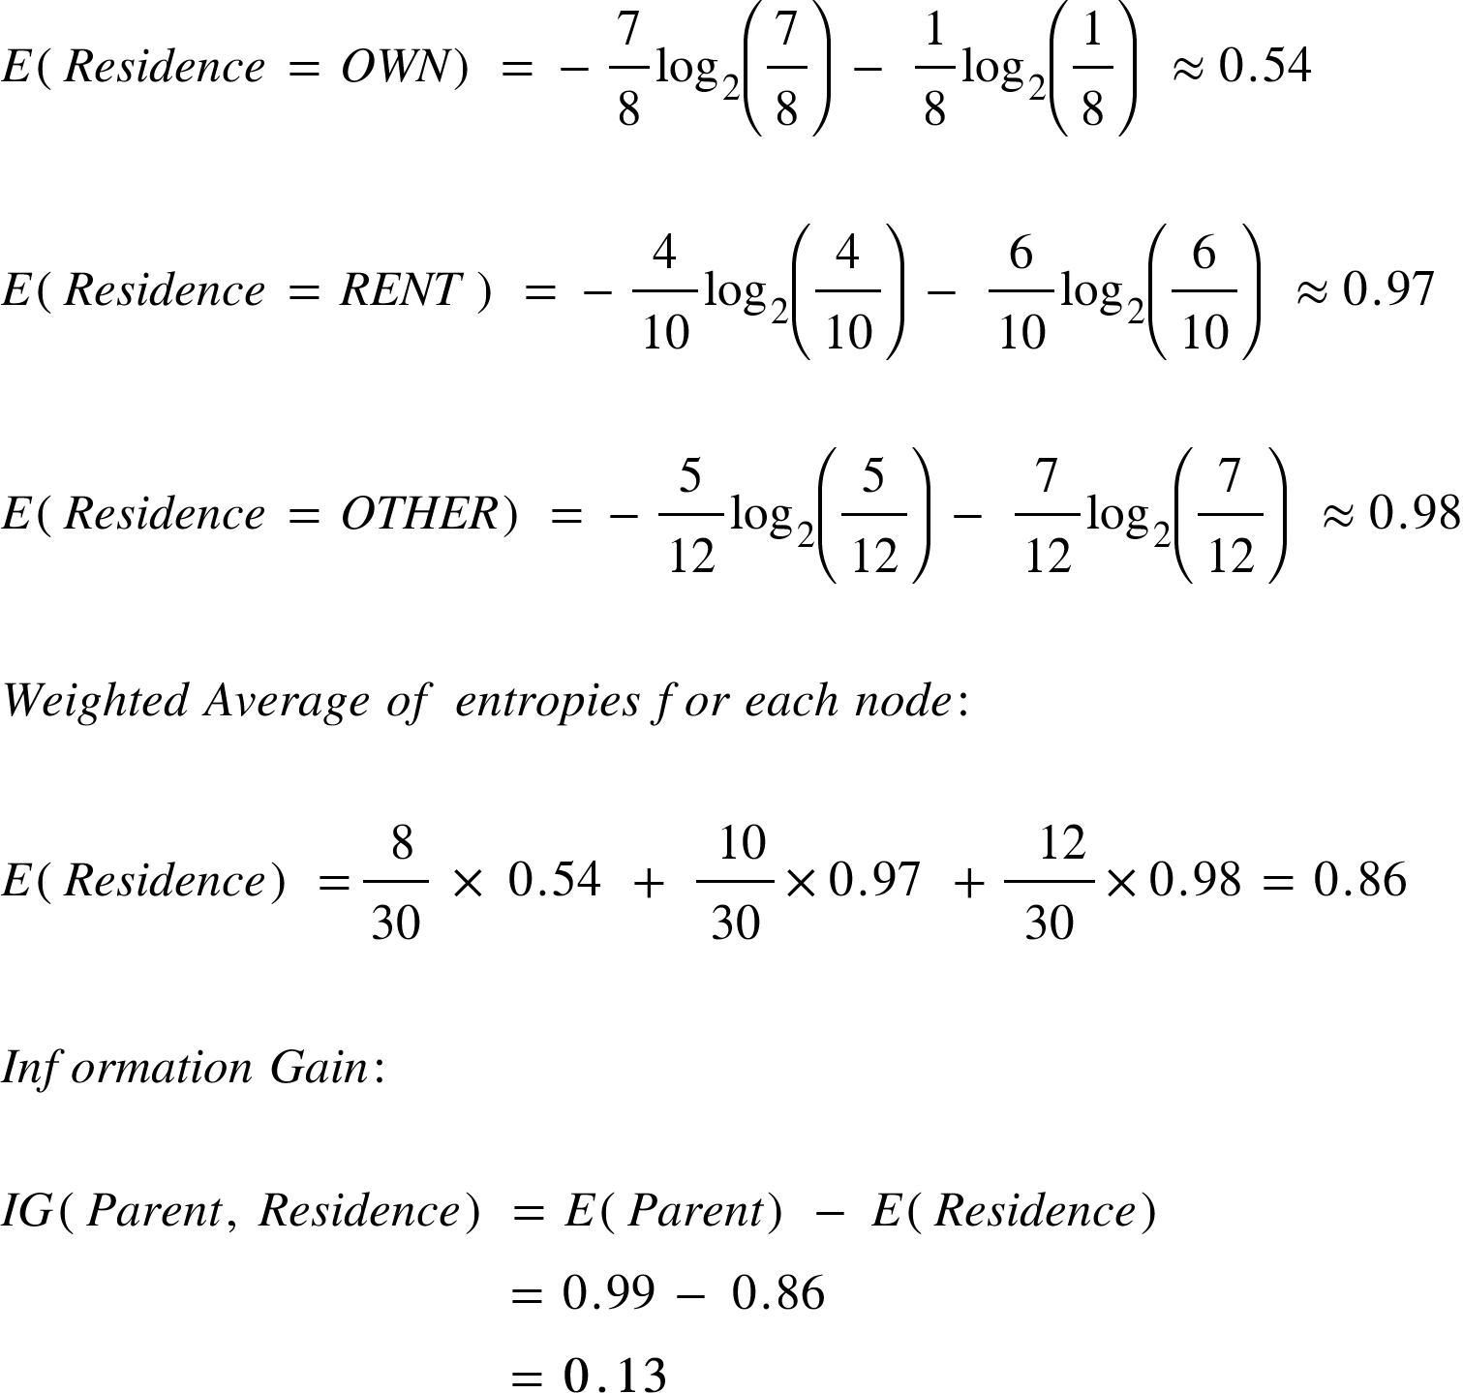

The information gain from feature, Balance is almost 3 times more than the information gain from Residence! If you go back and take a look at the graphs you can see that the child nodes from splitting on Balance do seem purer than those of Residence. However the left most node for residence is also very pure but this is where the weighted averages come in play. Even though that node is very pure, it has the least amount of the total observations and a result contributes a small portion of its purity when we calculate the total entropy from splitting on Residence. This is important because we’re looking for overall informative power of a feature and we don’t want our results to be skewed by a rare value in a feature.

By itself the feature, Balance provides more information about our target variable than Residence. It reduces more disorder in our target variable. A decision tree algorithm would use this result to make the first split on our data using Balance. From here on, the decision tree algorithm would use this process at every split to decide what feature it is going to split on next. In a real world scenario, with more than two features the first split is made on the most informative feature and then at every split the information gain for each additional feature needs to be recomputed because it would not be the same as the information gain from each feature by itself. The entropy and information gain would have to be calculated after one or more splits have already been made which would change the results. A decision tree would repeat this process as it grows deeper and deeper till either it reaches a pre-defined depth or no additional split can result in a higher information gain beyond a certain threshold which can also usually be specified as a hyper-parameter!

# ML | Classification vs Clustering

**Prerequisite:**[Classification](https://www.geeksforgeeks.org/getting-started-with-classification/) and [Clustering](https://www.geeksforgeeks.org/clustering-in-machine-learning/)

As you have read the articles about classification and clustering, here is the difference between them.

Both Classification and Clustering is used for the categorisation of objects into one or more classes based on the features. They appear to be a similar process as the basic difference is minute. In the case of Classification, there are predefined labels assigned to each input instances according to their properties whereas in clustering those labels are missing.

[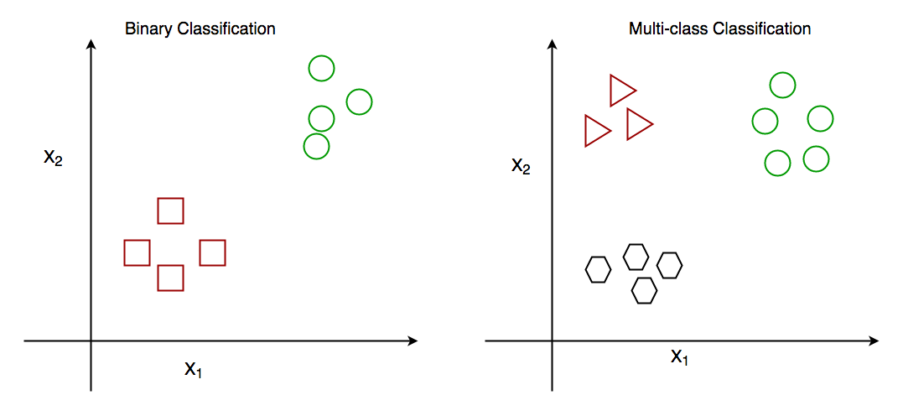](https://media.geeksforgeeks.org/wp-content/uploads/classification-1.png)

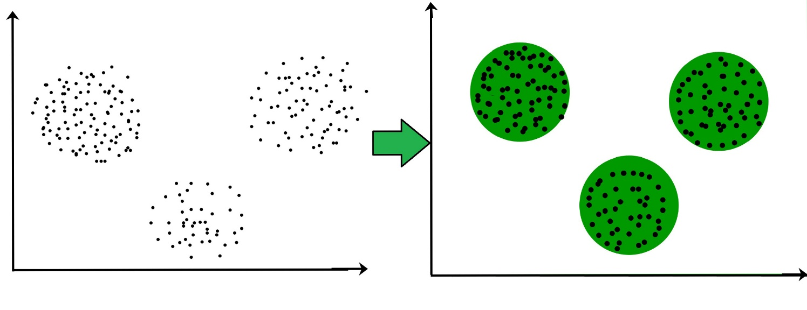

| **PARAMENTER** | **CLASSIFICATION** | **CLUSTERING** |
| --- | --- | --- |
| Type | used for supervised learning | used for unsupervised learning |
| Basic | process of classifying the input instances based on their corresponding class labels | grouping the instances based on their similarity without the help of class labels |
| Need | it has labels so there is need of training and testing dataset for verifying the model created | there is no need of training and testing dataset |
| Complexity | more complex as compared to clustering | less complex as compared to classification |
| Example Algorithms | Logistic regression, Naive Bayes classifier, Support vector machines etc. | k-means clustering algorithm, Fuzzy c-means clustering algorithm, Gaussian (EM) clustering algorithm etc. |

## Differences between Classification and Clustering

1. Classification is used for supervised learning whereas clustering is used for unsupervised learning.
2. The process of classifying the input instances based on their corresponding class labels is known as classification whereas grouping the instances based on their similarity without the help of class labels is known as clustering.
3. As Classification have labels so there is need of training and testing dataset for verifying the model created but there is no need for training and testing dataset in clustering.
4. Classification is more complex as compared to clustering as there are many levels in classification phase whereas only grouping is done in clustering.
5. Classification examples are Logistic regression, Naive Bayes classifier, Support vector machines etc. Whereas clustering examples are k-means clustering algorithm, Fuzzy c-means clustering algorithm, Gaussian (EM) clustering algorithm etc.

# Clustering

**Clustering** is one of the most common exploratory data analysis technique used to get an intuition about the structure of the data. It can be defined as the task of identifying subgroups in the data such that data points in the same subgroup (cluster) are very similar while data points in different clusters are very different. In other words, we try to find homogeneous subgroups within the data such that data points in each cluster are as similar as possible according to a similarity measure such as Euclidean-based distance or correlation-based distance. The decision of which similarity measure to use is application-specific.

Clustering analysis can be done on the basis of features where we try to find subgroups of samples based on features or on the basis of samples where we try to find subgroups of features based on samples. We’ll cover here clustering based on features. Clustering is used in market segmentation; where we try to fine customers that are similar to each other whether in terms of behaviours or attributes, image segmentation/compression; where we try to group similar regions together, document clustering based on topics, etc.

Unlike supervised learning, clustering is considered an unsupervised learning method since we don’t have the ground truth to compare the output of the clustering algorithm to the true labels to evaluate its performance. We only want to try to investigate the structure of the data by grouping the data points into distinct subgroups.

# K-means Algorithm

**K-means** algorithm is an iterative algorithm that tries to partition the dataset into *K* pre-defined distinct non-overlapping subgroups (clusters) where each data point belongs to **only one group**. It tries to make the inter-cluster data points as similar as possible while also keeping the clusters as different (far) as possible. It assigns data points to a cluster such that the sum of the squared distance between the data points and the cluster’s centroid (arithmetic mean of all the data points that belong to that cluster) is at the minimum. The less variation we have within clusters, the more homogeneous (similar) the data points are within the same cluster.

## The way k-means algorithm works is as follows:

1. Specify number of clusters K.
2. Initialize centroids by first shuffling the dataset and then randomly selecting K data points for the centroids without replacement.
3. Keep iterating until there is no change to the centroids. i.e assignment of data points to clusters isn’t changing.
4. Compute the sum of the squared distance between data points and all centroids.
5. Assign each data point to the closest cluster (centroid).
6. Compute the centroids for the clusters by taking the average of the all data points that belong to each cluster.

The approach k-means follows to solve the problem is called **Expectation-Maximization**. The E-step is assigning the data points to the closest cluster. The M-step is computing the centroid of each cluster. Below is a breakdown of how we can solve it mathematically (feel free to skip it).

The objective function is:

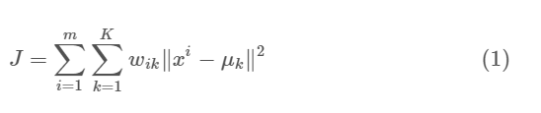

Where wik=1 for data point xi if it belongs to cluster *k*; otherwise, wik=0. Also, μk is the centroid of xi’s cluster.

It’s a minimization problem of two parts. We first minimize J w.r.t. wik and treat μk fixed. Then we minimize J w.r.t. μk and treat wik fixed. Technically speaking, we differentiate J w.r.t. wik first and update cluster assignments (*E-step*). Then we differentiate J w.r.t. μk and recomputed the centroids after the cluster assignments from previous step (*M-step*). Therefore, E-step is:

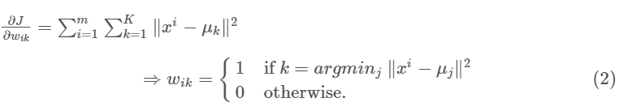

In other words, assign the data point xi to the closest cluster judged by its sum of squared distance from cluster’s centroid.

And M-step is:

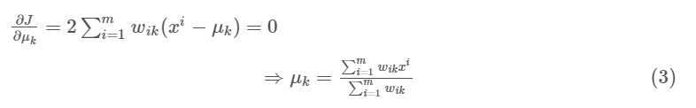

Which translates to re-computing the centroid of each cluster to reflect the new assignments.

Few things to note here:

* Since clustering algorithms including k-means use distance-based measurements to determine the similarity between data points, it’s recommended to standardize the data to have a mean of zero and a standard deviation of one since almost always the features in any dataset would have different units of measurements such as age vs income.
* Given k-means iterative nature and the random initialization of centroids at the start of the algorithm, different initializations may lead to different clusters since k-means algorithm may *stuck in a local optimum and may not converge to global optimum*. Therefore, it’s recommended to run the algorithm using different initializations of centroids and pick the results of the run that that yielded the lower sum of squared distance.
* Assignment of examples isn’t changing is the same thing as no change in within-cluster variation:

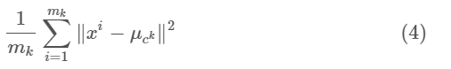

## Applications

k-means algorithm is very popular and used in a variety of applications such as market segmentation, document clustering, image segmentation and image compression, etc. The goal usually when we undergo a cluster analysis is either:

1. Get a meaningful intuition of the structure of the data we’re dealing with.
2. Cluster-then-predict where different models will be built for different subgroups if we believe there is a wide variation in the behaviours of different subgroups. An example of that is clustering patients into different subgroups and build a model for each subgroup to predict the probability of the risk of having heart attack.

we’ll apply clustering on two cases:

* Geyser eruptions segmentation (2D dataset).
* Image compression.

Check: <https://towardsdatascience.com/k-means-clustering-algorithm-applications-evaluation-methods-and-drawbacks-aa03e644b48a>

## Evaluation Methods

Contrary to supervised learning where we have the ground truth to evaluate the model’s performance, clustering analysis doesn’t have a solid evaluation metric that we can use to evaluate the outcome of different clustering algorithms. Moreover, since k-means requires *k* as an input and doesn’t learn it from data, there is no right answer in terms of the number of clusters that we should have in any problem. Sometimes domain knowledge and intuition may help but usually that is not the case. In the cluster-predict methodology, we can evaluate how well the models are performing based on different *K* clusters since clusters are used in the downstream modelling.

In this post we’ll cover two metrics that may give us some intuition about *k*:

* Elbow method
* Silhouette analysis

### Elbow Method

**Elbow** method gives us an idea on what a good *k* number of clusters would be based on the sum of squared distance (SSE) between data points and their assigned clusters’ centroids. We pick *k* at the spot where SSE starts to flatten out and forming an elbow. We’ll use the geyser dataset and evaluate SSE for different values of *k* and see where the curve might form an elbow and flatten out.

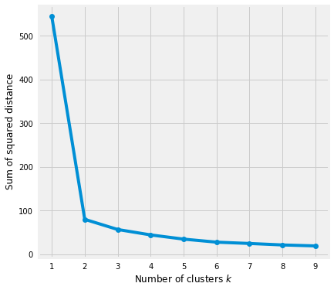

The graph above shows that k=2 is not a bad choice. Sometimes it’s still hard to figure out a good number of clusters to use because the curve is monotonically decreasing and may not show any elbow or has an obvious point where the curve starts flattening out.

### Silhouette Analysis

**Silhouette analysis** can be used to determine the degree of separation between clusters. For each sample:

* Compute the average distance from all data points in the same cluster (ai).
* Compute the average distance from all data points in the closest cluster (bi).
* Compute the coefficient:

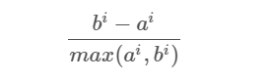

The coefficient can take values in the interval [-1, 1].

* If it is 0 –> the sample is very close to the neighbouring clusters.
* It it is 1 –> the sample is far away from the neighbouring clusters.
* It it is -1 –> the sample is assigned to the wrong clusters.

Therefore, we want the coefficients to be as big as possible and close to 1 to have a good clusters. We’ll use here geyser dataset again because its cheaper to run the silhouette analysis and it is actually obvious that there is most likely only two groups of data points.

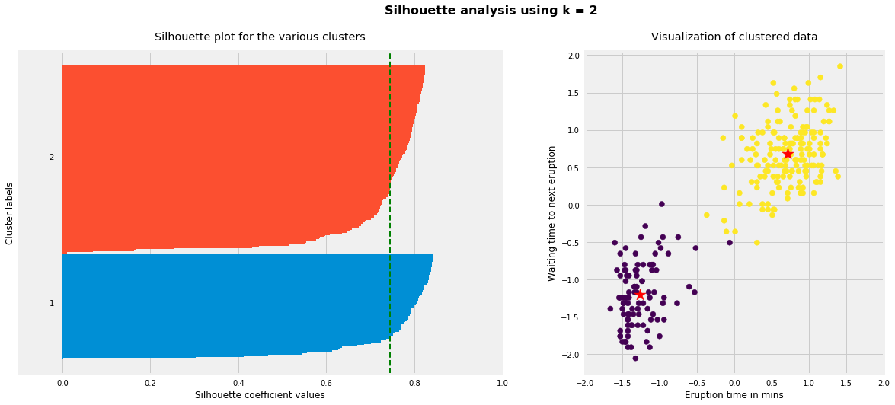

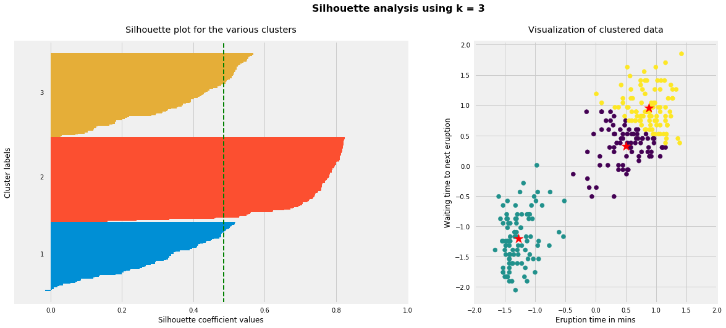

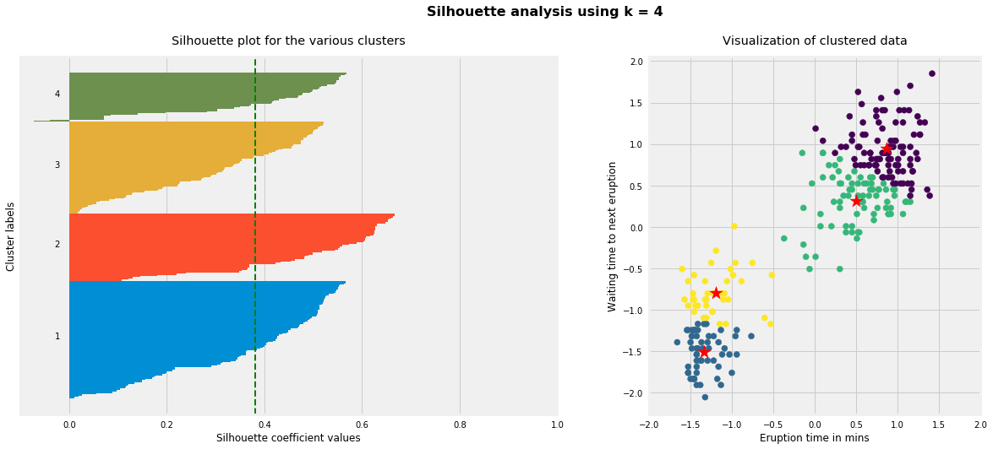

As the above plots show, n\_clusters=2 has the best average silhouette score of around 0.75 and all clusters being above the average shows that it is actually a good choice. Also, the thickness of the silhouette plot gives an indication of how big each cluster is. The plot shows that cluster 1 has almost double the samples than cluster 2. However, as we increased n\_clusters to 3 and 4, the average silhouette score decreased dramatically to around 0.48 and 0.39 respectively. Moreover, the thickness of silhouette plot started showing wide fluctuations. The bottom line is: Good n\_clusters will have a well above 0.5 silhouette average score as well as all of the clusters have higher than the average score.

## Drawbacks

K-means algorithm is good in capturing structure of the data if clusters have a spherical-like shape. It always try to construct a nice spherical shape around the centroid. That means, the minute the clusters have a complicated geometric shapes, k-means does a poor job in clustering the data. We’ll illustrate three cases where k-means will not perform well.

First, k-means algorithm doesn’t let data points that are far-away from each other share the same cluster even though they obviously belong to the same cluster. Below is an example of data points on two different horizontal lines that illustrates how k-means tries to group half of the data points of each horizontal lines together.

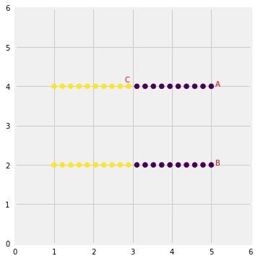

K-means considers the point ‘B’ closer to point ‘A’ than point ‘C’ since they have non-spherical shape. Therefore, points ‘A’ and ‘B’ will be in the same cluster but point ‘C’ will be in a different cluster. Note the **Single Linkage** hierarchical clustering method gets this right because it doesn’t separate similar points).

Second, we’ll generate data from multivariate normal distributions with different means and standard deviations. So we would have 3 groups of data where each group was generated from different multivariate normal distribution (different mean/standard deviation). One group will have a lot more data points than the other two combined. Next, we’ll run k-means on the data with K=3 and see if it will be able to cluster the data correctly. To make the comparison easier, I am going to plot first the data colored based on the distribution it came from. Then I will plot the same data but now colored based on the clusters they have been assigned to.

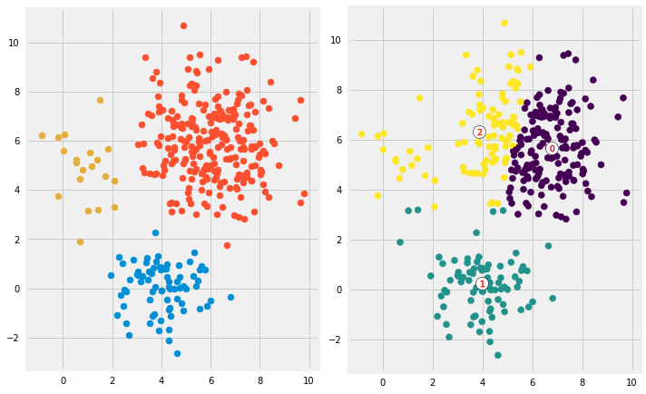

Looks like k-means couldn’t figure out the clusters correctly. Since it tries to minimize the within-cluster variation, it gives more weight to bigger clusters than smaller ones. In other words, data points in smaller clusters may be left away from the centroid in order to focus more on the larger cluster.

Last, we’ll generate data that have complicated geometric shapes such as moons and circles within each other and test k-means on both of the datasets.

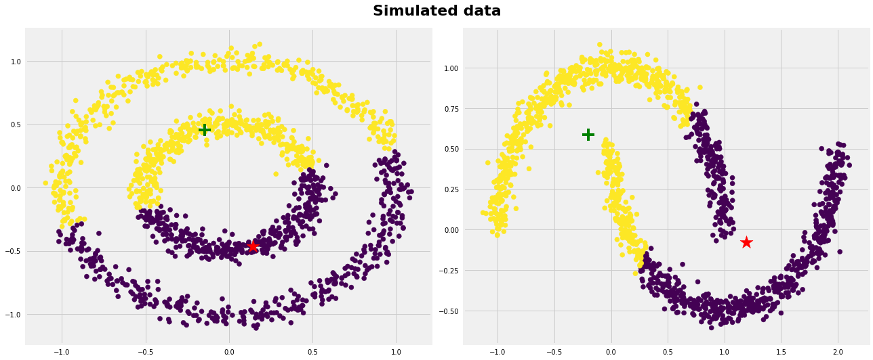

As expected, k-means couldn’t figure out the correct clusters for both datasets. However, we can help k-means perfectly cluster these kind of datasets if we use kernel methods. The idea is we transform to higher dimensional representation that make the data linearly separable (the same idea that we use in SVMs). Different kinds of algorithms work very well in such scenarios such as Spectral Clustering, see below:

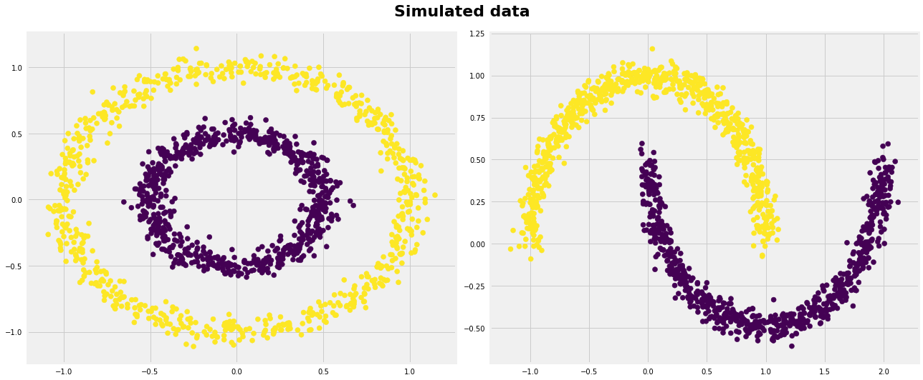

## Conclusion

K-means clustering is one of the most popular clustering algorithms and usually the first thing practitioners apply when solving clustering tasks to get an idea of the structure of the dataset. The goal of k-means is to group data points into distinct non-overlapping subgroups. It does a very good job when the clusters have a kind of spherical shapes. However, it suffers as the geometric shapes of clusters deviates from spherical shapes. Moreover, it also doesn’t learn the number of clusters from the data and requires it to be pre-defined. To be a good practitioner, it’s good to know the assumptions behind algorithms/methods so that you would have a pretty good idea about the strength and weakness of each method. This will help you decide when to use each method and under what circumstances. In this post, we covered both strength, weaknesses, and some evaluation methods related to k-means.

## Below are the main takeaways:

* Scale/standardize the data when applying k-means algorithm.
* Elbow method in selecting number of clusters doesn’t usually work because the error function is monotonically decreasing for all ks.
* K-means gives more weight to the bigger clusters.
* K-means assumes spherical shapes of clusters (with radius equal to the distance between the centroid and the furthest data point) and doesn’t work well when clusters are in different shapes such as elliptical clusters.
* If there is overlapping between clusters, k-means doesn’t have an intrinsic measure for uncertainty for the examples belong to the overlapping region in order to determine for which cluster to assign each data point.
* K-means may still cluster the data even if it can’t be clustered such as data that comes from uniform distributions.

# A Beginner’s Guide to Hierarchical Clustering and how to perform it in Python

## Introduction

It is crucial to understand customer behavior in any industry. I realized this last year when my chief marketing officer asked me – “Can you tell me which existing customers should we target for our new product?”

That was quite a learning curve for me. I quickly realized as a [data scientist](https://courses.analyticsvidhya.com/courses/applied-machine-learning-beginner-to-professional?utm_source=blog&utm_medium=beginners-guide-hierarchical-clustering) how important it is to segment customers so my organization can tailor and build targeted strategies. This is where the concept of clustering came in ever so handy!

Problems like segmenting customers are often deceptively tricky because we are not working with any target variable in mind. We are officially in the land of unsupervised learning where we need to figure out patterns and structures without a set outcome in mind. It’s both challenging and thrilling as a data scientist.

[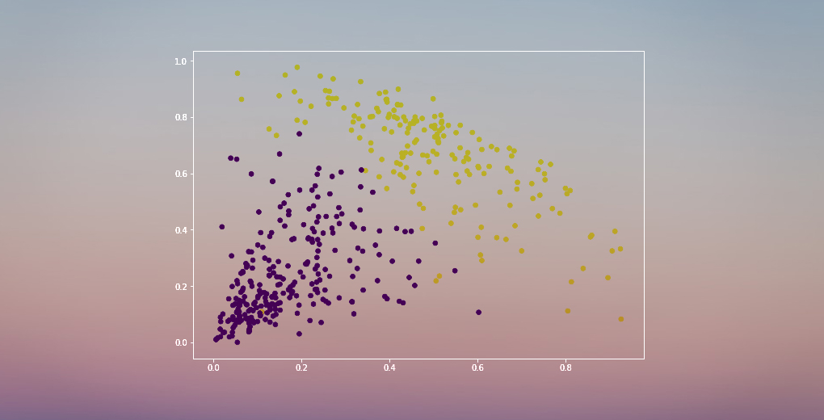](https://cdn.analyticsvidhya.com/wp-content/uploads/2019/05/hierarchical_clustering.jpg)

Now, there are a few different ways to perform clustering (as you’ll see below). I will introduce you to one such type in this article – hierarchical clustering.

We will learn what hierarchical clustering is, its advantage over the other clustering algorithms, the different types of hierarchical clustering and the steps to perform it. We will finally take up a customer segmentation dataset and then implement hierarchical clustering in Python. I love this technique and I’m sure you will too after this article!

Note: As mentioned, there are multiple ways to perform clustering. I encourage you to check out our awesome guide to the different types of clustering:

* [*An Introduction to Clustering and different methods of clustering*](https://www.analyticsvidhya.com/blog/2016/11/an-introduction-to-clustering-and-different-methods-of-clustering/?utm_source=blog&utm_medium=beginners-guide-hierarchical-clustering)

## Table of Contents

1. Supervised vs Unsupervised Learning
2. Why Hierarchical Clustering?
3. What is Hierarchical Clustering?
4. Types of Hierarchical Clustering
   1. Agglomerative Hierarchical Clustering
   2. Divisive Hierarchical Clustering
5. Steps to perform Hierarchical Clustering
6. How to Choose the Number of Clusters in Hierarchical Clustering?
7. Solving a Wholesale Customer Segmentation Problem using Hierarchical Clustering

## Supervised vs Unsupervised Learning

It’s important to understand the difference between supervised and unsupervised learning [unsupervised learning](https://courses.analyticsvidhya.com/courses/applied-machine-learning-beginner-to-professional?utm_source=blog&utm_medium=beginners-guide-hierarchical-clustering) before we dive into hierarchical clustering. Let me explain this difference using a simple example.

Suppose we want to estimate the count of bikes that will be rented in a city every day:

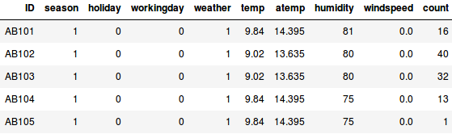

Or, let’s say we want to predict whether a person on board the Titanic survived or not:

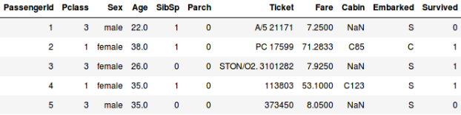

We have a fixed target to achieve in both these examples:

* In the first example, we have to predict the count of bikes based on features like the season, holiday, workingday, weather, temp, etc.
* We are predicting whether a passenger survived or not in the second example. In the ‘Survived’ variable, 0 represents that the person did not survive and 1 means the person did make it out alive. The independent variables here include Pclass, Sex, Age, Fare, etc.

*So, when we are given a target variable (count and Survival in the above two cases) which we have to predict based on a given set of predictors or independent variables (season, holiday, Sex, Age, etc.), such problems are called supervised learning problems.*

Let’s look at the figure below to understand this visually:

[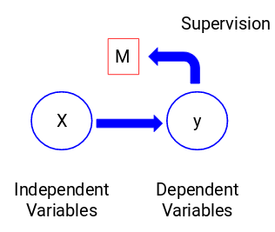](https://cdn.analyticsvidhya.com/wp-content/uploads/2019/05/Screenshot-from-2019-05-15-12-22-27.png)

Here, y is our dependent or target variable, and X represents the independent variables. The target variable is dependent on X and hence it is also called a dependent variable. **We train our model using the independent variables in the supervision of the target variable and hence the name supervised learning.**

Our aim, when training the model, is to generate a function that maps the independent variables to the desired target. Once the model is trained, we can pass new sets of observations and the model will predict the target for them. This, in a nutshell, is supervised learning.

*There might be situations when we do not have any target variable to predict. Such problems, without any explicit target variable, are known as unsupervised learning problems. We only have the independent variables and no target/dependent variable in these problems.*

[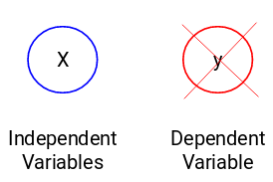](https://cdn.analyticsvidhya.com/wp-content/uploads/2019/05/Screenshot-from-2019-05-15-12-32-18.png)

We try to divide the entire data into a set of groups in these cases. These groups are known as clusters and the process of making these clusters is known as **clustering**.

[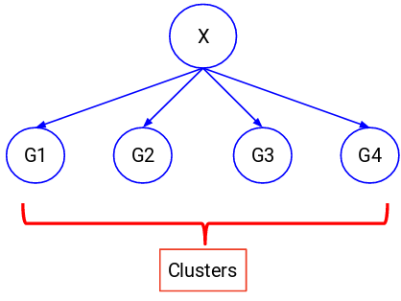](https://cdn.analyticsvidhya.com/wp-content/uploads/2019/05/Screenshot-from-2019-05-15-12-34-48.png)

This technique is generally used for clustering a population into different groups. A few common examples include segmenting customers, clustering similar documents together, recommending similar songs or movies, etc.

There are a LOT more applications of unsupervised learning. If you come across any interesting application, feel free to share them in the comments section below!

Now, there are various algorithms that help us to make these clusters. The most commonly used clustering algorithms are K-means and Hierarchical clustering.

## Why Hierarchical Clustering?

We should first know how K-means works before we dive into hierarchical clustering. Trust me, it will make the concept of hierarchical clustering all the more easier.

## Here’s a brief overview of how K-means works:

1. Decide the number of clusters (k)
2. Select k random points from the data as centroids
3. Assign all the points to the nearest cluster centroid
4. Calculate the centroid of newly formed clusters
5. Repeat steps 3 and 4

It is an iterative process. It will keep on running until the centroids of newly formed clusters do not change or the maximum number of iterations are reached.

But there are certain challenges with K-means. It always tries to make clusters of the same size. Also, we have to decide the number of clusters at the beginning of the algorithm. Ideally, we would not know how many clusters should we have, in the beginning of the algorithm and hence it a challenge with K-means.

This is a gap hierarchical clustering bridges with aplomb. It takes away the problem of having to pre-define the number of clusters. Sounds like a dream! So, let’s see what hierarchical clustering is and how it improves on K-means.

## **What is Hierarchical Clustering?**

Let’s say we have the below points and we want to cluster them into groups:

[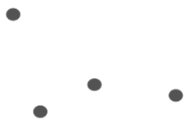](https://cdn.analyticsvidhya.com/wp-content/uploads/2019/05/Screenshot-from-2019-05-15-13-10-32.png)

We can assign each of these points to a separate cluster:

[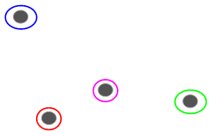](https://cdn.analyticsvidhya.com/wp-content/uploads/2019/05/Screenshot-from-2019-05-15-13-11-28.png)

Now, based on the similarity of these clusters, we can combine the most similar clusters together and repeat this process until only a single cluster is left:

[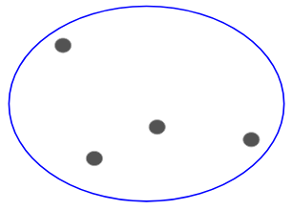](https://cdn.analyticsvidhya.com/wp-content/uploads/2019/05/Screenshot-from-2019-05-15-13-12-35.png)

We are essentially building a hierarchy of clusters. That’s why this algorithm is called hierarchical clustering. I will discuss how to decide the number of clusters in a later section. For now, let’s look at the different types of hierarchical clustering.

## Types of Hierarchical Clustering

There are mainly two types of hierarchical clustering:

1. Agglomerative hierarchical clustering
2. Divisive Hierarchical clustering

Let’s understand each type in detail.

### Agglomerative Hierarchical Clustering

We assign each point to an individual cluster in this technique. Suppose there are 4 data points. We will assign each of these points to a cluster and hence will have 4 clusters in the beginning:

[](https://cdn.analyticsvidhya.com/wp-content/uploads/2019/05/Screenshot-from-2019-05-15-13-11-28.png)

Then, at each iteration, we merge the closest pair of clusters and repeat this step until only a single cluster is left:

[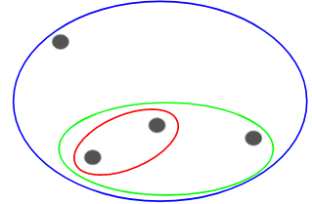](https://cdn.analyticsvidhya.com/wp-content/uploads/2019/05/Screenshot-from-2019-05-15-13-31-06.png)

We are merging (or adding) the clusters at each step, right? Hence, this type of clustering is also known as **additive hierarchical clustering.**

### Divisive Hierarchical Clustering

Divisive hierarchical clustering works in the opposite way. Instead of starting with n clusters (in case of n observations), we start with a single cluster and assign all the points to that cluster.

So, it doesn’t matter if we have 10 or 1000 data points. All these points will belong to the same cluster at the beginning:

[](https://cdn.analyticsvidhya.com/wp-content/uploads/2019/05/Screenshot-from-2019-05-15-13-12-35.png)

Now, at each iteration, we split the farthest point in the cluster and repeat this process until each cluster only contains a single point:



We are splitting (or dividing) the clusters at each step, hence the name divisive hierarchical clustering.

Agglomerative Clustering is widely used in the industry and that will be the focus in this article. Divisive hierarchical clustering will be a piece of cake once we have a handle on the agglomerative type.

## Steps to Perform Hierarchical Clustering

We merge the most similar points or clusters in hierarchical clustering – we know this. Now the question is – how do we decide which points are similar and which are not? It’s one of the most important questions in clustering!

Here’s one way to calculate similarity – Take the distance between the centroids of these clusters. The points having the least distance are referred to as similar points and we can merge them. We can refer to this as a **distance-based algorithm** as well (since we are calculating the distances between the clusters).

In hierarchical clustering, we have a concept called a **proximity matrix**. This stores the distances between each point. Let’s take an example to understand this matrix as well as the steps to perform hierarchical clustering.

Setting up the Example

Suppose a teacher wants to divide her students into different groups. She has the marks scored by each student in an assignment and based on these marks, she wants to segment them into groups. There’s no fixed target here as to how many groups to have. Since the teacher does not know what type of students should be assigned to which group, it cannot be solved as a supervised learning problem. So, we will try to apply hierarchical clustering here and segment the students into different groups.

Let’s take a sample of 5 students:

[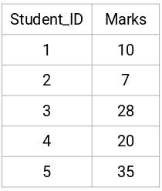](https://cdn.analyticsvidhya.com/wp-content/uploads/2019/05/Screenshot-from-2019-05-17-16-12-33.png)

## Creating a Proximity Matrix

First, we will create a proximity matrix which will tell us the distance between each of these points. Since we are calculating the distance of each point from each of the other points, we will get a square matrix of shape n X n (where n is the number of observations).

Let’s make the 5 x 5 proximity matrix for our example:

[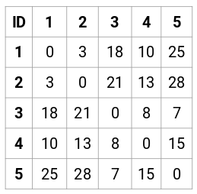](https://cdn.analyticsvidhya.com/wp-content/uploads/2019/05/Screenshot-from-2019-05-15-14-46-36.png)

The diagonal elements of this matrix will always be 0 as the distance of a point with itself is always 0. We will use the Euclidean distance formula to calculate the rest of the distances. So, let’s say we want to calculate the distance between point 1 and 2:

√(10-7)^2 = √9 = 3

Similarly, we can calculate all the distances and fill the proximity matrix.

## Steps to Perform Hierarchical Clustering

**Step 1:** First, we assign all the points to an individual cluster:

[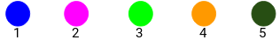](https://cdn.analyticsvidhya.com/wp-content/uploads/2019/05/Screenshot-from-2019-05-15-14-54-20.png)

Different colors here represent different clusters. You can see that we have 5 different clusters for the 5 points in our data.

**Step 2:** Next, we will look at the smallest distance in the proximity matrix and merge the points with the smallest distance. We then update the proximity matrix:

[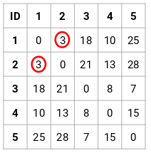](https://cdn.analyticsvidhya.com/wp-content/uploads/2019/05/Screenshot-from-2019-05-15-14-57-30.png)

Here, the smallest distance is 3 and hence we will merge point 1 and 2:

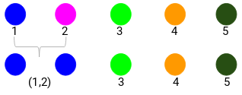

Let’s look at the updated clusters and accordingly update the proximity matrix:

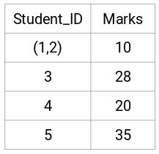

Here, we have taken the maximum of the two marks (7, 10) to replace the marks for this cluster. Instead of the maximum, we can also take the minimum value or the average values as well. Now, we will again calculate the proximity matrix for these clusters:

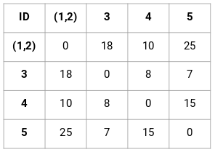

**Step 3:** We will repeat step 2 until only a single cluster is left.

So, we will first look at the minimum distance in the proximity matrix and then merge the closest pair of clusters. We will get the merged clusters as shown below after repeating these steps:

[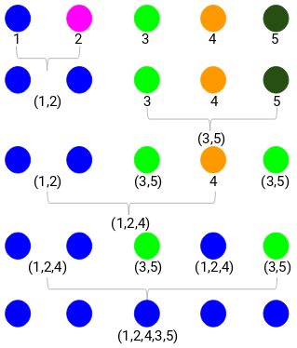](https://cdn.analyticsvidhya.com/wp-content/uploads/2019/05/Screenshot-from-2019-05-15-15-03-17.png)

We started with 5 clusters and finally have a single cluster. **This is how agglomerative hierarchical clustering works**. But the burning question still remains – how do we decide the number of clusters? Let’s understand that in the next section.

## How should we choose the Number of Clusters in Hierarchical Clustering?

Ready to finally answer this question that’s been hanging around since we started learning? To get the number of clusters for hierarchical clustering, we make use of an awesome concept called a **Dendrogram**.

*A dendrogram is a tree-like diagram that records the sequences of merges or splits.*

Let’s get back to our teacher-student example. Whenever we merge two clusters, a dendrogram will record the distance between these clusters and represent it in graph form. Let’s see how a dendrogram looks like:

[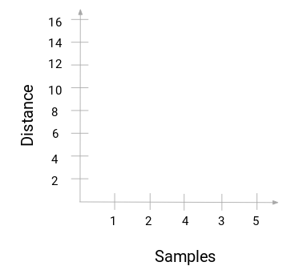](https://cdn.analyticsvidhya.com/wp-content/uploads/2019/05/Screenshot-from-2019-05-16-17-11-39.png)

We have the samples of the dataset on the x-axis and the distance on the y-axis. **Whenever two clusters are merged, we will join them in this dendrogram and the height of the join will be the distance between these points.** Let’s build the dendrogram for our example:

[](https://cdn.analyticsvidhya.com/wp-content/uploads/2019/05/Screenshot-from-2019-05-15-15-03-17.png)

Take a moment to process the above image. We started by merging sample 1 and 2 and the distance between these two samples was 3 (refer to the first proximity matrix in the previous section). Let’s plot this in the dendrogram:

[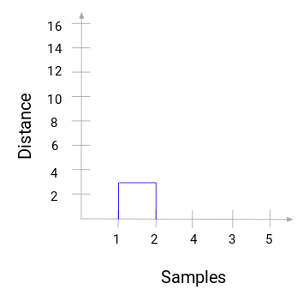](https://cdn.analyticsvidhya.com/wp-content/uploads/2019/05/Screenshot-from-2019-05-16-18-06-37.png)

Here, we can see that we have merged sample 1 and 2. The vertical line represents the distance between these samples. Similarly, we plot all the steps where we merged the clusters and finally, we get a dendrogram like this:

[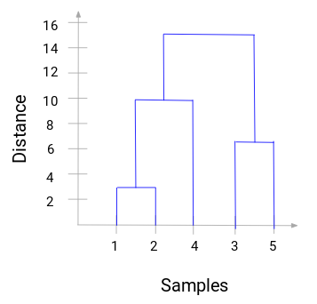](https://cdn.analyticsvidhya.com/wp-content/uploads/2019/05/Screenshot-from-2019-05-16-18-10-06.png)

We can clearly visualize the steps of hierarchical clustering. **More the distance of the vertical lines in the dendrogram, more the distance between those clusters.**

Now, we can set a threshold distance and draw a horizontal line (Generally, we try to set the threshold in such a way that it cuts the tallest vertical line). Let’s set this threshold as 12 and draw a horizontal line:

[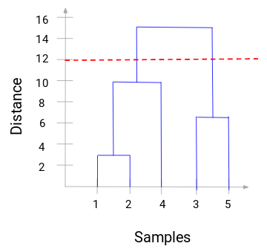](https://cdn.analyticsvidhya.com/wp-content/uploads/2019/05/Screenshot-from-2019-05-16-18-12-55.png)

**The number of clusters will be the number of vertical lines which are being intersected by the line drawn using the threshold.** In the above example, since the red line intersects 2 vertical lines, we will have 2 clusters. One cluster will have a sample (1,2,4) and the other will have a sample (3,5). Pretty straightforward, right?

This is how we can decide the number of clusters using a dendrogram in Hierarchical Clustering. In the next section, we will implement hierarchical clustering which will help you to understand all the concepts that we have learned in this article.

## End Notes

Hierarchical clustering is a super useful way of segmenting observations. The advantage of not having to pre-define the number of clusters gives it quite an edge over k-Means.

If you are still relatively new to data science, I highly recommend taking the [**Applied Machine Learning**](https://courses.analyticsvidhya.com/courses/applied-machine-learning-beginner-to-professional?utm_source=blog&utm_medium=beginners-guide-hierarchical-clustering) course. It is one of the most comprehensive end-to-end machine learning courses you will find anywhere. Hierarchical clustering is just one of a diverse range of topics we cover in the course.

What are your thoughts on hierarchical clustering? Do you feel there’s a better way to create clusters using less computational resources? Connect with me in the comments section below and let’s discuss!

Check: <https://www.analyticsvidhya.com/blog/2019/05/beginners-guide-hierarchical-clustering/>

# **DBSCAN**

**Density-based spatial clustering of applications with noise (DBSCAN)** is a well-known data clustering algorithm that is commonly used in data mining and machine learning.

Based on a set of points (let’s think in a bidimensional space as exemplified in the figure), DBSCAN groups together points that are close to each other based on a distance measurement (usually Euclidean distance) and a minimum number of points. It also marks as outliers the points that are in low-density regions.

## Parameters:

The DBSCAN algorithm basically requires 2 parameters:

***eps****: specifies how close points should be to each other to be considered a part of a cluster. It means that if the distance between two points is lower or equal to this value (eps), these points are considered neighbors.*

***minPoints****: the minimum number of points to form a dense region. For example, if we set the minPoints parameter as 5, then we need at least 5 points to form a dense region.*

## Parameter estimation:

The parameter estimation is a problem for every data mining task. To choose good parameters we need to understand how they are used and have at least a basic previous knowledge about the data set that will be used.

***eps****: if the eps value chosen is too small, a large part of the data will not be clustered. It will be considered outliers because don’t satisfy the number of points to create a dense region. On the other hand, if the value that was chosen is too high, clusters will merge and the majority of objects will be in the same cluster. The eps should be chosen based on the distance of the dataset (we can use a k-distance graph to find it), but in general small eps values are preferable.*

***minPoints****: As a general rule, a minimum minPoints can be derived from a number of dimensions (D) in the data set, as minPoints ≥ D + 1. Larger values are usually better for data sets with noise and will form more significant clusters. The minimum value for the minPoints must be 3, but the larger the data set, the larger the minPoints value that should be chosen.*

You can find more about parameter estimation [here](https://en.wikipedia.org/wiki/DBSCAN#Parameter_estimation).

## Why should we use DBSCAN?

The DBSCAN algorithm should be used to find associations and structures in data that are hard to find manually but that can be relevant and useful to find patterns and predict trends.

Clustering methods are usually used in biology, medicine, social sciences, archaeology, marketing, characters recognition, management systems and so on.

Let’s think in a practical use of DBSCAN. Suppose we have an e-commerce and we want to improve our sales by recommending relevant products to our customers. We don’t know exactly what our customers are looking for but based on a data set we can predict and recommend a relevant product to a specific customer. We can apply the DBSCAN to our data set (based on the e-commerce database) and find clusters based on the products that the users have bought. Using this clusters we can find similarities between customers, for example, the customer A have bought 1 pen, 1 book and 1 scissors and the customer B have bought 1 book and 1 scissors, then we can recommend 1 pen to the customer B. This is just a little example of use of DBSCAN, but it can be used in a lot of applications in several areas.

## Highlights of DBSCAN

* does not require the user to set the number of clusters a priori
* can capture clusters of complex shapes
* can identify points that are not part of any cluster (very useful as outliers detector)
* Is somewhat slower than agglomerative clustering and k-means, but still scales to relatively large datasets.
* works by identifying points that are in crowded regions of the feature space, where many data points are close together (dense regions in feature space)
* Points that are within a dense region are called core samples (or core points)
* There are two parameters in DBSCAN: min\_samples and eps
* If there are at least min\_samples many data points within a distance of eps to a given data point, that data point is classified as a core sample
* core samples that are closer to each other than the distance eps are put into the same cluster by DBSCAN.

# What are Dimension Reduction techniques?

Dimension Reduction refers to the process of converting a set of data having vast dimensions into data with lesser dimensions ensuring that it conveys similar information concisely. These techniques are typically used while solving **machine learning problems** to obtain better features for a classification or regression task.

Let’s look at the image shown below. It shows 2 dimensions x1 and x2, which are let us say measurements of several object in cm (x1) and inches (x2). Now, if you were to use both these dimensions in machine learning, they will convey similar information and introduce a lot of noise in system, so you are better of just using one dimension. Here we have converted the dimension of data from 2D (from x1 and x2) to 1D (z1), which has made the data relatively easier to explain.

[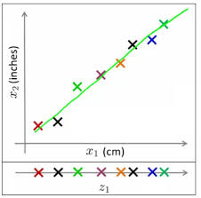](https://www.analyticsvidhya.com/wp-content/uploads/2015/07/2D_1D.jpg)

In similar ways, we can reduce n dimensions of data set to k dimensions (k < n) . These k dimensions can be directly identified (filtered) or can be a combination of dimensions (weighted averages of dimensions) or new dimension(s) that represent existing multiple dimensions well.

One of the most common application of this technique is **Image processing**. You might have come across this Facebook application – “[**Which Celebrity Do You Look Like?**](https://apps.facebook.com/qbquiz-fntbv/)“. But, have you ever thought about the algorithm used behind this?

Here’s the answer: To identify the matched celebrity image, we use pixel data and each pixel is equivalent to one dimension. In every image, there are high number of pixels i.e. high number of dimensions. And every dimension is important here. You can’t omit dimensions randomly to make better sense of your overall data set. In such cases, dimension reduction techniques help you to find the significant dimension(s) using various method(s). We’ll discuss these methods shortly.

## What are the benefits of Dimension Reduction?

Let’s look at the benefits of applying Dimension Reduction process:

* It helps in data compressing and reducing the storage space required
* It fastens the time required for performing same computations. Less dimensions leads to less computing, also less dimensions can allow usage of algorithms unfit for a large number of dimensions
* It takes care of multi-collinearity that improves the model performance. It removes redundant features. For example: there is no point in storing a value in two different units (meters and inches).
* Reducing the dimensions of data to 2D or 3D may allow us to plot and visualize it precisely. You can then observe patterns more clearly. Below you can see that, how a 3D data is converted into 2D. First it has identified the 2D plane then represented the points on these two new axis z1 and z2.  
  [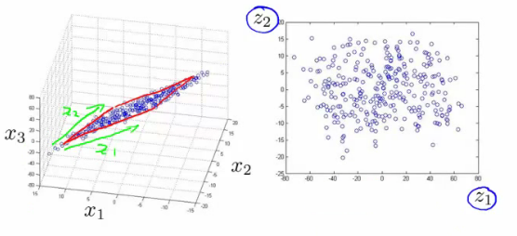](https://www.analyticsvidhya.com/wp-content/uploads/2015/07/Image-4.png)
* It is helpful in noise removal also and as result of that we can improve the performance of models.

## What are the common methods to perform Dimension Reduction?

There are many methods to perform Dimension reduction. I have listed the most common methods below:

**1.**[**Missing Values:**](https://www.analyticsvidhya.com/blog/2015/02/7-steps-data-exploration-preparation-building-model-part-2/)While exploring data, if we encounter missing values, what we do? Our first step should be to identify the reason then impute missing values/ drop variables using appropriate methods. But, what if we have too many missing values? Should we impute [missing values](http://discuss.analyticsvidhya.com/t/what-should-be-the-allowed-percentage-of-missing-values/2456/2) or drop the variables?

I would prefer the latter, because it would not have lot more details about data set. Also, it would not help in improving the power of model. Next question, is there any threshold of missing values for dropping a variable? It varies from case to case. If the information contained in the variable is not that much, you can drop the variable if it has more than ~40-50% missing values.

**2. Low Variance:**Let’s think of a scenario where we have a constant variable (all observations have same value, 5) in our data set. Do you think, it can improve the power of model? Ofcourse NOT, because it has zero variance. In case of high number of dimensions, we should drop variables having low variance compared to others because these variables will not explain the variation in target variables.

**3.**[**Decision Trees:**](https://www.analyticsvidhya.com/blog/2015/01/decision-tree-simplified/)It is one of my favorite techniques. It can be used as a ultimate solution to tackle multiple challenges like missing values, outliers and identifying significant variables. It worked well in our Data Hackathon also. Several data scientists used decision tree and it worked well for them.

**4.**[**Random Forest:**](https://www.analyticsvidhya.com/blog/2014/06/introduction-random-forest-simplified/)Similar to decision tree is Random Forest. I would also recommend using the in-built feature importance provided by random forests to select a smaller subset of input features. Just be careful that random forests have a tendency to bias towards variables that have more no. of distinct values i.e. favor numeric variables over binary/categorical values.

**5. High Correlation:**Dimensions exhibiting higher correlation can lower down the performance of model. Moreover, it is not good to have multiple variables of similar information or variation also known as **“Multicollinearity”.** You can use Pearson (continuous variables) or Polychoric (discrete variables) correlation matrix to identify the variables with high correlation and select one of them using [VIF](https://en.wikipedia.org/wiki/Variance_inflation_factor) (Variance Inflation Factor). Variables having higher value ( VIF > 5 ) can be dropped.

**6. Backward Feature Elimination:**In this method, we start with all n dimensions. Compute the sum of square of error (SSR) after eliminating each variable (n times). Then, identifying variables whose removal has produced the smallest increase in the SSR and removing it finally, leaving us with n-1 input features.

Repeat this process until no other variables can be dropped. Recently in [Online Hackathon organised by Analytics Vidhya (11-12 Jun’15)](http://discuss.analyticsvidhya.com/t/data-hackathon-online-11th-12th-july-2015-register-here/1599), Data scientist who held second position used Backward Feature Elimination in linear regression to train his model.  
Reverse to this, we can use “**Forward Feature Selection**” method. In this method, we select one variable and analyse the performance of model by adding another variable. Here, selection of variable is based on higher improvement in model performance.

**7. Factor Analysis:**Let’s say some variables are highly correlated. These variables can be grouped by their correlations i.e. all variables in a particular group can be highly correlated among themselves but have low correlation with variables of other group(s). Here each group represents a single underlying construct or factor. These factors are small in number as compared to large number of dimensions. However, these factors are difficult to observe. There are basically two methods of performing factor analysis:

* EFA (Exploratory Factor Analysis)
* CFA (Confirmatory Factor Analysis)

**8. Principal Component Analysis (PCA):**In this technique, variables are transformed into a new set of variables, which are linear combination of original variables. These new set of variables are known as **principle components.** They are obtained in such a way that first principle component accounts for most of the possible variation of original data after which each succeeding component has the highest possible variance.

The second principal component must be orthogonal to the first principal component. In other words, it does its best to capture the variance in the data that is not captured by the first principal component. For two-dimensional dataset, there can be only two principal components. Below is a snapshot of the data and its first and second principal components. You can notice that second principle component is orthogonal to first principle component.[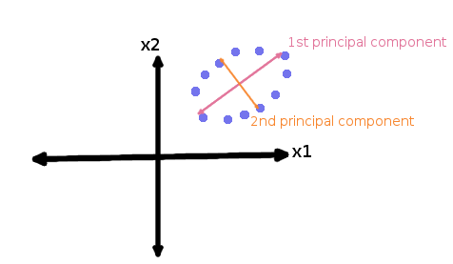](https://www.analyticsvidhya.com/wp-content/uploads/2015/07/PCA.png)The principal components are sensitive to the scale of measurement, now to fix this issue we should always standardize variables before applying PCA. Applying PCA to your data set loses its meaning. If interpretability of the results is important for your analysis, PCA is not the right technique for your project.

## Is Dimension Reduction Good or Bad?

Recently, we received this question on our data science forum. Here’s the complete [answer](http://discuss.analyticsvidhya.com/t/dimensionality-reduction-is-good-or-bad/2444/4).

## End Note

In this article, we looked at the simplified version of Dimension Reduction covering its importance, benefits, the commonly methods and the discretion as to when to choose a particular technique. In future post, I would write about the PCA and Factor analysis in more detail.

Did you find the article useful? Do let us know your thoughts about this article in the comment box below. I would also want to know which dimension reduction technique you use most and why?

# Principal Component Analysis with Python

**Principal Component Analyis** is basically a statistical procedure to convert a set of observation of possibly correlated variables into a set of values of linearly uncorrelated variables.  
Each of the principal components is chosen in such a way so that it would describe most of the still available variance and all these principal components are orthogonal to each other. In all principal components first principal component has maximum variance.

## Uses of PCA:

* It is used to find inter-relation between variables in the data.
* It is used to interpret and visualize data.
* As number of variables are decreasing it makes further analysis simpler.
* It’s often used to visualize genetic distance and relatedness between populations.

These are basically performed on square symmetric matrix. It can be a pure sums of squares and cross products matrix or Covariance matrix or Correlation matrix. A correlation matrix is used if the individual variance differs much.

## Objectives of PCA:

* It is basically a non-dependent procedure in which it reduces attribute space from a large number of variables to a smaller number of factors.
* PCA is basically a dimension reduction process but there is no guarantee that the dimension is interpretable.
* Main task in this PCA is to select a subset of variables from a larger set, based on which original variables have the highest correlation with the principal amount.

**Principal Axis Method:** PCA basically search a linear combination of variables so that we can extract maximum variance from the variables. Once this process completes it removes it and search for another linear combination which gives an explanation about the maximum proportion of remaining variance which basically leads to orthogonal factors. In this method, we analyze total variance.

**Eigenvector:** It is a non-zero vector that stays parallel after matrix multiplication. Let’s suppose x is eigen vector of dimension r of matrix M with dimension r\*r if Mx and x are parallel. Then we need to solve Mx=Ax where both x and A are unknown to get eigen vector and eigen values.  
Under Eigen-Vectors we can say that Principal components show both common and unique variance of the variable. Basically, it is variance focused approach seeking to reproduce total variance and correlation with all components. The principal components are basically the linear combinations of the original variables weighted by their contribution to explain the variance in a particular orthogonal dimension.

**Eigen Values:** It is basically known as characteristic roots. It basically measures the variance in all variables which is accounted for by that factor. The ratio of eigenvalues is the ratio of explanatory importance of the factors with respect to the variables. If the factor is low then it is contributing less in explanation of variables. In simple words, it measures the amount of variance in the total given database accounted by the factor. We can calculate the factor’s eigen value as the sum of its squared factor loading for all the variables.

Now, let’s understand Principal Component Analysis with Python.

To get the dataset used in the implementation, click [here](https://media.geeksforgeeks.org/wp-content/uploads/Wine.csv).

**Step 1:** Importing the libraries

filter\_none

brightness\_4

|  |
| --- |
| # importing required libraries  import numpy as np  import matplotlib.pyplot as plt  import pandas as pd |

**Step 2:** Importing the data set

Import the dataset and distributing the dataset into X and y components for data analysis.

filter\_none

brightness\_4

|  |
| --- |
| # importing or loading the dataset  dataset = pd.read\_csv('wines.csv')    # distributing the dataset into two components X and Y  X = dataset.iloc[:, 0:13].values  y = dataset.iloc[:, 13].values |

**Step 3:** Splitting the dataset into the Training set and Test set

filter\_none

brightness\_4

|  |
| --- |
| # Splitting the X and Y into the  # Training set and Testing set  from sklearn.model\_selection import train\_test\_split    X\_train, X\_test, y\_train, y\_test = train\_test\_split(X, y, test\_size = 0.2, random\_state = 0) |

**Step 4:** Feature Scaling

Doing the pre-processing part on training and testing set such as fitting the Standard scale.

filter\_none

brightness\_4

|  |
| --- |
| # performing preprocessing part  from sklearn.preprocessing import StandardScaler  sc = StandardScaler()    X\_train = sc.fit\_transform(X\_train)  X\_test = sc.transform(X\_test) |

**Step 5:**Applying PCA function

Applying the PCA function into training and testing set for analysis.

filter\_none

brightness\_4

|  |
| --- |
| # Applying PCA function on training  # and testing set of X component  from sklearn.decomposition import PCA    pca = PCA(n\_components = 2)    X\_train = pca.fit\_transform(X\_train)  X\_test = pca.transform(X\_test)    explained\_variance = pca.explained\_variance\_ratio\_ |

**Step 6:**Fitting Logistic Regression To the training set

filter\_none

brightness\_4

|  |
| --- |
| # Fitting Logistic Regression To the training set  from sklearn.linear\_model import LogisticRegression    classifier = LogisticRegression(random\_state = 0)  classifier.fit(X\_train, y\_train) |

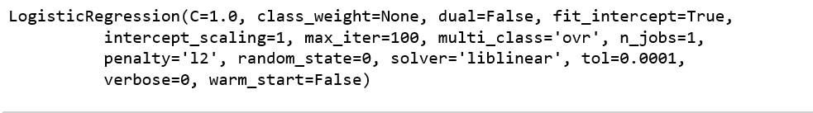

**Step 7:**Predicting the test set result

filter\_none

brightness\_4

|  |
| --- |
| # Predicting the test set result using  # predict function under LogisticRegression  y\_pred = classifier.predict(X\_test) |

**Step 8:**Making the confusion matrix

filter\_none

brightness\_4

|  |
| --- |
| # making confusion matrix between  #  test set of Y and predicted value.  from sklearn.metrics import confusion\_matrix    cm = confusion\_matrix(y\_test, y\_pred) |

**Step 9:** Predicting the training set result

filter\_none

brightness\_4

|  |
| --- |
| # Predicting the training set  # result through scatter plot  from matplotlib.colors import ListedColormap  X\_set, y\_set = X\_train, y\_train  X1, X2 = np.meshgrid(np.arange(start = X\_set[:, 0].min() - 1,                       stop = X\_set[:, 0].max() + 1, step = 0.01),                       np.arange(start = X\_set[:, 1].min() - 1,                       stop = X\_set[:, 1].max() + 1, step = 0.01))    plt.contourf(X1, X2, classifier.predict(np.array([X1.ravel(),               X2.ravel()]).T).reshape(X1.shape), alpha = 0.75,               cmap = ListedColormap(('yellow', 'white', 'aquamarine')))    plt.xlim(X1.min(), X1.max())  plt.ylim(X2.min(), X2.max())    for i, j in enumerate(np.unique(y\_set)):      plt.scatter(X\_set[y\_set == j, 0], X\_set[y\_set == j, 1],                  c = ListedColormap(('red', 'green', 'blue'))(i), label = j)    plt.title('Logistic Regression (Training set)')  plt.xlabel('PC1') # for Xlabel  plt.ylabel('PC2') # for Ylabel  plt.legend() # to show legend    # show scatter plot  plt.show() |

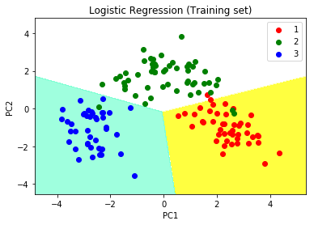  
   
**Step 10:** Visualising the Test set results

filter\_none

brightness\_4

|  |
| --- |
| # Visualising the Test set results through scatter plot  from matplotlib.colors import ListedColormap    X\_set, y\_set = X\_test, y\_test    X1, X2 = np.meshgrid(np.arange(start = X\_set[:, 0].min() - 1,                       stop = X\_set[:, 0].max() + 1, step = 0.01),                       np.arange(start = X\_set[:, 1].min() - 1,                       stop = X\_set[:, 1].max() + 1, step = 0.01))    plt.contourf(X1, X2, classifier.predict(np.array([X1.ravel(),               X2.ravel()]).T).reshape(X1.shape), alpha = 0.75,               cmap = ListedColormap(('yellow', 'white', 'aquamarine')))    plt.xlim(X1.min(), X1.max())  plt.ylim(X2.min(), X2.max())    for i, j in enumerate(np.unique(y\_set)):      plt.scatter(X\_set[y\_set == j, 0], X\_set[y\_set == j, 1],                  c = ListedColormap(('red', 'green', 'blue'))(i), label = j)    # title for scatter plot  plt.title('Logistic Regression (Test set)')  plt.xlabel('PC1') # for Xlabel  plt.ylabel('PC2') # for Ylabel  plt.legend()    # show scatter plot  plt.show() |

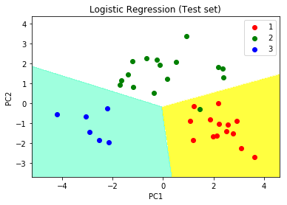

# ML | Introduction to Kernel PCA

**PRINCIPAL COMPONENT ANALYSIS:** is a tool which is used to reduce the dimension of the data. It allows us to reduce the dimension of the data without much loss of information. PCA reduces the dimension by finding a few orthogonal linear combinations (principal components) of the original variables with the largest variance.  
The first principal component captures most of the variance in the data. The second principal component is orthogonal to the first principal component and captures the remaining variance, which is left of first principal component and so on. There are as many principal components as the number of original variables.  
These principal components are uncorrelated and are ordered in such a way that the first several principal components explain most of the variance of the original data. To learn more about PCA you can read the article [Principal Component Analysis](https://www.geeksforgeeks.org/principal-component-analysis-with-python/)

**KERNEL PCA:**

PCA is a linear method. That is it can only be applied to datasets which are linearly separable. It does an excellent job for datasets, which are linearly separable. But, if we use it to non-linear datasets, we might get a result which may not be the optimal dimensionality reduction. Kernel PCA uses a kernel function to project dataset into a higher dimensional feature space, where it is linearly separable. It is similar to the idea of Support Vector Machines.

There are various kernel methods like linear, polynomial, and gaussian.

**Code:**Create a dataset which is nonlinear and then apply PCA on the dataset.

filter\_none

edit

play\_arrow

brightness\_4

|  |
| --- |
| import matplotlib.pyplot as plt  from sklearn.datasets import make\_moons    X, y = make\_moons(n\_samples = 500, noise = 0.02, random\_state = 417)    plt.scatter(X[:, 0], X[:, 1], c = y)  plt.show() |

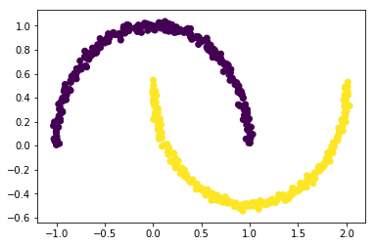

**Code:**Let’s apply PCA on this dataset

filter\_none

edit

play\_arrow

brightness\_4

|  |
| --- |
| from sklearn.decomposition import PCA  pca = PCA(n\_components = 2)  X\_pca = pca.fit\_transform(X)    plt.title("PCA")  plt.scatter(X\_pca[:, 0], X\_pca[:, 1], c = y)  plt.xlabel("Component 1")  plt.ylabel("Component 2")  plt.show() |

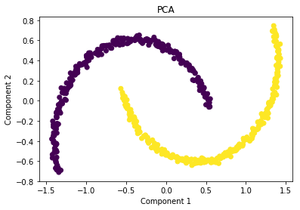  
As you can see PCA failed to distinguish the two classes.  
   
**Code:**Applying kernel PCA on this dataset with RBF kernel with a gamma value of 15.

filter\_none

edit

play\_arrow

brightness\_4

|  |
| --- |
| from sklearn.decomposition import KernelPCA  kpca = KernelPCA(kernel ='rbf', gamma = 15)  X\_kpca = kpca.fit\_transform(X)    plt.title("Kernel PCA")  plt.scatter(X\_kpca[:, 0], X\_kpca[:, 1], c = y)  plt.show() |

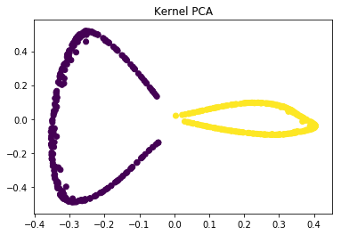  
In the kernel space the two classes are linearly separable. Kernel PCA uses a kernel function to project the dataset into a higher-dimensional space, where it is linearly separable.  
Finally, we applied the kernel PCA to a non-linear dataset using scikit-learn.

**References:**  
<https://en.wikipedia.org/wiki/Kernel_principal_component_analysis>  
<http://fourier.eng.hmc.edu/e161/lectures/kernelPCA/node4.html>

ML | Linear Discriminant Analysis

**Linear Discriminant Analysis** or **Normal Discriminant Analysis** or **Discriminant Function Analysis** is a dimensionality reduction technique which is commonly used for the supervised classification problems. It is used for modelling differences in groups i.e. separating two or more classes. It is used to project the features in higher dimension space into a lower dimension space.

For example, we have two classes and we need to separate them efficiently. Classes can have multiple features. Using only a single feature to classify them may result in some overlapping as shown in the below figure. So, we will keep on increasing the number of features for proper classification.  
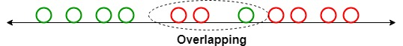

**Example:**  
Suppose we have two sets of data points belonging to two different classes that we want to classify. As shown in the given 2D graph, when the data points are plotted on the 2D plane, there’s no straight line that can separate the two classes of the data points completely. Hence, in this case, LDA (Linear Discriminant Analysis) is used which reduces the 2D graph into a 1D graph in order to maximize the separability between the two classes.  
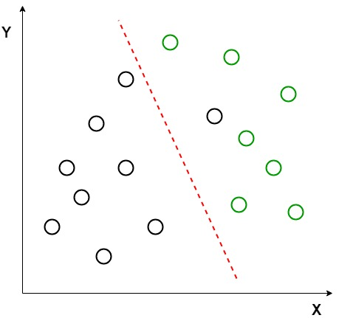  
Here, Linear Discriminant Analysis uses both the axes (X and Y) to create a new axis and projects data onto a new axis in a way to maximize the separation of the two categories and hence, reducing the 2D graph into a 1D graph.

Two criteria are used by LDA to create a new axis:

1. Maximize the distance between means of the two classes.
2. Minimize the variation within each class.

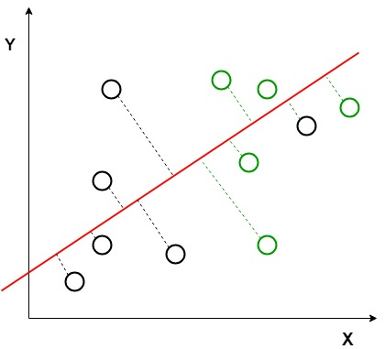  
In the above graph, it can be seen that a new axis (in red) is generated and plotted in the 2D graph such that it maximizes the distance between the means of the two classes and minimizes the variation within each class. In simple terms, this newly generated axis increases the separation between the dtla points of the two classes. After generating this new axis using the above-mentioned criteria, all the data points of the classes are plotted on this new axis and are shown in the figure given below.  
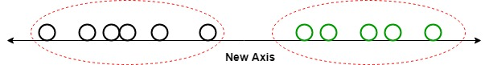

But Linear Discriminant Analysis fails when the mean of the distributions are shared, as it becomes impossible for LDA to find a new axis that makes both the classes linearly separable. In such cases, we use non-linear discriminant analysis.

**Extensions to LDA:**

1. **Quadratic Discriminant Analysis (QDA):** Each class uses its own estimate of variance (or covariance when there are multiple input variables).
2. **Flexible Discriminant Analysis (FDA):** Where non-linear combinations of inputs is used such as splines.
3. **Regularized Discriminant Analysis (RDA):** Introduces regularization into the estimate of the variance (actually covariance), moderating the influence of different variables on LDA.

**Applications:**

1. **Face Recognition:** In the field of Computer Vision, face recognition is a very popular application in which each face is represented by a very large number of pixel values. Linear discriminant analysis (LDA) is used here to reduce the number of features to a more manageable number before the process of classification. Each of the new dimensions generated is a linear combination of pixel values, which form a template. The linear combinations obtained using Fisher’s linear discriminant are called Fisher faces.
2. **Medical:** In this field, Linear discriminant analysis (LDA) is used to classify the patient disease state as mild, moderate or severe based upon the patient various parameters and the medical treatment he is going through. This helps the doctors to intensify or reduce the pace of their treatment.
3. **Customer Identification:** Suppose we want to identify the type of customers which are most likely to buy a particular product in a shopping mall. By doing a simple question and answers survey, we can gather all the features of the customers. Here, Linear discriminant analysis will help us to identify and select the features which can describe the characteristics of the group of customers that are most likely to buy that particular product in the shopping mall.

# Why and how to Cross Validate a Model?

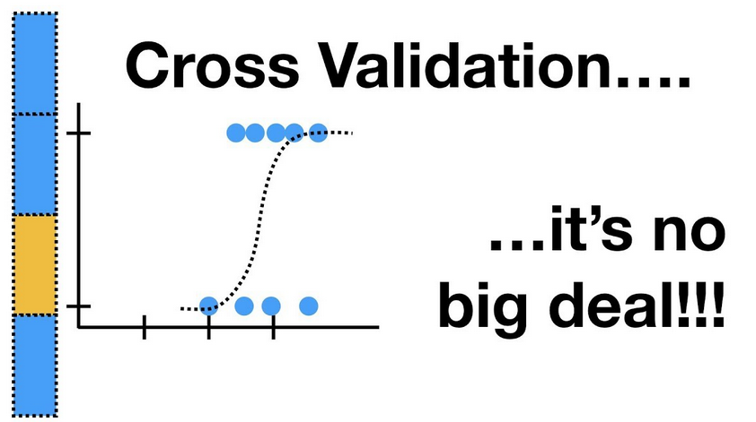

Once we are done with training our model, we just can’t assume that it is going to work well on data that it has not seen before. In other words, we cant be sure that the model will have the desired accuracy and variance in production environment. We need some kind of assurance of the accuracy of the predictions that our model is putting out. For this, we need to validate our model. This process of deciding whether the numerical results quantifying hypothesised relationships between variables, are acceptable as descriptions of the data, is known as validation..

To evaluate the performance of any machine learning model we need to test it on some unseen data. Based on the models performance on unseen data we can say weather our model is Under-fitting/Over-fitting/Well generalised. Cross validation (CV) is one of the technique used to test the effectiveness of a machine learning models, it is also a re-sampling procedure used to evaluate a model if we have a limited data. To perform CV we need to keep aside a sample/portion of the data on which is do not use to train the model, later us this sample for testing/validating. There are many methods

## Below are the few common techniques used for CV

### Train\_Test Split approach.

In this approach we randomly split the complete data into training and test sets. Then Perform the model training on the training set and use the test set for validation purpose, ideally split the data into 70:30 or 80:20. With this approach there is a possibility of high bias if we have limited data, because we would miss some information about the data which we have not used for training. If our data is huge and our test sample and train sample has the same distribution then this approach is acceptable.

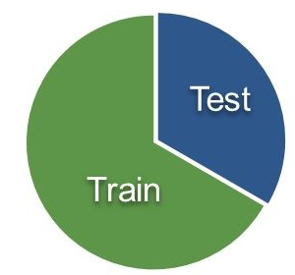

We can manually split the data into train and test set using slicing or we can use the **train\_test\_split** of scikit-learn method for this task. Complete documentation is [here](https://scikit-learn.org/stable/modules/generated/sklearn.model_selection.train_test_split.html).

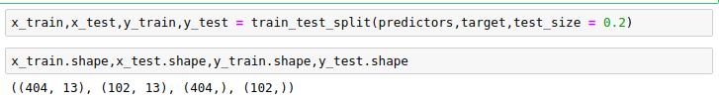

### 2. K-Folds Cross Validation:

K-Fold is a popular and easy to understand, it generally results in a less biased model compare to other methods. Because it ensures that every observation from the original dataset has the chance of appearing in training and test set. This is one among the best approach if we have a limited input data. This method follows the below steps.

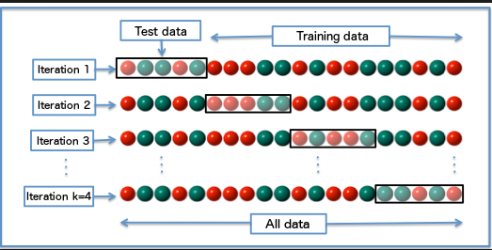

Image Sourced From Wikipedia

1. Split the entire data randomly into k folds (value of k shouldn’t be too small or too high, ideally we choose 5 to 10 depending on the data size). The higher value of K leads to less biased model (but large variance might lead to overfit), where as the lower value of K is similar to the train-test split approach we saw before.
2. Then fit the model using the K — 1 (K minus 1) folds and validate the model using the remaining Kth fold. Note down the scores/errors.
3. Repeat this process until every K-fold serve as the test set. Then take the average of your recorded scores. That will be the performance metric for the model.

We can write a logic manually to perform this or we can use the built in **cross\_val\_score**(returns score of each test folds)/**corss\_val\_predict**(returns the predicted score for each observation in the input dataset when it was part of the test set) from the scikit\_learn library.

If the esitmator (model) is a claissifier and ‘y’(target variable) is either binary/multicalss, then ‘**StratifiedKfold**’ technique is used by default. In all other cases ‘**K\_Fold**’ technique is used as a default to split and train the model.

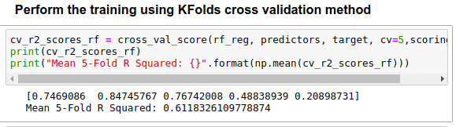

Similar to K\_Fold cross-validator, StratifiedKfold returns stratified folds, i.e while making the folds it maintains the percentage of samples for each class in every fold. So that model gets equally distributed data for training/test folds.

We can use the folds from K-Fold as an iterator and use it in a for loop to perform the training on a pandas data frame. Below is the example.

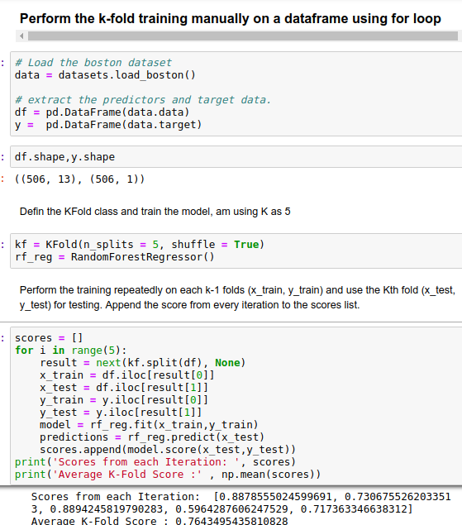

Complete code is available [here](https://github.com/Msanjayds/Scikit-learn/blob/master/CrossValidation.ipynb).

That’s all i have and thanks a lot for reading. Please let me know if any corrections/suggestions. Please do 👏 if you like the post. Thanks in advance… 😉

# XGBoost Algorithm:

I still remember the day 1 of my very first job fifteen years ago. I had just finished my graduate studies and joined a global investment bank as an analyst. On my first day, I kept straightening my tie and trying to remember everything that I had studied. Meanwhile, deep down, I wondered if I was good enough for the corporate world. Sensing my anxiety, my boss smiled and said:

“Don’t worry! The only thing that you need to know is the regression modelling!”

I remember thinking myself, “I got this!”. I knew regression modelling; both linear and logistic regression. My boss was right. In my tenure, I exclusively built regression-based statistical models. I wasn’t alone. In fact, at that time, regression modelling was the undisputed queen of predictive analytics. Fast forward fifteen years, the era of regression modelling is over. The old queen has passed. Long live the new queen with a funky name; XGBoost or Extreme Gradient Boosting!

## What is XGBoost?

[XGBoost](https://xgboost.ai/)is a decision-tree-based ensemble Machine Learning algorithm that uses a [gradient boosting](https://en.wikipedia.org/wiki/Gradient_boosting) framework. In prediction problems involving unstructured data (images, text, etc.) artificial neural networks tend to outperform all other algorithms or frameworks. However, when it comes to small-to-medium structured/tabular data, decision tree based algorithms are considered best-in-class right now. Please see the chart below for the evolution of tree-based algorithms over the years.

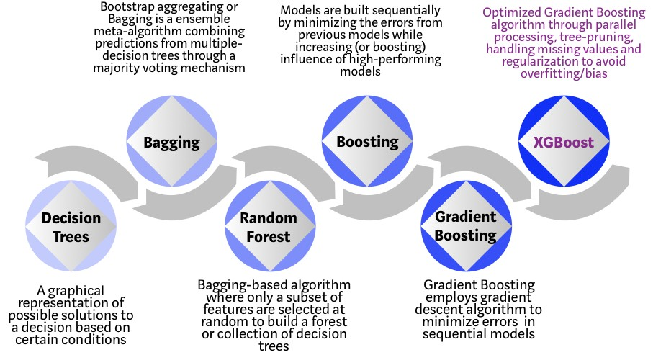

## Evolution of XGBoost Algorithm from Decision Trees

XGBoost algorithm was developed as a research project at the University of Washington. [Tianqi Chen and Carlos Guestrin](https://arxiv.org/pdf/1603.02754.pdf" \t "_blank) presented their paper at SIGKDD Conference in 2016 and caught the Machine Learning world by fire. Since its introduction, this algorithm has not only been credited with winning numerous Kaggle competitions but also for being the driving force under the hood for several cutting-edge industry applications. As a result, there is a strong community of data scientists contributing to the XGBoost open source projects with ~350 contributors and ~3,600 commits on [GitHub](https://github.com/dmlc/xgboost/). The algorithm differentiates itself in the following ways:

1. A wide range of applications: Can be used to solve regression, classification, ranking, and user-defined prediction problems.
2. Portability: Runs smoothly on Windows, Linux, and OS X.
3. Languages: Supports all major programming languages including C++, Python, R, Java, Scala, and Julia.
4. Cloud Integration: Supports AWS, Azure, and Yarn clusters and works well with Flink, Spark, and other ecosystems.

## How to build an intuition for XGBoost?

Decision trees, in their simplest form, are easy-to-visualize and fairly interpretable algorithms but building intuition for the next-generation of tree-based algorithms can be a bit tricky. See below for a simple analogy to better understand the evolution of tree-based algorithms.

Imagine that you are a hiring manager interviewing several candidates with excellent qualifications. Each step of the evolution of tree-based algorithms can be viewed as a version of the interview process.

1. **Decision Tree**: Every hiring manager has a set of criteria such as education level, number of years of experience, interview performance. A decision tree is analogous to a hiring manager interviewing candidates based on his or her own criteria.
2. **Bagging**: Now imagine instead of a single interviewer, now there is an interview panel where each interviewer has a vote. Bagging or bootstrap aggregating involves combining inputs from all interviewers for the final decision through a democratic voting process.
3. **Random Forest**: It is a bagging-based algorithm with a key difference wherein only a subset of features is selected at random. In other words, every interviewer will only test the interviewee on certain randomly selected qualifications (e.g. a technical interview for testing programming skills and a behavioral interview for evaluating non-technical skills).
4. **Boosting**: This is an alternative approach where each interviewer alters the evaluation criteria based on feedback from the previous interviewer. This ‘boosts’ the efficiency of the interview process by deploying a more dynamic evaluation process.
5. **Gradient Boosting**: A special case of boosting where errors are minimized by gradient descent algorithm e.g. the strategy consulting firms leverage by using case interviews to weed out less qualified candidates.
6. **XGBoost**: Think of XGBoost as gradient boosting on ‘steroids’ (well it is called ‘Extreme Gradient Boosting’ for a reason!). It is a perfect combination of software and hardware optimization techniques to yield superior results using less computing resources in the shortest amount of time.

## Why does XGBoost perform so well?

XGBoost and Gradient Boosting Machines (GBMs) are both ensemble tree methods that apply the principle of boosting weak learners ([CARTs](https://www.datasciencecentral.com/profiles/blogs/introduction-to-classification-regression-trees-cart) generally) using the gradient descent architecture. However, XGBoost improves upon the base GBM framework through systems optimization and algorithmic enhancements.

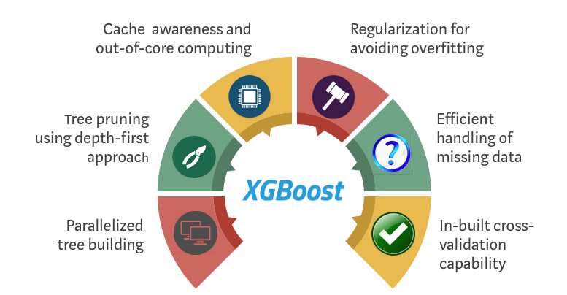

## How XGBoost optimizes standard GBM algorithm

### **System Optimization:**

1. **Parallelization**: XGBoost approaches the process of sequential tree building using [parallelized](http://zhanpengfang.github.io/418home.html) implementation. This is possible due to the interchangeable nature of loops used for building base learners; the outer loop that enumerates the leaf nodes of a tree, and the second inner loop that calculates the features. This nesting of loops limits parallelization because without completing the inner loop (more computationally demanding of the two), the outer loop cannot be started. Therefore, to improve run time, the order of loops is interchanged using initialization through a global scan of all instances and sorting using parallel threads. This switch improves algorithmic performance by offsetting any parallelization overheads in computation.
2. **Tree Pruning:** The stopping criterion for tree splitting within GBM framework is greedy in nature and depends on the negative loss criterion at the point of split. XGBoost uses ‘max\_depth’ parameter as specified instead of criterion first, and starts pruning trees backward. This ‘depth-first’ approach improves computational performance significantly.
3. **Hardware Optimization**: This algorithm has been designed to make efficient use of hardware resources. This is accomplished by cache awareness by allocating internal buffers in each thread to store gradient statistics. Further enhancements such as ‘out-of-core’ computing optimize available disk space while handling big data-frames that do not fit into memory.

## **Algorithmic Enhancements:**

1. **Regularization**: It penalizes more complex models through both LASSO (L1) and Ridge (L2) [regularization](https://towardsdatascience.com/l1-and-l2-regularization-methods-ce25e7fc831c) to prevent overfitting.
2. **Sparsity Awareness**: XGBoost naturally admits sparse features for inputs by automatically ‘learning’ best missing value depending on training loss and handles different types of [sparsity patterns](https://www.kdnuggets.com/2017/10/xgboost-concise-technical-overview.html) in the data more efficiently.
3. **Weighted Quantile Sketch:** XGBoost employs the distributed [weighted Quantile Sketch algorithm](https://arxiv.org/pdf/1603.02754.pdf) to effectively find the optimal split points among weighted datasets.
4. **Cross-validation**: The algorithm comes with built-in [cross-validation](https://towardsdatascience.com/cross-validation-in-machine-learning-72924a69872f) method at each iteration, taking away the need to explicitly program this search and to specify the exact number of boosting iterations required in a single run.

## Where is the proof?

We used Scikit-learn’s ‘[Make\_Classification](https://scikit-learn.org/stable/modules/generated/sklearn.datasets.make_classification.html" \t "_blank)’ data package to create a random sample of 1 million data points with 20 features (2 informative and 2 redundant). We tested several algorithms such as Logistic Regression, Random Forest, standard Gradient Boosting, and XGBoost.

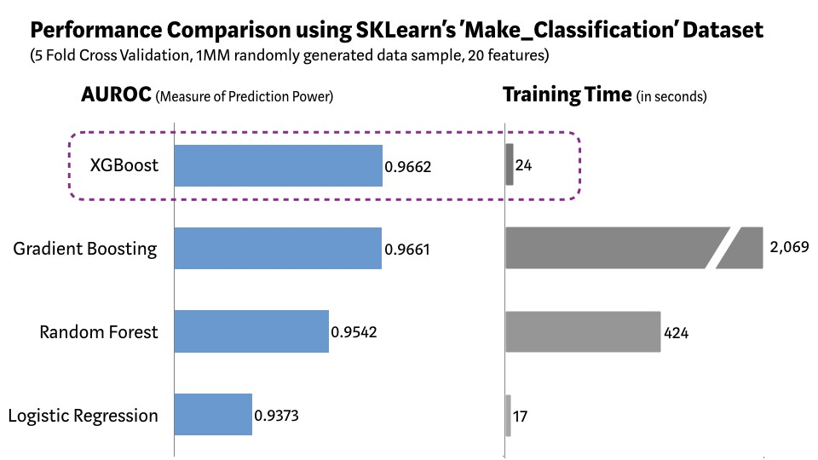

XGBoost vs. Other ML Algorithms using SKLearn’s Make\_Classification Dataset

As demonstrated in the chart above, XGBoost model has the best combination of prediction performance and processing time compared to other algorithms. Other rigorous [benchmarking](https://github.com/szilard/benchm-ml) studies have produced similar results. No wonder XGBoost is widely used in recent Data Science competitions.

*“When in doubt, use XGBoost” — Owen Zhang, Winner of [Avito](http://blog.kaggle.com/2015/08/26/avito-winners-interview-1st-place-owen-zhang/" \t "_blank) Context Ad Click Prediction competition on Kaggle*

## So should we use just XGBoost all the time?

When it comes to Machine Learning (or even life for that matter), there is no free lunch. As Data Scientists, we must test all possible algorithms for data at hand to identify the champion algorithm. Besides, picking the right algorithm is not enough. We must also choose the right configuration of the algorithm for a dataset by tuning the [hyper-parameters](https://www.analyticsvidhya.com/blog/2016/03/complete-guide-parameter-tuning-xgboost-with-codes-python/). Furthermore, there are several other considerations for choosing the winning algorithm such as computational complexity, explainability, and ease of implementation. This is exactly the point where Machine Learning starts drifting away from science towards art, but honestly, that’s where the magic happens!

## What does the future hold?

Machine Learning is a very active research area and already there are several viable alternatives to XGBoost. Microsoft Research recently released [LightGBM](https://www.microsoft.com/en-us/research/project/lightgbm/" \t "_blank) framework for gradient boosting that shows great potential. [CatBoost](https://catboost.ai/" \t "_blank) developed by Yandex Technology has been delivering impressive bench-marking results. It is a matter of time when we have a better model framework that beats XGBoost in terms of prediction performance, flexibility, explanability, and pragmatism. However, until a time when a strong challenger comes along, XGBoost will continue to reign over the Machine Learning world!

# Accuracy, Recall & Precision

When it comes to evaluating how well a model performs there are multiple metrics that can be used. To choose the evaluation metric to best evaluate your model, it is vital that you understand what each metric calculates. You may hear a model is extremely accurate but depending on the business question your model is attempting to answer, another metric may be better suited to evaluate the model.

## Accuracy

Accuracy is an evaluation metric that allows you to measure the total number of predictions a model gets right. The formula for accuracy is below:

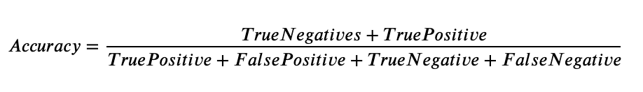

Accuracy will answer the question, what percent of the models predictions were correct? Accuracy looks at True Positives and True Negatives. We will see in some of the evaluation metrics later, not both are used.

A confusion matrix displays counts of the True Positives, False Positives, True Negatives, and False Negatives produced by a model. Using a confusion matrix we can get the values needed to compute the accuracy of a model. Looking at the below confusion matrix, we can use the formula above to calculate accuracy.

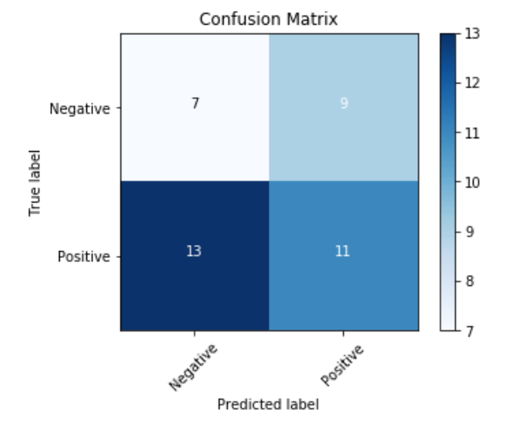

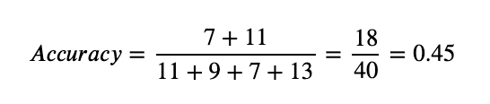

An accuracy of 0.45 is pretty low, meaning our model is not predicting many True Positives or True Negatives correctly. However having a high accuracy does not mean we have a good model either.

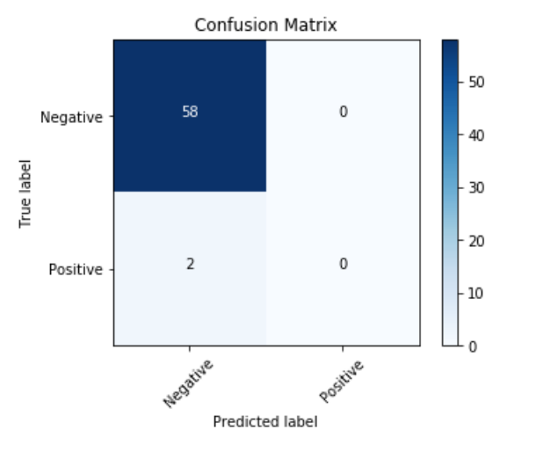

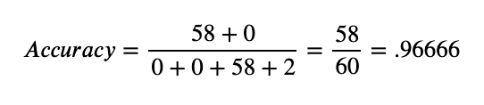

An accuracy of .96666 is very high. You may be tempted to choose a model that has a high accuracy but you need to think about the business question. Perhaps you built a model that to predict if someone had a disease or not. If most people don’t have the disease and the model predicts negative every time like in the example above, you will achieve a high accuracy. However, this model will never recognize the disease in anyone and therefore would be useless in predicting whether someone has a disease. When accuracy is not a good metric to evaluate your model you can look at other metrics.

## Precision

Precision evaluates how precise a model is in predicting positive labels. Precision answers the question, out of the number of times a model predicted positive, how often was it correct? Precision is the percentage of your results which are relevant. The formula for precision is below:

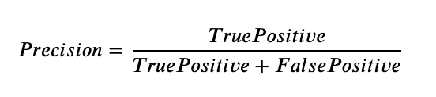

The top of the formula is the number of positive observations that a model predicted correctly. The denominator is the number of times the model predicted a positive label in total. Precision is a good evaluation metric to use when the cost of a false positive is very high and the cost of a false negative is low. For example, precision is good to use if you are a restaurant owner looking to buy wine for your restaurant only if it is predicted to be good by a classifier algorithm. If you are only looking to buy wine that is good to sell to your customers then the cost of a false positive, selling a customer a wine that you say is good when it is not, can result in the restaurant owner upsetting a customer and perhaps losing that customer. If the restaurant owner says I hear this is not good wine and the customer chooses to buy anyway, and it turns out to be good, no big deal. This would be a false negative and the cost of this scenario is not really bad.

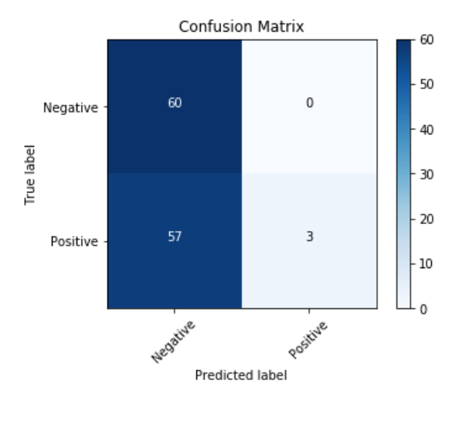

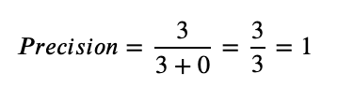

The above example shows a model that produces a precision of 1. This may sound good but if you investigate the confusion matrix, you’ll see that it only predicted positive 3 times when the data was labelled positive 60 times or 50% of the time. If this model was used to predict whether someone would have a disease or not, it would be telling people majority of the people who had a disease they were healthy. When the cost of false negatives is high, it is better to use recall as an evaluation metric.

## Recall

Recall calculates the percentage of actual positives a model correctly identified (True Positive). When the cost of a false negative is high, you should use recall. The formula for recall is below:

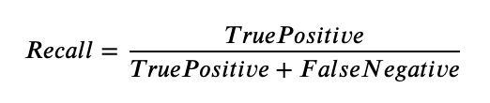

The numerator is the number of true positives or the number of positives the model correctly identified. The denominator is the number of actual positives predicted by the model and the number of positives incorrectly predicted as negative by the model. For example, you should use recall when looking to predict whether a credit card charge is fraudulent or not. If you have a lot of false negatives, then you have a lot of fraudulent charges that are being labelled as not fraudulent and customers will have money stolen from them.

However having a high recall doesn’t necessary mean a model is good? For example, if a model predicted that everyone had a disease, the model would have a perfect recall but it would have a lot of false positives and be telling people they were sick when they were not.

It is important to consider what question you are trying to answer when deciding what evaluation metric to use and whether false positives or false negatives are worse.

# 11 Important Model Evaluation Metrics for Machine Learning Everyone should know

## Overview

* Evaluating a model is a core part of building an effective machine learning model
* There are several evaluation metrics, like confusion matrix, cross-validation, AUC-ROC curve, etc.
* Different evaluation metrics are used for different kinds of problems

This article was originally published in February 2016 and updated in August 2019. With four new evaluation metrics.

## Introduction

The idea of [building machine learning models](https://courses.analyticsvidhya.com/courses/applied-machine-learning-beginner-to-professional?utm_source=blog&utm_medium=11-important-model-evaluation-error-metrics) works on a constructive feedback principle. You build a model, get feedback from metrics, make improvements and continue until you achieve a desirable accuracy. Evaluation metrics explain the performance of a model. An important aspect of evaluation metrics is their capability to discriminate among model results.

I have seen plenty of analysts and aspiring data scientists not even bothering to check how robust their model is. Once they are finished building a model, they hurriedly map predicted values on unseen data. This is an incorrect approach.

Simply building a predictive model is not your motive. It’s about creating and selecting a model which gives high accuracy on out of sample data. Hence, it is crucial to check the accuracy of your model prior to computing predicted values.

In our industry, we consider different kinds of metrics to evaluate our models. The choice of metric completely depends on the type of model and the implementation plan of the model.

After you are finished building your model, these 11 metrics will help you in evaluating your model’s accuracy. Considering the rising popularity and importance of cross-validation, I’ve also mentioned its principles in this article.

And if you’re starting out your machine learning journey, you should check out the comprehensive and popular [*‘Applied Machine Learning’ cours*](https://courses.analyticsvidhya.com/courses/applied-machine-learning-beginner-to-professional?utm_source=blog&utm_medium=11-important-model-evaluation-error-metrics)e which covers this concept in a lot of detail along with the various algorithms and components of machine learning.

## Table of Contents

1. Confusion Matrix
2. F1 Score
3. Gain and Lift Charts
4. Kolmogorov Smirnov Chart
5. AUC – ROC
6. Log Loss
7. Gini Coefficient
8. Concordant – Discordant Ratio
9. Root Mean Squared Error
10. Cross Validation (Not a metric though!)

## Warming up: Types of Predictive models

When we talk about predictive models, we are talking either about a regression model (continuous output) or a classification model (nominal or binary output). The evaluation metrics used in each of these models are different.

In classification problems, we use two types of algorithms (dependent on the kind of output it creates):

1. **Class output**: Algorithms like SVM and KNN create a class output. For instance, in a binary classification problem, the outputs will be either 0 or 1. However, today we have algorithms which can convert these class outputs to probability. But these algorithms are not well accepted by the statistics community.
2. **Probability output**: Algorithms like Logistic Regression, Random Forest, Gradient Boosting, Adaboost etc. give probability outputs. Converting probability outputs to class output is just a matter of creating a threshold probability.

In regression problems, we do not have such inconsistencies in output. The output is always continuous in nature and requires no further treatment.

**Illustrative Example**

For a classification model evaluation metric discussion, I have used my predictions for the problem BCI challenge on Kaggle. The solution of the problem is out of the scope of our discussion here. However the final predictions on the training set have been used for this article. The predictions made for this problem were probability outputs which have been converted to class outputs assuming a threshold of 0.5.

## 1. Confusion Matrix

A confusion matrix is an N X N matrix, where N is the number of classes being predicted. For the problem in hand, we have N=2, and hence we get a 2 X 2 matrix. Here are a few definitions, you need to remember for a confusion matrix:

* **Accuracy:** the proportion of the total number of predictions that were correct.
* **Positive Predictive Value or Precision:** the proportion of positive cases that were correctly identified.
* **Negative Predictive Value**: the proportion of negative cases that were correctly identified.
* **Sensitivity or Recall:** the proportion of actual positive cases which are correctly identified.
* **Specificity:** the proportion of actual negative cases which are correctly identified.

[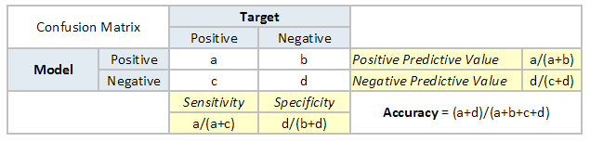](https://www.analyticsvidhya.com/blog/wp-content/uploads/2015/01/Confusion_matrix.png)

[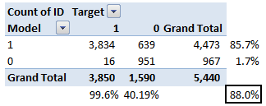](https://www.analyticsvidhya.com/blog/wp-content/uploads/2015/01/Confusion_matrix1.png)

The accuracy for the problem in hand comes out to be 88%.  As you can see from the above two tables, the Positive predictive Value is high, but negative predictive value is quite low. Same holds for Sensitivity and Specificity. This is primarily driven by the threshold value we have chosen. If we decrease our threshold value, the two pairs of starkly different numbers will come closer.

In general we are concerned with one of the above defined metric. For instance, in a pharmaceutical company, they will be more concerned with minimal wrong positive diagnosis. Hence, they will be more concerned about high Specificity. On the other hand an attrition model will be more concerned with Sensitivity. Confusion matrix are generally used only with class output models.

## 2. F1 Score

In the last section, we discussed precision and recall for classification problems and also highlighted the importance of choosing precision/recall basis our use case. What if for a use case, we are trying to get the best precision and recall at the same time? F1-Score is the harmonic mean of precision and recall values for a classification problem. The formula for F1-Score is as follows:

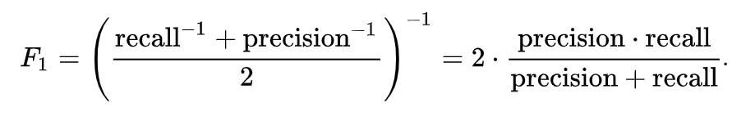

Now, an obvious question that comes to mind is why taking a harmonic mean and not an arithmetic mean are. This is because HM punishes extreme values more. Let us understand this with an example. We have a binary classification model with the following results:

Precision: 0, Recall: 1

Here, if we take the arithmetic mean, we get 0.5. It is clear that the above result comes from a dumb classifier which just ignores the input and just predicts one of the classes as output. Now, if we were to take HM, we will get 0 which is accurate as this model is useless for all purposes.

This seems simple. There are situations however for which a data scientist would like to give a percentage more importance/weight to either precision or recall. Altering the above expression a bit such that we can include an adjustable parameter beta for this purpose, we get:

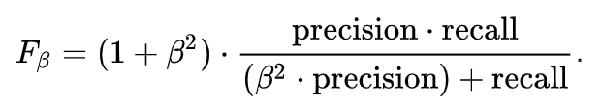

Fbeta measures the effectiveness of a model with respect to a user who attaches β times as much importance to recall as precision.

## 3. Gain and Lift charts

Gain and Lift chart are mainly concerned to check the rank ordering of the probabilities. Here are the steps to build a Lift/Gain chart:

Step 1: Calculate probability for each observation

Step 2: Rank these probabilities in decreasing order.

Step 3: Build deciles with each group having almost 10% of the observations.

Step 4: Calculate the response rate at each deciles for Good (Responders) ,Bad (Non-responders) and total.

You will get following table from which you need to plot Gain/Lift charts:

[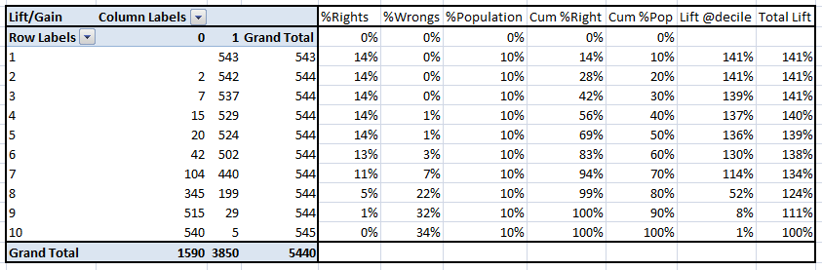](https://www.analyticsvidhya.com/blog/wp-content/uploads/2015/01/LiftnGain.png)

This is a very informative table. Cumulative Gain chart is the graph between Cumulative %Right and Cumulative %Population. For the case in hand here is the graph:

[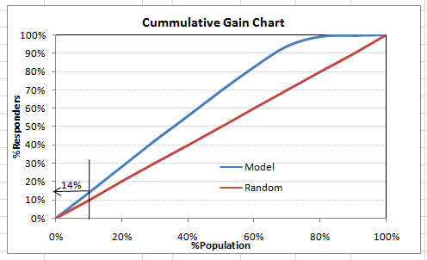](https://www.analyticsvidhya.com/blog/wp-content/uploads/2015/01/CumGain.png)

This graph tells you how well is your model segregating responders from non-responders. For example, the first decile however has 10% of the population, has 14% of responders. This means we have a 140% lift at first decile.

What is the maximum lift we could have reached in first decile? From the first table of this article, we know that the total number of responders are 3850. Also the first decile will contains 543 observations. Hence, the maximum lift at first decile could have been 543/3850 ~ 14.1%. Hence, we are quite close to perfection with this model.

Let’s now plot the lift curve. Lift curve is the plot between total lift and %population. Note that for a random model, this always stays flat at 100%. Here is the plot for the case in hand:

[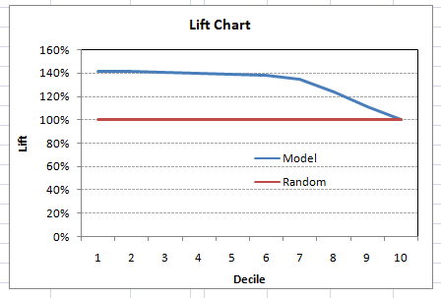](https://www.analyticsvidhya.com/blog/wp-content/uploads/2015/01/Lift.png)

You can also plot decile wise lift with decile number:

[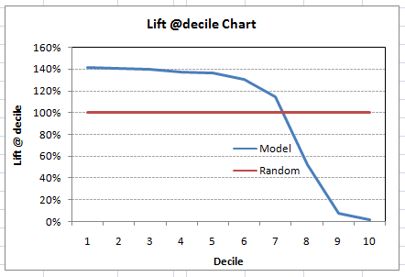](https://www.analyticsvidhya.com/blog/wp-content/uploads/2015/01/Liftdecile.png)

What does this graph tell you? It tells you that our model does well till the 7th decile. Post which every decile will be skewed towards non-responders. Any model with lift @ decile above 100% till minimum 3rd decile and maximum 7th decile is a good model. Else you might consider over sampling first.

Lift / Gain charts are widely used in campaign targeting problems. This tells us till which decile can we target customers for a specific campaign. Also, it tells you how much response you expect from the new target base.

## 4. Kolmogorov Smirnov chart

K-S or Kolmogorov-Smirnov chart measures performance of classification models. More accurately, K-S is a measure of the degree of separation between the positive and negative distributions. The K-S is 100, if the scores partition the population into two separate groups in which one group contains all the positives and the other all the negatives.

On the other hand, if the model cannot differentiate between positives and negatives, then it is as if the model selects cases randomly from the population. The K-S would be 0. In most classification models the K-S will fall between 0 and 100, and that the higher the value the better the model is at separating the positive from negative cases.

For the case in hand, following is the table:

[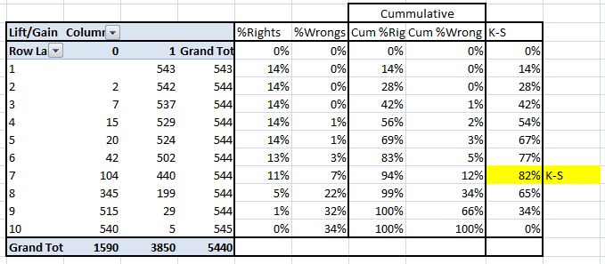](https://www.analyticsvidhya.com/blog/wp-content/uploads/2015/01/KS.png)

We can also plot the %Cumulative Good and Bad to see the maximum separation. Following is a sample plot:

[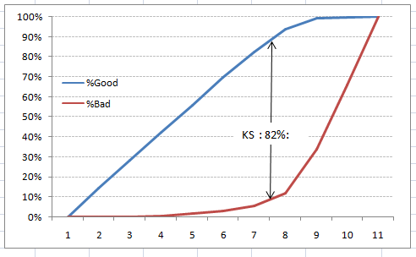](https://www.analyticsvidhya.com/blog/wp-content/uploads/2015/01/KS_plot.png)

The metrics covered till here are mostly used in classification problems. Till here, we learnt about confusion matrix, lift and gain chart and kolmogorov-smirnov chart. Let’s proceed and learn few more important metrics.

## 5. Area under the ROC curve (AUC – ROC)

This is again one of the popular metrics used in the industry.  The biggest advantage of using ROC curve is that it is independent of the change in proportion of responders. This statement will get clearer in the following sections.

Let’s first try to understand what ROC (Receiver operating characteristic) curve is. If we look at the confusion matrix below, we observe that for a probabilistic model, we get different value for each metric.

[](https://www.analyticsvidhya.com/blog/wp-content/uploads/2015/01/Confusion_matrix.png)

Hence, for each sensitivity, we get a different specificity.The two vary as follows:

[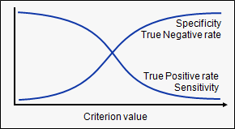](https://www.analyticsvidhya.com/blog/wp-content/uploads/2015/01/curves.png)

The ROC curve is the plot between sensitivity and (1- specificity). (1- specificity) is also known as false positive rate and sensitivity is also known as True Positive rate. Following is the ROC curve for the case in hand.

[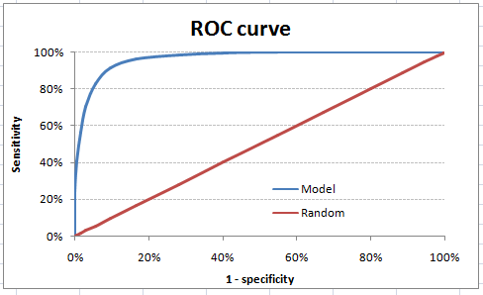](https://www.analyticsvidhya.com/blog/wp-content/uploads/2015/01/ROC.png)

Let’s take an example of threshold = 0.5 (refer to confusion matrix). Here is the confusion matrix:

[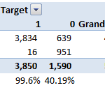](https://www.analyticsvidhya.com/blog/wp-content/uploads/2015/01/Confusion_matrix2.png)

As you can see, the sensitivity at this threshold is 99.6% and the (1-specificity) is ~60%. This coordinate becomes on point in our ROC curve. To bring this curve down to a single number, we find the area under this curve (AUC).

Note that the area of Entire Square is 1\*1 = 1. Hence AUC itself is the ratio under the curve and the total area. For the case in hand, we get AUC ROC as 96.4%. Following are a few thumb rules:

* .90-1 = excellent (A)
* .80-.90 = good (B)
* .70-.80 = fair (C)
* .60-.70 = poor (D)
* .50-.60 = fail (F)

We see that we fall under the excellent band for the current model. But this might simply be over-fitting. In such cases it becomes very important to to in-time and out-of-time validations.

### **Points to Remember:**

1. For a model which gives class as output, will be represented as a single point in ROC plot.

2. Such models cannot be compared with each other as the judgement needs to be taken on a single metric and not using multiple metrics. For instance, model with parameters (0.2, 0.8) and model with parameter (0.8, 0.2) can be coming out of the same model, hence these metrics should not be directly compared.

3. In case of probabilistic model, we were fortunate enough to get a single number which was AUC-ROC. But still, we need to look at the entire curve to make conclusive decisions. It is also possible that one model performs better in some region and other performs better in other.

### **Advantages of using ROC**

Why should you use ROC and not metrics like lift curve?

Lift is dependent on total response rate of the population. Hence, if the response rate of the population changes, the same model will give a different lift chart. A solution to this concern can be true lift chart (finding the ratio of lift and perfect model lift at each decile). But such ratio rarely makes sense for the business.

ROC curve on the other hand is almost independent of the response rate. This is because it has the two axis coming out from columnar calculations of confusion matrix. The numerator and denominator of both x and y axis will change on similar scale in case of response rate shift.

## 6. Log Loss

AUC ROC considers the predicted probabilities for determining our model’s performance. However, there is an issue with AUC ROC, it only takes into account the order of probabilities and hence it does not take into account the model’s capability to predict higher probability for samples more likely to be positive. In that case, we could us the log loss which is nothing but negative average of the log of corrected predicted probabilities for each instance.

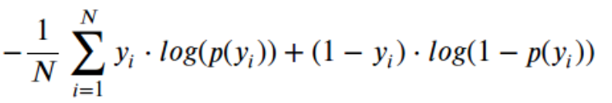

* p(yi) is predicted probability of positive class
* 1-p(yi) is predicted probability of negative class
* yi = 1 for positive class and 0 for negative class (actual values)

Let us calculate log loss for a few random values to get the gist of the above mathematical function:

Logloss(1, 0.1) = 2.303

Logloss(1, 0.5) = 0.693

Logloss(1, 0.9) = 0.105

If we plot this relationship, we will get a curve as follows:

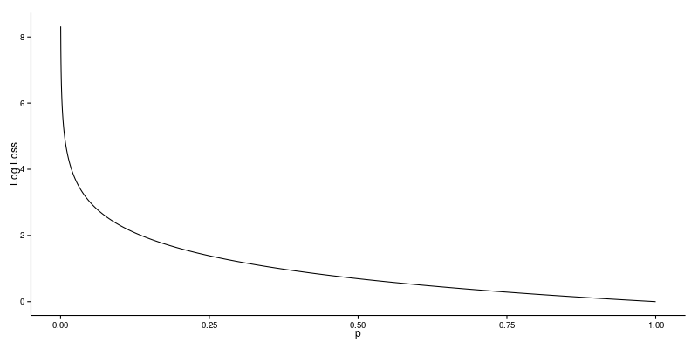

It’s apparent from the gentle downward slope towards the right that the Log Loss gradually declines as the predicted probability improves. Moving in the opposite direction though, the Log Loss ramps up very rapidly as the predicted probability approaches 0.

So, lower the log loss, better the model. However, there is no absolute measure on a good log loss and it is use-case/application dependent.

Whereas the AUC is computed with regards to binary classification with a varying decision threshold, log loss actually takes “certainty” of classification into account.

## 7. Gini Coefficient

Gini coefficient is sometimes used in classification problems. Gini coefficient can be straight away derived from the AUC ROC number. Gini is nothing but ratio between area between the ROC curve and the diagnol line & the area of the above triangle. Following is the formulae used:

Gini = 2\*AUC – 1

Gini above 60% is a good model. For the case in hand we get Gini as 92.7%.

## 8. Concordant – Discordant ratio

This is again one of the most important metric for any classification predictions problem. To understand this let’s assume we have 3 students who have some likelihood to pass this year. Following are our predictions:

A – 0.9

B – 0.5

C – 0.3

Now picture this. if we were to fetch pairs of two from these three student, how many pairs will we have? We will have 3 pairs: AB, BC, CA. Now, after the year ends we saw that A and C passed this year while B failed. No, we choose all the pairs where we will find one responder and other non-responder. How many such pairs do we have?

We have two pairs AB and BC. Now for each of the 2 pairs, the concordant pair is where the probability of responder was higher than non-responder. Whereas discordant pair is where the vice-versa holds true. In case both the probabilities were equal, we say it’s a tie. Let’s see what happens in our case:

AB – Concordant

BC – Discordant

Hence, we have 50% of concordant cases in this example. Concordant ratio of more than 60% is considered to be a good model. This metric generally is not used when deciding how many customer to target etc. It is primarily used to access the model’s predictive power. For decisions like how many to target are again taken by KS / Lift charts.

## 9. Root Mean Squared Error (RMSE)

RMSE is the most popular evaluation metric used in regression problems. It follows an assumption that error are unbiased and follow a normal distribution. Here are the key points to consider on RMSE:

1. The power of ‘square root’ empowers this metric to show large number deviations.
2. The ‘squared’ nature of this metric helps to deliver more robust results which prevents cancelling the positive and negative error values. In other words, this metric aptly displays the plausible magnitude of error term.
3. It avoids the use of absolute error values which is highly undesirable in mathematical calculations.
4. When we have more samples, reconstructing the error distribution using RMSE is considered to be more reliable.
5. RMSE is highly affected by outlier values. Hence, make sure you’ve removed outliers from your data set prior to using this metric.
6. As compared to mean absolute error, RMSE gives higher weightage and punishes large errors.

RMSE metric is given by:

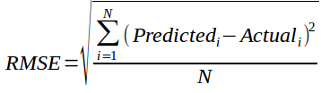

Where, N is Total Number of Observations.

## 10. Root Mean Squared Logarithmic Error

In case of Root mean squared logarithmic error, we take the log of the predictions and actual values. So basically, what changes are the variance that we are measuring? RMSLE is usually used when we don’t want to penalize huge differences in the predicted and the actual values when both predicted and true values are huge numbers.

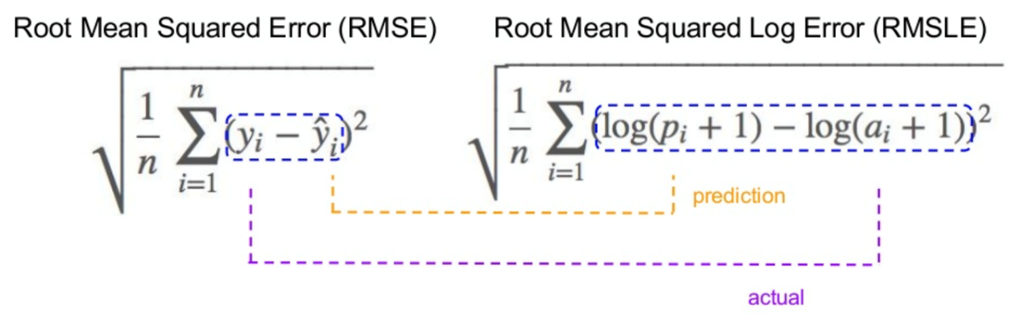

1. If both predicted and actual values are small: RMSE and RMSLE are same.
2. If either predicted or the actual value is big: RMSE > RMSLE
3. If both predicted and actual values are big: RMSE > RMSLE (RMSLE becomes almost negligible)

## 11. R-Squared/Adjusted R-Squared

We learned that when the RMSE decreases, the model’s performance will improve. But these values alone are not intuitive.

In the case of a classification problem, if the model has an accuracy of 0.8, we could gauge how good our model is against a random model, which has an accuracy of 0.5. So the random model can be treated as a benchmark. But when we talk about the RMSE metrics, we do not *have* a benchmark to compare.

This is where we can use R-Squared metric. The formula for R-Squared is as follows:

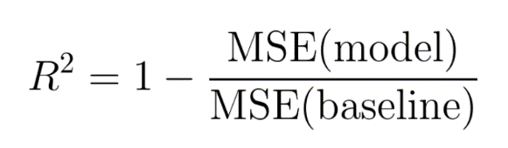

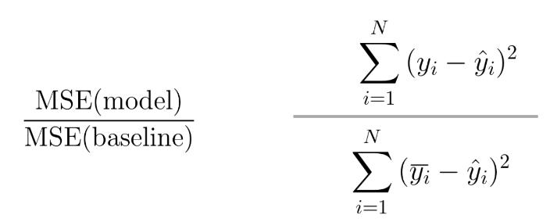

MSE (model): Mean Squared Error of the predictions against the actual values

MSE (baseline): Mean Squared Error of mean prediction against the actual values

In other words how good our regression model as compared to a very simple model that just predicts the mean value of target from the train set as predictions.

### Adjusted R-Squared

A model performing equal to baseline would give R-Squared as 0. Better the model, higher the r2 value. The best model with all correct predictions would give R-Squared as 1. However, on adding new features to the model, the R-Squared value either increases or remains the same. R-Squared does not penalize for adding features that add no value to the model. So an improved version over the R-Squared is the adjusted R-Squared. The formula for adjusted R-Squared is given by:

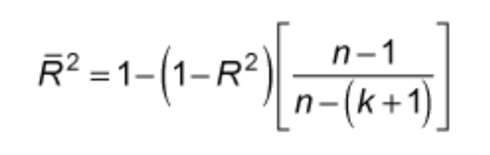

k: number of features

n: number of samples

As you can see, this metric takes the number of features into account. When we add more features, the term in the denominator n-(k +1) decreases, so the whole expression increases.

If R-Squared does not increase, that means the feature added isn’t valuable for our model. So overall we subtract a greater value from 1 and adjusted r2, in turn, would decrease.

Beyond these 11 metrics, there is another method to check the model performance. These 7 methods are statistically prominent in data science. But, with arrival of machine learning, we are now blessed with more robust methods of model selection. **Yes! I’m talking about Cross Validation**.

Though, cross validation isn’t a really an evaluation metric which is used openly to communicate model accuracy. But, the result of cross validation provides well enough intuitive result to generalize the performance of a model.

Let’s now understand cross validation in detail

## 12. Cross Validation

Let’s first understand the importance of cross validation. Due to busy schedules, these days I don’t get much time to participate in data science competitions. Long-time back, I participated in TFI Competition on Kaggle. Without delving into my competition performance, I would like to show you the dissimilarity between my public and private leaderboard score.

### Here is an example of scoring on Kaggle!

For TFI competition, following were three of my solution and scores (Lesser the better):

[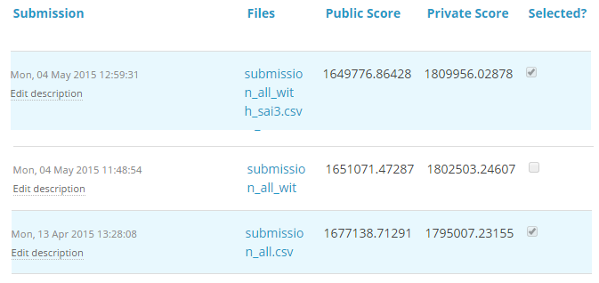](https://www.analyticsvidhya.com/wp-content/uploads/2015/05/kagglescores.png)

You will notice that the third entry which has the worst Public score turned to be the best model on Private ranking. There were more than 20 models above the “submission\_all.csv”, but I still chose “submission\_all.csv” as my final entry (which really worked out well). What caused this phenomenon? The dissimilarity in my public and private leader board is caused by over-fitting.

Over-fitting is nothing but when you model become highly complex that it starts capturing noise also. This ‘noise’ adds no value to model, but only inaccuracy.

In the following section, I will discuss how you can know if a solution is an over-fit or not before we actually know the test results.

### The concept: Cross Validation

Cross Validation is one of the most important concepts in any type of data modelling. It simply says, try to leave a sample on which you do not train the model and test the model on this sample before finalizing the model.

[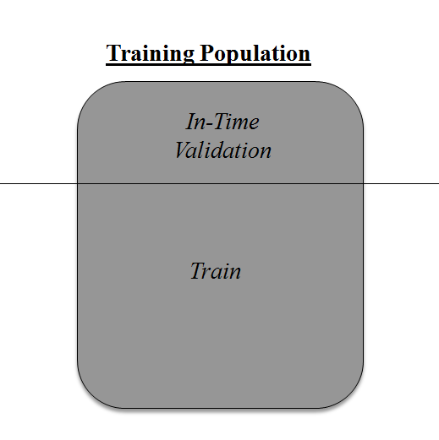](https://www.analyticsvidhya.com/wp-content/uploads/2015/05/validation.png)

Above diagram shows how to validate model with in-time sample. We simply divide the population into 2 samples, and build model on one sample. Rest of the population is used for in-time validation.

Could there be a negative side of the above approach?

I believe, a negative side of this approach is that we loose a good amount of data from training the model. Hence, the model is very high bias. And this won’t give best estimate for the coefficients. So what’s the next best option?

What if, we make a 50:50 split of training population and the train on first 50 and validate on rest 50. Then, we train on the other 50, test on first 50. This way we train the model on the entire population, however on 50% in one go. This reduces bias because of sample selection to some extent but gives a smaller sample to train the model on. This approach is known as 2-fold cross validation.

#### K-fold Cross validation

Let’s extrapolate the last example to k-fold from 2-fold cross validation. Now, we will try to visualize how a k-fold validation works.

[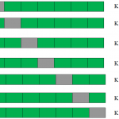](https://www.analyticsvidhya.com/wp-content/uploads/2015/05/kfolds.png)

This is a 7-fold cross validation.

Here’s what goes on behind the scene: we divide the entire population into 7 equal samples. Now we train models on 6 samples (Green boxes) and validate on 1 sample (grey box). Then, at the second iteration we train the model with a different sample held as validation. In 7 iterations, we have basically built model on each sample and held each of them as validation. This is a way to reduce the selection bias and reduce the variance in prediction power. Once we have all the 7 models, we take average of the error terms to find which of the models is best.

##### How does this help to find best (non-over-fit) model?

K-fold cross validation is widely used to check whether a model is an over fit or not. If the performance metrics at each of the k times modelling are close to each other and the mean of metric is highest. In a Kaggle competition, you might rely more on the cross validation score and not on the Kaggle public score. This way you will be sure that the Public score is not just by chance.

##### How do we implement k-fold with any model?

Coding k-fold in R and Python are very similar. Here is how you code a k-fold in Python:

from sklearn import cross\_validation model = RandomForestClassifier(n\_estimators=100) #Simple K-Fold cross validation. 5 folds. #(Note: in older scikit-learn versions the "n\_folds" argument is named "k".) cv = cross\_validation.KFold(len(train), n\_folds=5, indices=False) results = [] # "model" can be replaced by your model object # "Error\_function" can be replaced by the error function of your analysis for traincv, testcv in cv:             probas = model.fit(train[traincv], target[traincv]).predict\_proba(train[testcv])             results.append( Error\_function ) #print out the mean of the cross-validated results print "Results: " + str( np.array(results).mean() )

### But how do we choose k?

This is the tricky part. We have a trade off to choose k.

For a small k, we have a higher selection bias but low variance in the performances.

For a large k, we have a small selection bias but high variance in the performances.

Think of extreme cases:

k = 2 : We have only 2 samples similar to our 50-50 example. Here we build model only on 50% of the population each time. But as the validation is a significant population, the variance of validation performance is minimal.

k = number of observations (n):  This is also known as “Leave one out”. We have n samples and modelling repeated n number of times leaving only one observation out for cross validation. Hence, the selection bias is minimal but the variance of validation performance is very large.

Generally a value of k = 10 is recommended for most purpose.

## End Notes

Measuring the performance on training sample is point less. And leaving a in-time validation batch aside is a waste of data. K-Fold gives us a way to use every singe datapoint which can reduce this selection bias to a good extent. Also, K-fold cross validation can be used with any modelling technique.

In addition, the metrics covered in this article are some of the most used metrics of evaluation in a classification and regression problems.

Which metric do you often use in classification and regression problem? Have you used k-fold cross validation before for any kind of analysis? Did you see any significant benefits against using a batch validation? Do let us know your thoughts about this guide in the comments section below.

# Importance of Distance Metrics in Machine Learning Modelling

A number of Machine Learning Algorithms - Supervised or Unsupervised, use Distance Metrics to know the input data pattern in order to make any Data Based decision. A good distance metric helps in improving the performance of Classification, Clustering and Information Retrieval process significantly. In this article, we will discuss about different Distance Metrics and how do they help in Machine Learning Modelling.

## Introduction

In many real world applications, we use Machine Learning algorithms for classifying or recognizing images and for retrieving information through an Image’s content. For example - Face recognition, Censored Images online, Retail Catalog, Recommendation Systems etc. Choosing a good distance metric becomes really important here. The distance metric helps algorithms to recognize similarities between the contents.

Basic Mathematics Definition (Source Wikipedia),

*Distance metric uses distance function which provides a relationship metric between each elements in the dataset.*

Some of you might be thinking, what is this distance function? How does it work? How does it decide that a particular content or element in the data has any kind of relationship with another one? Well let’s try and find this out in next couple of sections.

## Distance Function

Do you remember studying Pythagorean Theorem? If you do, then you might remember calculating distance between two data points using the theorem.

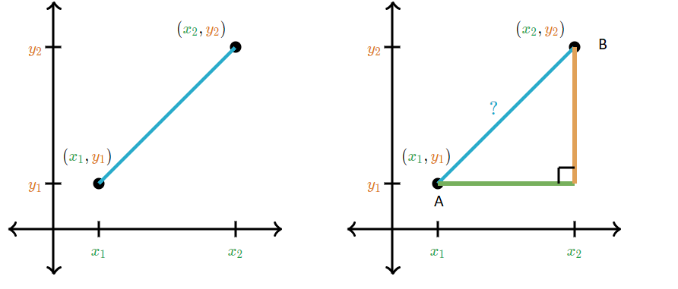

Taken from Khan Academy’s Distance Formula Tutorial

In order to calculate the distance between data points A and B Pythagorean theorem considers the length of x and y axis.

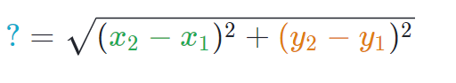

Many of you must be wondering that, do we even use this theorem in machine learning algorithm to find the distance. To answer your question, yes we do use it. In many machine learning algorithms we use the above formula as a distance function. We will talk about the algorithms where it is used.

Now you probably have got an idea what is a distance function? Here is a simplified definition.

Basic Definition from Math.net,

*A distance function provides distance between the elements of a set. If the distance is zero then elements are equivalent else they are different from each other.*

A distance function is nothing but a mathematical formula used by distance metrics. The distance function can differ across different distance metrics. Let’s talk about different distance metrics and understand their role in machine learning modelling.

## Distance Metrics

There are a number of distance metrics, but to keep this article concise, we will only be discussing a few widely used distance metrics. We will first try to understand the mathematics behind these metrics and then we will identify the machine learning algorithms where we use these distance metrics.

## Below are the commonly used distance metrics -

### **Minkowski Distance:**

Minkowski distance is a metric in Normed vector space. What is Normed vector space? A Normed vector space is a vector space on which a norm is defined. Suppose X is a vector space then a norm on X is a real valued function ||x||which satisfies below conditions -

1. **Zero Vector-**Zero vector will have zero length.
2. **Scalar Factor-** The direction of vector doesn’t change when you multiply it with a positive number though its length will be changed.
3. **Triangle Inequality-** If distance is a norm then the calculated distance between two points will always be a straight line.

You might be wondering why do we need normed vector, can we just not go for simple metrics? As normed vector has above properties which helps to keep the norm induced metric- homogeneous and translation invariant. More details can be found [here](https://math.stackexchange.com/questions/152340/whats-the-need-of-defining-notion-of-distance-using-norm-function-in-a-metric-s).

The distance can be calculated using below formula -

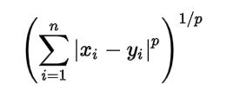

Minkowski distance is the generalized distance metric. Here generalized means that we can manipulate the above formula to calculate the distance between two data points in different ways.

As mentioned above, we can manipulate the value of p and calculate the distance in three different ways-

*p = 1, Manhattan Distance*

*p = 2, Euclidean Distance*

*p = ∞, Chebychev Distance*

We will discuss these distance metrics below in detail.

### **Manhattan Distance:**

We use Manhattan Distance if we need to calculate the distance between two data points in a grid like path. As mentioned above, we use **Minkowski distance**formula to find Manhattan distance by setting **p’s** value as **1**.

Let’s say, we want to calculate the distance, **d**, between two data points- **x** and **y**.

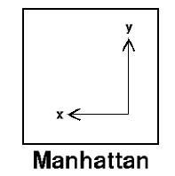

Distance **d**will be calculated using an **absolute sum of difference**between its Cartesian co-ordinates as below:

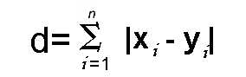

Where, n- number of variables, **xi** and **yi** are the variables of vectors x and y respectively, in the two dimensional vector space. I.e. **x = (x1,x2,x3,...)** and **y = (y1,y2,y3,…)**.

Now the distance **d** will be calculated as-

**(x1 - y1)** + **(x2 - y2)**+ **(x3 - y3)** + … +**(xn - yn)**.

If you try to visualize the distance calculation, it will look something like as below:

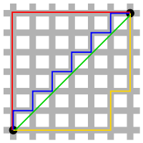

Source — Taxicab geometry Wikipedia

Manhattan distance is also known as Taxicab Geometry, City Block Distance etc.

### **Euclidean Distance:**

Euclidean distance is one of the most used distance metric. It is calculated using Minkowski Distance formula by setting **p’s** value to **2**. This will update the distance‘d’formula as below:

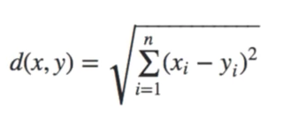

Let’s stop for a while! Does this formula look familiar? Well yes, we just saw this formula above in this article while discussing **“Pythagorean Theorem”.**

Euclidean distance formula can be used to calculate the distance between two data points in a plane.

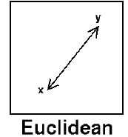

### **Cosine Distance:**

Mostly Cosine distance metric is used to find similarities between different documents. In cosine metric we measure the degree of angle between two documents/vectors (the term frequencies in different documents collected as metrics). This particular metric is used when the magnitude between vectors does not matter but the orientation.

Cosine similarity formula can be derived from the equation of dot products:-

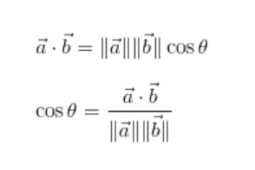

Now, you must be thinking which value of cosine angle will be helpful in finding out the similarities.

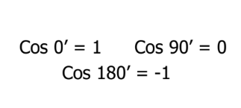

Now that we have the values which will be considered in order to measure the similarities, we need to know what 1, 0 and 1 signify.

Here cosine value 1 is for vectors pointing in the same direction i.e. there are similarities between the documents/data points. At zero for orthogonal vectors i.e. unrelated (some similarity found). Value -1 for vectors pointing in opposite directions (No similarity).

### **Mahalanobis Distance:**

Mahalanobis Distance is used for calculating the distance between two data points in a multivariate space.

According to Wikipedia Definition,

*The****Mahalanobis distance****is a measure of the distance between a point P and a distribution D. The idea of measuring is, how many standard deviations away P is from the mean of D.*

The benefit of using mahalanobis distance is, it takes covariance in account which helps in measuring the strength/similarity between two different data objects. The distance between an observation and the mean can be calculated as below -

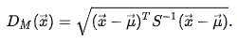

Here, S is the covariance metrics. We are using inverse of the covariance metric to get a variance-normalized distance equation.

Now that we have a basic idea about different distance metrics, we can move to the next step i.e. machine learning techniques/modelling which use these disatance metrics.

## Machine Learning Modelling and distance metrics

In this section, we will be working on some basic classification and clustering use cases. This will help us in understanding the usage of distance metrics in machine learning modelling. We will start with quick introduction of supervised and unsupervised algorithms and slowly will move on to the examples.

### 1. Classification

**K-Nearest Neighbours (KNN)-**

KNN is a non-probabilistic supervised learning algorithm i.e. it doesn’t produce the probability of membership of any data point rather KNN classifies the data on hard assignment, e.g the data point will either belong to 0 or 1. Now, you must be thinking how KNN works if there is no probability equation involved. KNN uses distance metrics in order to find similarities or dissimilarities.

Let’s take iris dataset which has three classes and see how KNN will identify the classes for test data.

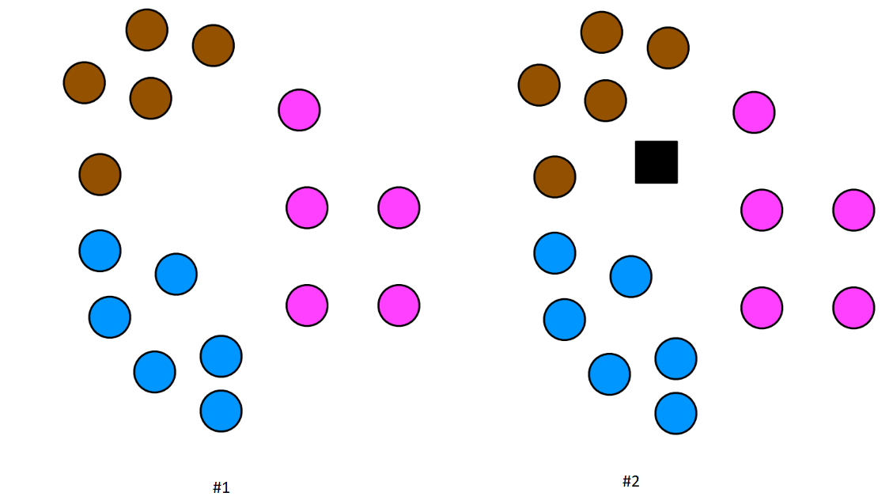

In the #2 image above the black square is a test data point. Now, we need to find which class this test data point belong to, with the help of KNN algorithm. We will now prepare the dataset to create machine learning model to predict the class for our test data.

#Import required libraries#Import required librariesimport numpy as np  
import pandas as pd  
from sklearn.model\_selection import train\_test\_split  
from sklearn.Neighbours import KNeighboursClassifier  
from sklearn.metrics import accuracy\_score#Load the dataset  
url = "<https://raw.githubusercontent.com/SharmaNatasha/Machine-Learning-using-Python/master/Datasets/IRIS.csv>"  
df = pd.read\_csv(url)#quick look into the data  
df.head(5)#Separate data and label  
x = df.iloc[:,1:4]  
y = df.iloc[:,4]#Prepare data for classification process  
x\_train, x\_test, y\_train, y\_test = train\_test\_split(x, y, test\_size=0.3, random\_state=0)

In KNN classification algorithm, we define the constant “K”. K is the number of nearest neighbours of a test data point. These K data points then will be used to decide the class for test data point.(Note this is in a training data set)

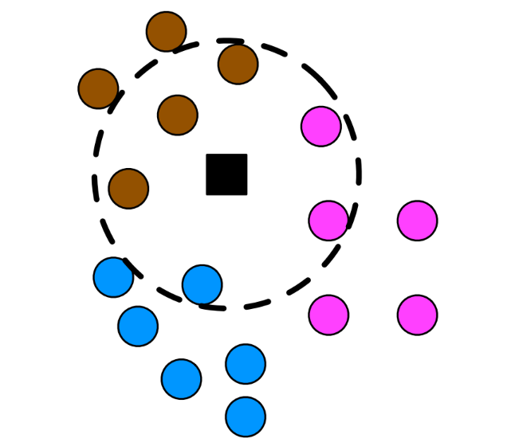

Are you wondering that how would we find the nearest neighbours. Well that’s where the distance metric comes into pictures. First, we calculate the distance between each train and test data point and then select the top nearest according to the value of k.

We won’t be creating the KNN from scratch but will be using scikit KNN classifier.

#Create a modelKNN\_Classifier = KNeighboursClassifier(n\_Neighbours = 6, p = 2, metric='minkowski')

You can see in the above code we are using Minkowski distance metric with value of p as 2 i.e. KNN classifier is going to use Euclidean Distance Metric formula.

As we move forward with machine learning modelling we can now train our model and start predicting the class for test data.

#Train the model  
KNN\_Classifier.fit(x\_train, y\_train)#Let's predict the classes for test data  
pred\_test = KNN\_Classifier.predict(x\_test)

Once the top nearest neighbours are selected, we check most voted class in neighbours -

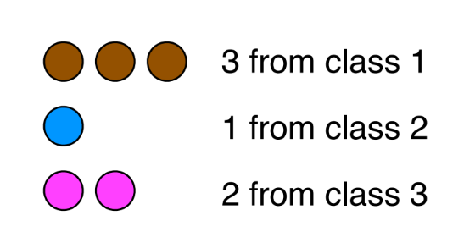

From the above image, can you guess the class for test point? It’s class 1 as it is most voted class.

Through this small example we saw how distance metric was important for KNN classifier. It helped us to get the closest train data points for which classes were known. There is a possibility that using different distance metrics we might get better results. So, in non-probabilistic algorithm like KNN distance metrics plays an important role.

### 2. Clustering

**K-means-**

In classification algorithms, probabilistic or non-probabilistic we will be provided with labeled data so, it gets easier to predict the classes. Though in clustering algorithm we have no information on which data point belongs to which class. Distance metrics are important part of these kind of algorithm.

In K-means, we select number of centroids that define number of clusters. Each data point will then be assigned to its nearest centroid using distance metric (Euclidean). We will be using iris data to understand the underlying process of K-means.

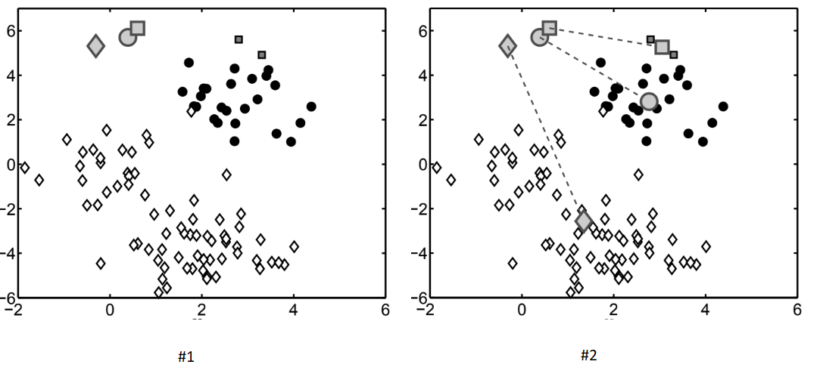

In the above image #1 as you can see we randomly placed the centroids and in the image #2, using distance metric tried to find their closest cluster class.

import numpy as np  
import pandas as pd  
from sklearn.cluster import K-means  
import matplotlib.pyplot as plt#Load the dataset  
url = "<https://raw.githubusercontent.com/SharmaNatasha/Machine-Learning-using-Python/master/Datasets/IRIS.csv>"  
df = pd.read\_csv(url)#quick look into the data  
df.head(5)#Separate data and label  
x = df.iloc[:,1:4].values#Creating the k-means classifier  
K-means\_Cluster = K-means(n\_clusters = 3)  
y\_class = K-means\_Cluster.fit\_predict(x)

We will need to keep repeating the assignment of centroids until we have a clear cluster structure.

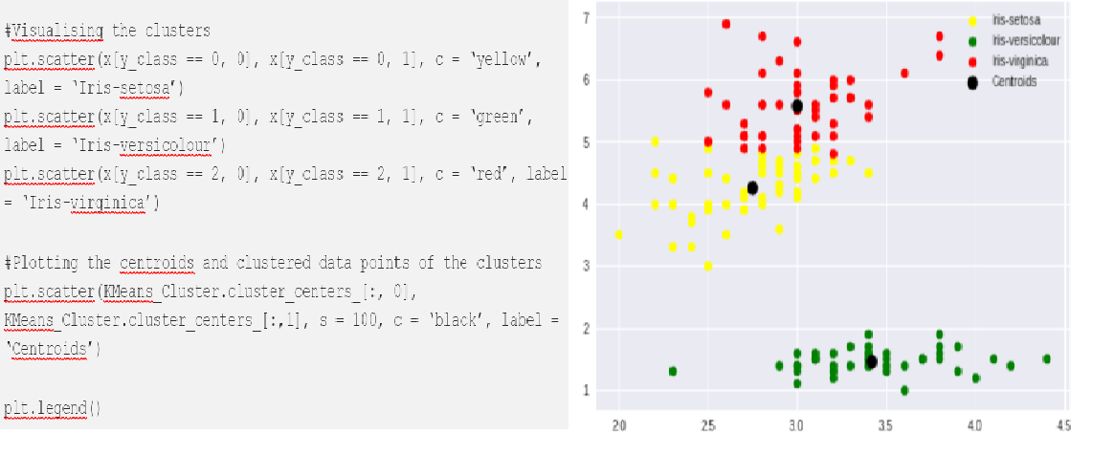

As we saw in the above example, without having any knowledge about the labels with the help of distance metric in K-Means we clustered the data into 3 classes.

### 3 Natural Language Processing

**Information Retrieval**

In information retrieval we work with unstructured data. The data can be an article, website, emails, text messages, a social media post etc. With the help of techniques used in NLP we can create vector data in a manner that can be used to retrieve information when queried. Once the unstructured data is transformed into vector form, we can use cosine similarity metric to filter out the irrelevant documents from the corpus.

Let’s take an example and understand the usage of cosine similarity.

1. Create vector form for Corpus and Query-

import math  
import numpy as np  
import pandas as pd  
import matplotlib.pyplot as pyplot  
from sklearn.metrics.pairwise import cosine\_similarity  
from sklearn.feature\_extraction.text import TfidfVectorizervectorizer = TfidfVectorizer()corpus = [  
 'the brown fox jumped over the brown dog',  
 'the quick brown fox',  
 'the brown brown dog',  
 'the fox ate the dog'  
]query = ["brown"]X = vectorizer.fit\_transform(corpus)  
Y = vectorizer.transform(query)

2. Check the similarities i.e find which document in corpus is relevant to our query-

cosine\_similarity(Y, X.toarray())**Results:**  
**array([[0.54267123, 0.44181486, 0.84003859, 0. ]])**

As you can see from the above example, we queried for word “brown” and in corpus there are only three documents which contain word “brown”. When checked with cosine similarity metric it gave the same results by having >0 values for three document except the forth one.

### Conclusion

Throughout this article, we got to know about few popular distance/similarity metrics and how these can be used in order to solve complicated machine learning problems. Hope this will be helpful for people who are in their first stage of getting into Machine Learning/Data Science.

# Polynomial Regression with Python

# Check out the Linear Regression first

In my previous post, we discussed about [Linear Regression](https://towardsdatascience.com/machine-learning-simple-linear-regression-with-python-f04ecfdadc13). Let’s take a look back. Linear Regression is applied for the data set that their values are **linear**as below example:

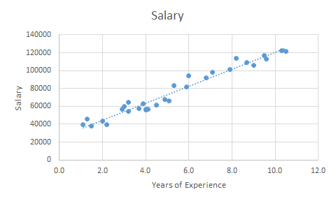

Salary based on Years of Experience ([salary\_data.csv](https://s3.us-west-2.amazonaws.com/public.gamelab.fun/dataset/salary_data.csv))

And real life is not that simple, especially when you observe from many different companies in different industries. Salary of 1 YE teacher is different from 1 YE engineer; even 1 YE civil engineer is different from mechanical engineer; and if you compare 2 mechanical engineers from 2 different companies, their salary mostly different as well. So how can we predict the salary of a candidate?

Today, we will use another data set to represent the Polynomial shape.

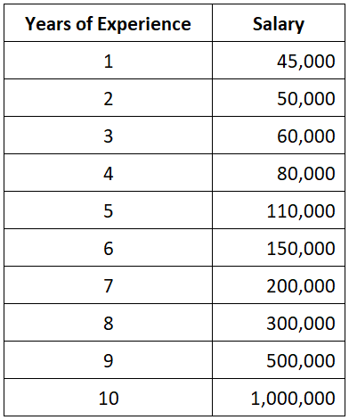

Salary based on Years of Experience ([position\_salaries.csv](https://s3.us-west-2.amazonaws.com/public.gamelab.fun/dataset/position_salaries.csv))

To get an overview of the increment of salary, let’s visualize the data set into a chart:

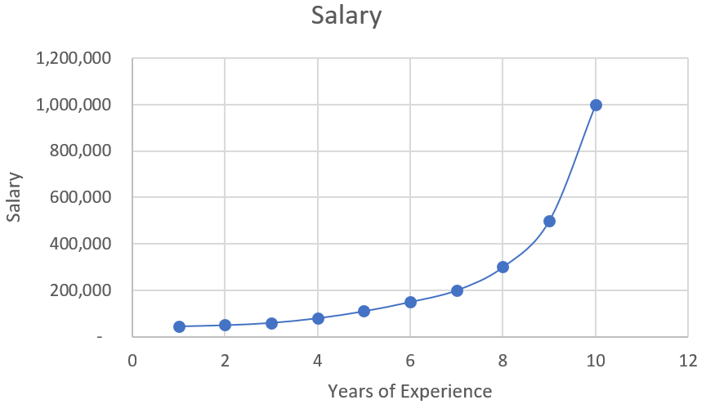

Salary based on Years of Experience — Plotting

Let’s think about our candidate. He has 5 YE. What if we use the [Linear Regression](https://towardsdatascience.com/machine-learning-simple-linear-regression-with-python-f04ecfdadc13) in this example?

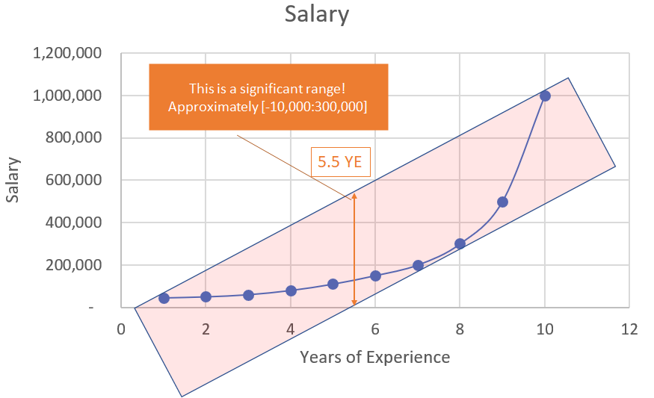

Linear visualization

According to the picture above, the salary range of our candidate could be approximately from **minus** $10,000 to $300,000. Why? Look, the salary observations in this scenarios are not linear. **They are in a curved shape!** That’s why applying [Linear Regression](https://towardsdatascience.com/machine-learning-simple-linear-regression-with-python-f04ecfdadc13) in this scenario is not giving you the right value. It’s time for **Polynomial Regression**.

# Why Polynomial Regression?

Because it’s much much more accurate!

We are already know the salary of 5 YE is $110,000 and 6 YE is $150,000. It means the salary of 5.5 YE should be between them! And this is how the best value should be:

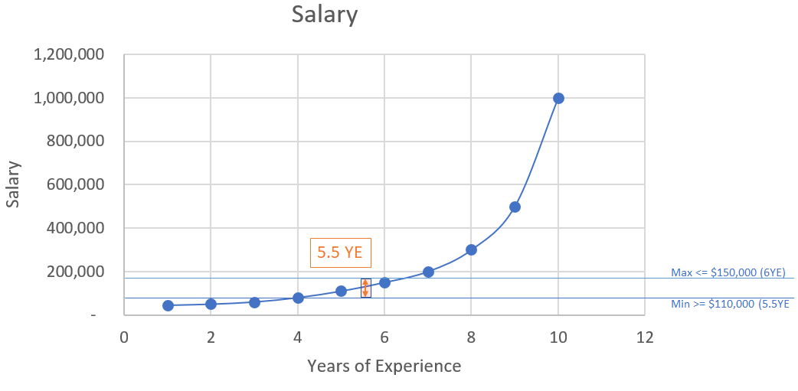

Polynomial visualization

Let’s compare the gaps between using Linear and Polynomial. Pay attention to the red circle:

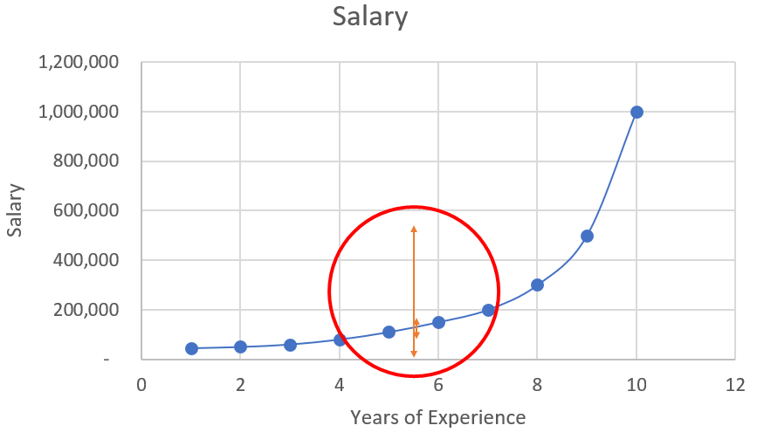

Comparison between Linear and Polynomial

It’s too small to see? Zoom it out!

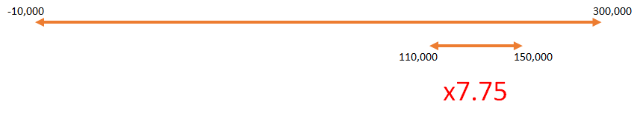

Gaps between Linear and Polynomial

It’s mostly **7.75 times** more accurate than using [Linear Regression](https://towardsdatascience.com/machine-learning-simple-linear-regression-with-python-f04ecfdadc13)!

So how to calculate the salary for our 5.5 YE candidate? We can quick calculate by using the Mean value. Because 5.5 is the average of 5 and 6, so the salary could be calculated as:

*(150,000 + 110,000) / 2 =****$130,000***

Note: if you don’t know what is Mean value, please read my previous post about [Mean, Median, and Mode](https://medium.com/@nhan.tran/mean-median-an-mode-in-statistics-3359d3774b0b). Thanks.

But it’s not the highest accuracy rate and too manual! Let’s apply the Machine Learning for more accuracy and flexible calculation. Time to start your Spyder IDE!

# Polynomial Regression with Python

In this sample, we have to use 4 libraries as numpy, pandas, matplotlib and sklearn. Now we have to import libraries and get the data set first:

Code explanation:

* + dataset: the table contains all values in our csv file
  + X: the 2nd column which contains Years Experience array
  + y: the last column which contains Salary array

Let’s split our dataset to get training set and testing set (both X and y values per each set)

Code explanation:

* + test\_size=0.2: we will split our dataset (10 observations) into 2 parts (training set, test set) and the ratio of **test set**compare to dataset is 0.2 (2 observations will be put into the **test set**. You can put it 1/5 to get 20% or 0.2, they are the same. We should not let the test set too big; if it’s too big, we will lack of data to train. Normally, we should pick around 5% to 30%.
  + train\_size: if we use the test\_size already, the rest of data will automatically be assigned to train\_size.
  + random\_state: this is the seed for the random number generator. We can put an instance of the RandomState class as well. If we leave it blank or 0, the RandomState instance used by np.random will be used instead.

We already have the train set and test set, now we have to build the Regression Model. Firstly, we will build a Linear Regression model and visualize it (it’s no need to include this step in your practice, we just do this for comparison between Linear and Polynomial only):

After calling the viz\_linear() function, you can see a plotting as per below:

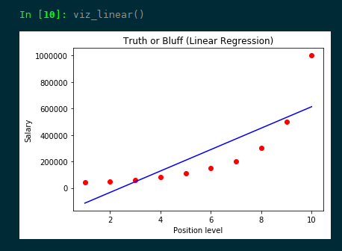

Linear Regression model visualization

In another hand, we will build the Polynomial Regression model and visualize it to see the differences:

After calling the viz\_polynomial() function, you can see a plotting as per below:

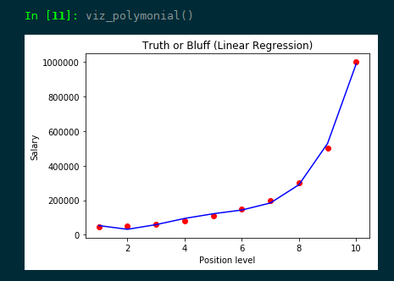

Polynomial Regression model visualization

Last step, let’s predict the value of our candidate (with 5.5 YE) using both Linear Regression model and Polynomial Regression model:

You can see, the predicted values using Linear Regression model and Polynomial Regression model are totally different!

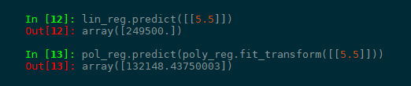

Comparison between lin\_reg and pol\_reg

Let’s scroll up and check again what we got? According to our data set, our salary should be:

*$110,000 < the salary < $150,000*

But the predicted salary using Linear Regression lin\_reg is **$249,500**. It’s unacceptable (but still in the range of -10,000 to 300,000 according to Linear Regression)! What’s about using Polynomial Regression? Our pol\_reg value is **$132,148.43750** which is very close to our **Mean value which is $130,000**.

Bingo! It’s time to let our candidate know we will offer him a best salary in class with $132,148!

Before ending my post, here is our complete source code and data set for you to practice on your playground:

* + [position\_salaries.csv](https://s3.us-west-2.amazonaws.com/public.gamelab.fun/dataset/position_salaries.csv)
  + [polynomial\_regression.py](https://gist.github.com/panicpotatoe/dcc956002ed879394e91d184c227a520)

# Imbalanced Data: How to handle Imbalanced Classification Problems

## Introduction

If you have spent some time in machine learning and data science, you would have definitely come across imbalanced class distribution. This is a scenario where the number of observations belonging to one class is significantly lower than those belonging to the other classes.

This problem is predominant in scenarios where anomaly detection is crucial like electricity pilferage, fraudulent transactions in banks, identification of rare diseases, etc. In this situation, the predictive model developed using conventional machine learning algorithms could be biased and inaccurate.

This happens because Machine Learning Algorithms are usually designed to improve accuracy by reducing the error. Thus, they do not take into account the class distribution / proportion or balance of classes.

This guide describes various approaches for solving such class imbalance problems using various sampling techniques. We also weigh each technique for its pros and cons. Finally, I reveal an approach using which you can create a balanced class distribution and apply ensemble learning technique designed especially for this purpose.

## Table of Content

1. Challenges faced with Imbalanced datasets
2. Approach to handling Imbalanced Datasets
3. Illustrative Example
4. Conclusion

## 1. Challenges faced with imbalanced data

One of the main challenges faced by the utility industry today is electricity theft. Electricity theft is the third largest form of theft worldwide. Utility companies are increasingly turning towards advanced analytics and machine learning algorithms to identify consumption patterns that indicate theft.

However, one of the biggest stumbling blocks is the humongous data and its distribution. Fraudulent transactions are significantly lower than normal healthy transactions i.e. accounting it to around 1-2 % of the total number of observations. They ask to improve identification of the rare minority class as opposed to achieving higher overall accuracy.

Machine Learning algorithms tend to produce unsatisfactory classifiers when faced with imbalanced datasets. For any imbalanced data set, if the event to be predicted belongs to the minority class and the event rate is less than 5%, it is usually referred to as a rare event.

### Example of imbalanced data

Let’s understand this with the help of an example.

**Ex:** In an utilities fraud detection data set you have the following data:

Total Observations = 1000

Fraudulent  Observations = 20

Non Fraudulent Observations = 980

Event Rate= 2 %

The main question faced during data analysis is – How to get a balanced dataset by getting a decent number of samples for these anomalies given the rare occurrence for some them?

### Challenges with standard Machine learning techniques

The conventional model evaluation methods do not accurately measure model performance when faced with imbalanced datasets.

Standard classifier algorithms like Decision Tree and Logistic Regression have a bias towards classes which have number of instances. They tend to only predict the majority class data. The features of the minority class are treated as noise and are often ignored. Thus, there is a high probability of misclassification of the minority class as compared to the majority class.

Evaluation of a classification algorithm performance is measured by the Confusion Matrix which contains information about the actual and the predicted class.

*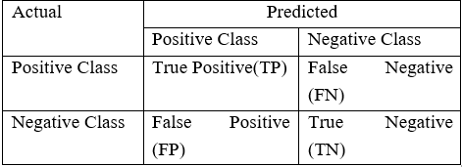***Accuracy of a model = (TP+TN) / (TP+FN+FP+TN)**

However, while working in an imbalanced domain accuracy is not an appropriate measure to evaluate model performance**.**For eg: A classifier which achieves an accuracy of 98 % with an event rate of 2 % is not accurate, if it classifies all instances as the majority class. And eliminates the 2 % minority class observations as noise.

### Examples of imbalanced data

Thus, to sum it up, while trying to resolve specific business challenges with imbalanced data sets, the classifiers produced by standard machine learning algorithms might not give accurate results. Apart from fraudulent transactions, other examples of a common business problem with imbalanced dataset are:

* Datasets to identify customer churn where a vast majority of customers will continue using the service. Specifically, Telecommunication companies where Churn Rate is lower than 2 %.
* Data sets to identify rare diseases in medical diagnostics etc.
* Natural Disaster like Earthquakes

### Dataset used

In this article, we will illustrate the various techniques to train a model to perform well against highly imbalanced datasets. And accurately predict rare events using the following fraud detection dataset:

Total Observations = 1000

Fraudulent   Observations =20

Non-Fraudulent Observations = 980

Event Rate= 2 %

Fraud Indicator = 0 for Non-Fraud Instances

Fraud Indicator = 1 for Fraud

## 2. Approach to handling Imbalanced Data

### 2.1 Data Level approach: Resampling Techniques

Dealing with imbalanced datasets entails strategies such as improving classification algorithms or balancing classes in the training data (data pre-processing) before providing the data as input to the machine learning algorithm. The later technique is preferred as it has wider application.

The main objective of balancing classes is to either increasing the frequency of the minority class or decreasing the frequency of the majority class. This is done in order to obtain approximately the same number of instances for both the classes. Let us look at a few resampling techniques:

#### 2.1.1 Random Under-Sampling

Random Under sampling aims to balance class distribution by randomly eliminating majority class examples.  This is done until the majority and minority class instances are balanced out.

Total Observations = 1000

Fraudulent   Observations =20

Non Fraudulent Observations = 980

Event Rate= 2 %

In this case we are taking 10 % samples without replacement from Non Fraud instances.  And combining them with Fraud instances.

Non Fraudulent Observations after random under sampling = 10 % of 980 =98

Total Observations after combining them with Fraudulent observations = 20+98=118

Event Rate for the new dataset after under sampling = 20/118 = 17%

* **Advantages**
  + It can help improve run time and storage problems by reducing the number of training data samples when the training data set is huge.
* **Disadvantages**
  + It can discard potentially useful information which could be important for building rule classifiers.
  + The sample chosen by random under sampling may be a biased sample. And it will not be an accurate representative of the population. Thereby, resulting in inaccurate results with the actual test data set.

#### 2.1.2 Random Over-Sampling

Over-Sampling increases the number of instances in the minority class by randomly replicating them in order to present a higher representation of the minority class in the sample.

Total Observations = 1000

Fraudulent   Observations =20

Non Fraudulent Observations = 980

Event Rate= 2 %

In this case we are replicating 20 fraud observations   20 times.

Non Fraudulent Observations =980

Fraudulent Observations after replicating the minority class observations= 400

Total Observations in the new data set after oversampling=1380

Event Rate for the new data set after under sampling= 400/1380 = 29 %

* **Advantages**
  + Unlike under sampling this method leads to no information loss.
  + Outperforms under sampling
* **Disadvantages**
  + It increases the likelihood of overfitting since it replicates the minority class events.

#### 2.1.3 Cluster-Based Over Sampling

In this case, the K-means clustering algorithm is independently applied to minority and majority class instances. This is to identify clusters in the dataset. Subsequently, each cluster is oversampled such that all clusters of the same class have an equal number of instances and all classes have the same size. 

Total Observations = 1000

Fraudulent   Observations =20

Non Fraudulent Observations = 980

Event Rate= 2 %

* **Majority Class Clusters**
  1. Cluster 1: 150 Observations
  2. Cluster 2: 120 Observations
  3. Cluster 3: 230 observations
  4. Cluster 4: 200 observations
  5. Cluster 5: 150 observations
  6. Cluster 6: 130 observations
* **Minority  Class Clusters**
  1. Cluster 1: 8 Observations
  2. Cluster 2: 12 Observations

**After oversampling of each cluster, all clusters of the same class contain the same number of observations.**

* **Majority Class Clusters**
  1. Cluster 1: 170 Observations
  2. Cluster 2: 170 Observations
  3. Cluster 3: 170 observations
  4. Cluster 4: 170   observations
  5. Cluster 5: 170   observations
  6. Cluster 6: 170   observations
* **Minority   Class Clusters**
  1. Cluster 1: 250 Observations
  2. Cluster 2: 250 Observations

Event Rate post cluster based oversampling sampling = 500/ (1020+500) = 33 %

* **Advantages**
  + This clustering technique helps overcome the challenge between class imbalance. Where the number of examples representing positive class differs from the number of examples representing a negative class.
  + Also, overcome challenges within class imbalance, where a class is composed of different sub clusters. And each sub cluster does not contain the same number of examples.
* **Disadvantages**
  + The main drawback of this algorithm, like most oversampling techniques is the possibility of over-fitting the training data.

#### 2.1.4 Informed Over Sampling: Synthetic Minority Over-sampling Technique for imbalanced data

This technique is followed to avoid overfitting which occurs when exact replicas of minority instances are added to the main dataset. A subset of data is taken from the minority class as an example and then new synthetic similar instances are created. These synthetic instances are then added to the original dataset. The new dataset is used as a sample to train the classification models.

Total Observations = 1000

Fraudulent Observations = 20

Non Fraudulent Observations = 980

Event Rate = 2 %

A sample of 15 instances is taken from the minority class and similar synthetic instances are generated 20 times

Post generation of synthetic instances, the following data set is created

Minority Class (Fraudulent Observations) = 300

Majority Class (Non-Fraudulent Observations) = 980

Event rate= 300/1280 = 23.4 %

* **Advantages**
  + Mitigates the problem of overfitting caused by random oversampling as synthetic examples are generated rather than replication of instances
  + No loss of useful information
* **Disadvantages**
  + While generating synthetic examples SMOTE does not take into consideration neighbouring examples from other classes. This can result in increase in overlapping of classes and can introduce additional noise
  + SMOTE is not very effective for high dimensional data

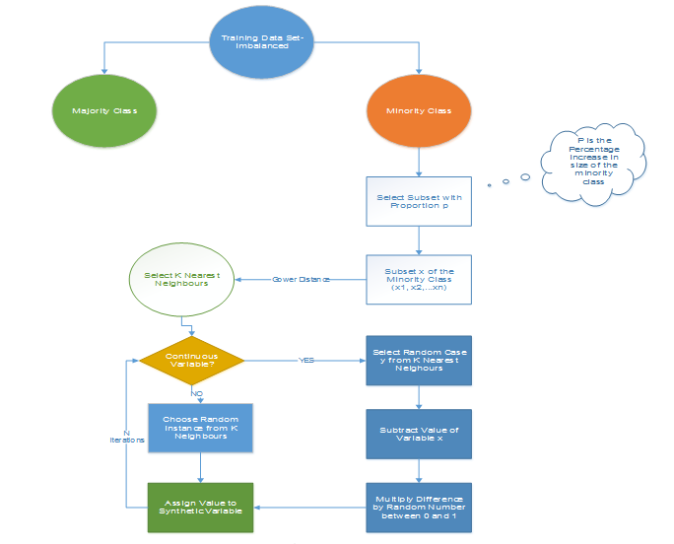

\*\*N is the number of attributes

**Figure 1:  Synthetic Minority Oversampling Algorithm**

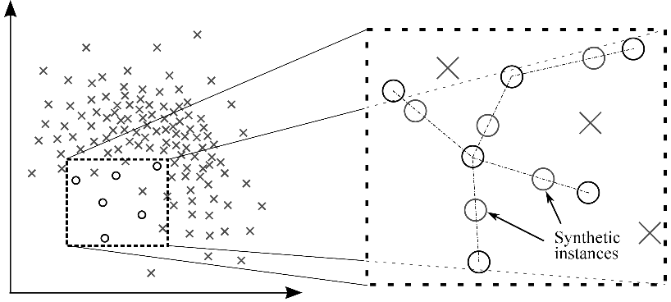

**Figure 2: Generation of Synthetic Instances with the help of SMOTE**

#### 2.1.5 Modified synthetic minority oversampling technique (MSMOTE) for imbalanced data

It is a modified version of SMOTE. SMOTE does not consider the underlying distribution of the minority class and latent noises in the dataset. To improve the performance of SMOTE a modified method MSMOTE is used.

This algorithm classifies the samples of minority classes into 3 distinct groups – Security/Safe samples, Border samples, and latent nose samples. This is done by calculating the distances among samples of the minority class and samples of the training data.

Security samples are those data points which can improve the performance of a classifier. While on the other hand, noise are the data points which can reduce the performance of the classifier.  The ones which are difficult to categorize into any of the two are classified as border samples.

While the basic flow of MSOMTE is the same as that of SMOTE (discussed in the previous section).  In MSMOTE the strategy of selecting nearest neighbors is different from SMOTE**.** The algorithm randomly selects a data point from the k nearest neighbors for the security sample, selects the nearest neighbor from the border samples and does nothing for latent noise.

### 2.2 Algorithmic Ensemble Techniques

The above section, deals with handling imbalanced data by resampling original data to provide balanced classes. In this section, we are going to look at an alternate approach i.e.  Modifying existing classification algorithms to make them appropriate for imbalanced data sets.

The main objective of ensemble methodology is to improve the performance of single classifiers. The approach involves constructing several two stage classifiers from the original data and then aggregate their predictions. **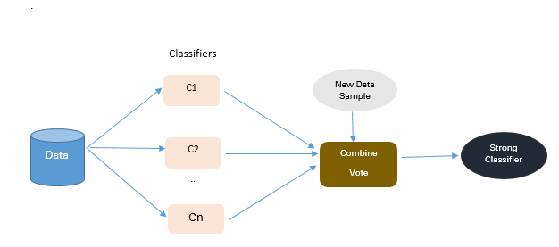**

**Figure 3: Approach to Ensemble based Methodologies**

#### 2.2.1. Bagging Based techniques for imbalanced data

Bagging is an abbreviation of Bootstrap Aggregating. The conventional bagging algorithm involves generating ‘n’ different bootstrap training samples with replacement. And training the algorithm on each bootstrapped algorithm separately and then aggregating the predictions at the end.

Bagging is used for reducing Overfitting in order to create strong learners for generating accurate predictions. Unlike boosting, bagging allows replacement in the bootstrapped sample.

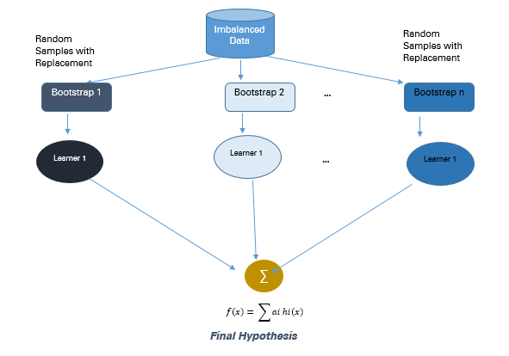

**Figure 4:  Approach to Bagging Methodology**

Total Observations = 1000

Fraudulent   Observations =20

Non Fraudulent Observations = 980

Event Rate= 2 %

There are 10 bootstrapped samples chosen from the population with replacement. Each sample contains 200 observations. And each sample is different from the original dataset but resembles the dataset in distribution & variability**.**

The machine learning algorithms like logistic regression, neural networks, decision tree  are fitted to each bootstrapped sample of 200 observations. And the Classifiers c1, c2…c10 are aggregated to produce a compound classifier.  This ensemble methodology produces a stronger compound classifier since it combines the results of individual classifiers to come up with an improved one.

* **Advantages**
  + Improves stability & accuracy of machine learning algorithms
  + Reduces variance
  + Overcomes overfitting
  + Improved misclassification rate of the bagged classifier
  + In noisy data environments bagging outperforms boostin
* **Disadvantages**
  + Bagging works only if the base classifiers are not bad to begin with. Bagging bad classifiers can further degrade performance

#### 2.2.2. Boosting-Based techniques for imbalanced data

Boosting is an ensemble technique to combine weak learners to create a strong learner that can make accurate predictions. Boosting starts out with a base classifier / weak classifier that is prepared on the training data.

What are base learners / weak classifiers?

The base learners / Classifiers are weak learners i.e. the prediction accuracy is only slightly better than average. A classifier learning algorithm is said to be weak when small changes in data induce big changes in the classification model.

In the next iteration, the new classifier focuses on or places more weight to those cases which were incorrectly classified in the last round.

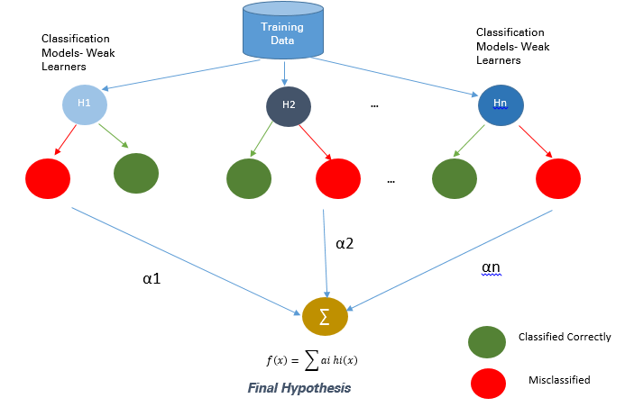

**Figure 5: Approach to Boosting Methodologies**

#### 2.2.2.1. Adaptive Boosting- Ada Boost techniques for imbalanced data

Ada Boost is the first original boosting technique which creates a highly accurate prediction rule by combining many weak and inaccurate rules.  Each classifier is serially trained with the goal of correctly classifying examples in every round that were incorrectly classified in the previous round.

For a learned classifier to make strong predictions it should follow the following three conditions:

* The rules should be simple
* Classifier should have been trained on sufficient number of training examples
* The Classifier should have low training error for the training instances

Each of the weak hypothesis has an accuracy slightly better than random guessing i.e. Error Term € (t) should be slightly more than ½-β where β >0. This is the fundamental assumption of this boosting algorithm which can produce a final hypothesis with a small error

After each round, it gives more focus to examples that are harder to classify.  The quantity of focus is measured by a weight, which initially is equal for all instances. After each iteration, the weights of misclassified instances are increased and the weights of correctly classified instances are decreased.

**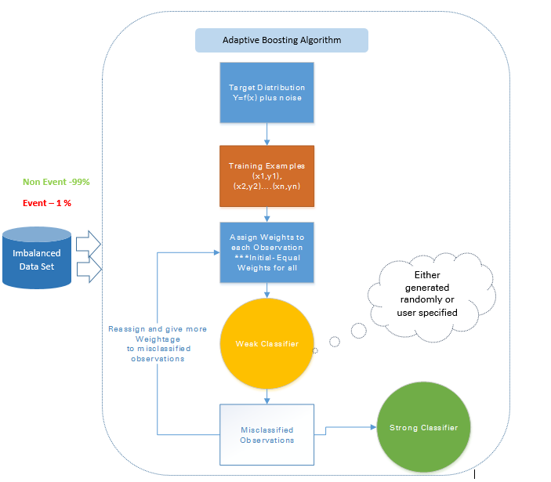**

**Figure 6:  Approach to Adaptive Boosting**

For example in a data set containing 1000 observations out of which 20 are labelled fraudulent. Equal weights W1 are assigned to all observations and the base classifier accurately classifies 400 observations.

Weight of each of the 600 misclassified observations is increased to w2 and weight of each of the correctly classified observations is reduced to w3.

In each iteration, these updated weighted observations are fed to the weak classifier to improve its performance. This process continues till the misclassification rate significantly decreases thereby resulting in a strong classifier.

* **Advantages**
  1. Very Simple to implement
  2. Good generalization- suited for any kind of classification problem ü Not prone to overfitting
* **Disadvantages**
  1. Sensitive to noisy data and outliers

#### 2.2.2.2  Gradient Tree Boosting techniques for imbalanced data

In Gradient Boosting many models are trained sequentially. It is a numerical optimization algorithm where each model minimizes the loss function, **y = ax+b+e**, using the Gradient Descent Method.

Decision Trees are used as weak learners in Gradient Boosting.

While both Adaboost and Gradient Boosting work on weak learners / classifiers. And try to boost them into a strong learner, there are some fundamental differences in the two methodologies. Adaboost either requires the users to specify a set of weak learners  or randomly generates the weak learners before the actual learning process. The weight of each learner is adjusted at every step depending on whether it predicts a sample correctly.

On the other hand, Gradient Boosting builds the first learner on the training dataset to predict the samples, calculates the loss (Difference between real value and output of the first learner). And use this loss to build an improved learner in the second stage.

At every step, the residual of the loss function is calculated using the Gradient Descent Method and the new residual becomes a target variable for the subsequent iteration.

Gradient Boosting can be done using the Gradient Boosting Node in SAS Miner and GBM package in R

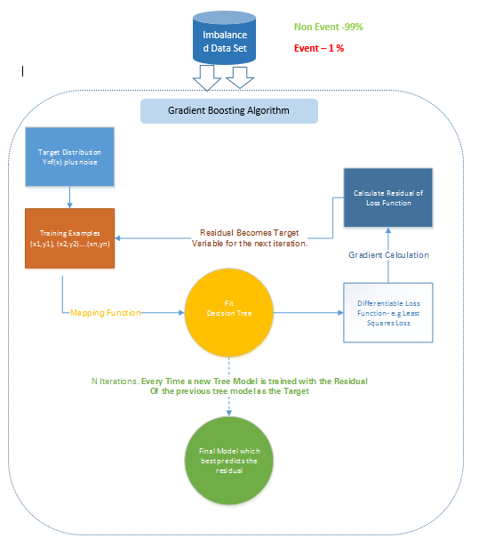

**Figure 7:  Approach to Gradient Boosting**

For example: In a training data set containing 1000 observations out of which 20 are labelled fraudulent an initial base classifier. Target Variable Fraud =1 for fraudulent transactions and Fraud=0 for not fraud transactions.

For eg: Decision tree is fitted which accurately classifying only 5 observations as Fraudulent observations. A differentiable loss function is calculated based on the difference between the actual output and the predicted output of this step.  The residual of the loss function is the target variable (F1) for the next iteration.

Similarly, this algorithm internally calculates the loss function, updates the target at every stage and comes up with an improved classifier as compared to the initial classifier.

* **Disadvantages**
  + Gradient Boosted trees are harder to fit than random forests
  + Gradient Boosting Algorithms generally have 3 parameters which can be fine-tuned, Shrinkage parameter, depth of the tree, the number of trees. Proper training of each of these parameters is needed for a good fit. If parameters are not tuned correctly it may result in over-fitting.

#### **2.2.2.3 XG Boost techniques for imbalanced data**

XGBoost (Extreme Gradient Boosting) is an advanced and more efficient implementation of Gradient Boosting Algorithm discussed in the previous section.

Advantages over Other Boosting Techniques

* It is 10 times faster than the normal Gradient Boosting as it implements parallel processing. It is highly flexible as users can define custom optimization objectives and evaluation criteria, has an inbuilt mechanism to handle missing values.
* Unlike gradient boosting which stops splitting a node as soon as it encounters a negative loss, XG Boost splits up to the maximum depth specified and prunes the tree backward and removes splits beyond which there is an only negative loss.

Extreme gradient boosting can be done using the XGBoost package in R and Python

## 3. Illustrative Example on dealing with imbalanced data

### 3.1. Data Description

The illustrative telecom churn dataset has  47241 client records with each record containing information about 27 key predictor variables.

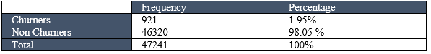

The data structure  of the rare event data set is shown below post missing value removal, outlier treatment and dimension reduction.

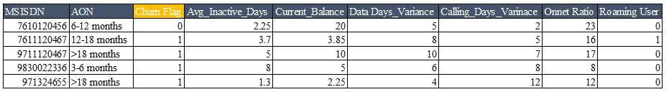

Download the Dataset from here: [Sample Dataset](https://www.analyticsvidhya.com/wp-content/uploads/2017/03/SampleData_IMC.csv)

## 4. Conclusion

When faced with imbalanced data sets there is no one stop solution to improve the accuracy of the prediction model.  One may need to try out multiple methods to figure out the best-suited sampling techniques for the dataset. In most cases, synthetic techniques like SMOTE and MSMOTE will outperform the conventional oversampling and undersampling methods.

For better results, one can use synthetic sampling methods like SMOTE and MSMOTE along with advanced boosting methods like Gradient boosting and XG Boost.

One of the advanced bagging techniques commonly used to counter the imbalanced dataset problem is SMOTE bagging. It follows an entirely different approach from conventional bagging to create each Bag/Bootstrap. It generates the positive instances by the SMOTE Algorithm by setting a SMOTE resampling rate in each iteration. The set of negative instances is bootstrapped in each iteration.

Depending on the characteristics of the imbalanced data set, the most effective techniques will vary. Relevant evaluation parameters should be considered during the model comparison.

While comparing multiple prediction models built through an exhaustive combination of the above-mentioned techniques Lift & Area under the ROC Curve will be instrumental in determining which model is superior to the others.

# A Simple Guide to Scikit-learn Pipelines

In most machine learning projects the data that you have to work with is unlikely to be in the ideal format for producing the best performing model. There are quite often a number of transformational steps such as encoding categorical variables, feature scaling and normalisation that need to be performed. Scikit-learn has built in functions for most of these commonly used transformations in it’s [preprocessing](https://scikit-learn.org/stable/modules/preprocessing.html" \l "preprocessing" \t "_blank) package.

However, in a typical machine learning workflow you will need to apply all these transformations at least twice. Once when training the model and again on any new data you want to predict on. Of course you could write a function to apply them and reuse that but you would still need to run this first and then call the model separately. Scikit-learn pipelines are a tool to simplify this process.

They have several key benefits:

* They make your workflow much easier to read and understand.
* They enforce the implementation and order of steps in your project.
* These in turn make your work much more reproducible.

In the following post I am going to use a data set, taken from Analytics Vidhya’s [loan prediction](https://datahack.analyticsvidhya.com/contest/practice-problem-loan-prediction-iii/) practice problem, to describe how the pipelines work and how to implement them.

**Transformers**

First I have imported the train and test files into a jupyter notebook. I have dropped the ‘Loan\_ID’ column as this will not be needed in training or prediction. I have used the pandas dtypes function to get a little information about the dataset.

import pandas as pd  
train = pd.read\_csv('train.csv')  
test = pd.read\_csv('test.csv')  
train = train.drop('Loan\_ID', axis=1)  
train.dtypes

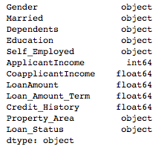

I can see that I have both categorical and numeric variables so as a minimum I am going to have to apply a one hot encoding transformation and some sort of scaler. I am going to use a scikit-learn pipeline to perform those transformations, and at the same time apply the fit method.

Before building the pipeline I am splitting the training data into a train and test set so that I can validate the performance of the model.

X = train.drop('Loan\_Status', axis=1)  
y = train['Loan\_Status']from sklearn.model\_selection import train\_test\_splitX\_train, X\_test, y\_train, y\_test = train\_test\_split(X, y, test\_size=0.2)

The first step in building the pipeline is to define each transformer type. The convention here is generally to create transformers for the different variable types. In the code below I have created a numeric transformer which applies a StandardScaler, and includes a [SimpleImputer](https://scikit-learn.org/stable/modules/generated/sklearn.impute.SimpleImputer.html" \t "_blank) to fill in any missing values. This is a really nice function in scikit-learn and has a number of options for filling missing values. I have chosen to use median but another method may result in better performance. The categorical transformer also has a SimpleImputer with a different fill method, and leverages OneHotEncoder to transform the categorical values into integers.

from sklearn.pipeline import Pipeline  
from sklearn.impute import SimpleImputer  
from sklearn.preprocessing import StandardScaler, OneHotEncodernumeric\_transformer = Pipeline(steps=[  
 ('imputer', SimpleImputer(strategy='median')),  
 ('scaler', StandardScaler())])categorical\_transformer = Pipeline(steps=[  
 ('imputer', SimpleImputer(strategy='constant', fill\_value='missing')),  
 ('onehot', OneHotEncoder(handle\_unknown='ignore'))])

Next we use the ColumnTransformer to apply the transformations to the correct columns in the dataframe. Before building this I have stored lists of the numeric and categorical columns using the pandas dtype method.

numeric\_features = train.select\_dtypes(include=['int64', 'float64']).columns  
categorical\_features = train.select\_dtypes(include=['object']).drop(['Loan\_Status'], axis=1).columnsfrom sklearn.compose import ColumnTransformerpreprocessor = ColumnTransformer(  
 transformers=[  
 ('num', numeric\_transformer, numeric\_features),  
 ('cat', categorical\_transformer, categorical\_features)])

## Fitting the classifier

The next step is to create a pipeline that combines the preprocessor created above with a classifier. In this case I have used a simple RandomForestClassifier to start with.

from sklearn.ensemble import RandomForestClassifierrf = Pipeline(steps=[('preprocessor', preprocessor),  
 ('classifier', RandomForestClassifier())])

You can then simply call the fit method on the raw data and the preprocessing steps will be applied followed by training the classifier.

rf.fit(X\_train, y\_train)

To predict on new data it is as simple as calling the predict method and the preprocessing steps will be applied followed by the prediction.

y\_pred = rf.predict(X\_test)

## Model selection

A pipeline can also be used during the model selection process. The following example code loops through a number of scikit-learn classifiers applying the transformations and training the model.

from sklearn.metrics import accuracy\_score, log\_loss  
from sklearn.Neighbours import KNeighboursClassifier  
from sklearn.svm import SVC, LinearSVC, NuSVC  
from sklearn.tree import DecisionTreeClassifier  
from sklearn.ensemble import RandomForestClassifier, AdaBoostClassifier, GradientBoostingClassifier  
from sklearn.discriminant\_analysis import LinearDiscriminantAnalysis  
from sklearn.discriminant\_analysis import QuadraticDiscriminantAnalysisclassifiers = [  
 KNeighboursClassifier(3),  
 SVC(kernel="rbf", C=0.025, probability=True),  
 NuSVC(probability=True),  
 DecisionTreeClassifier(),  
 RandomForestClassifier(),  
 AdaBoostClassifier(),  
 GradientBoostingClassifier()  
 ]for classifier in classifiers:  
 pipe = Pipeline(steps=[('preprocessor', preprocessor),  
 ('classifier', classifier)])  
 pipe.fit(X\_train, y\_train)   
 print(classifier)  
 print("model score: %.3f" % pipe.score(X\_test, y\_test))

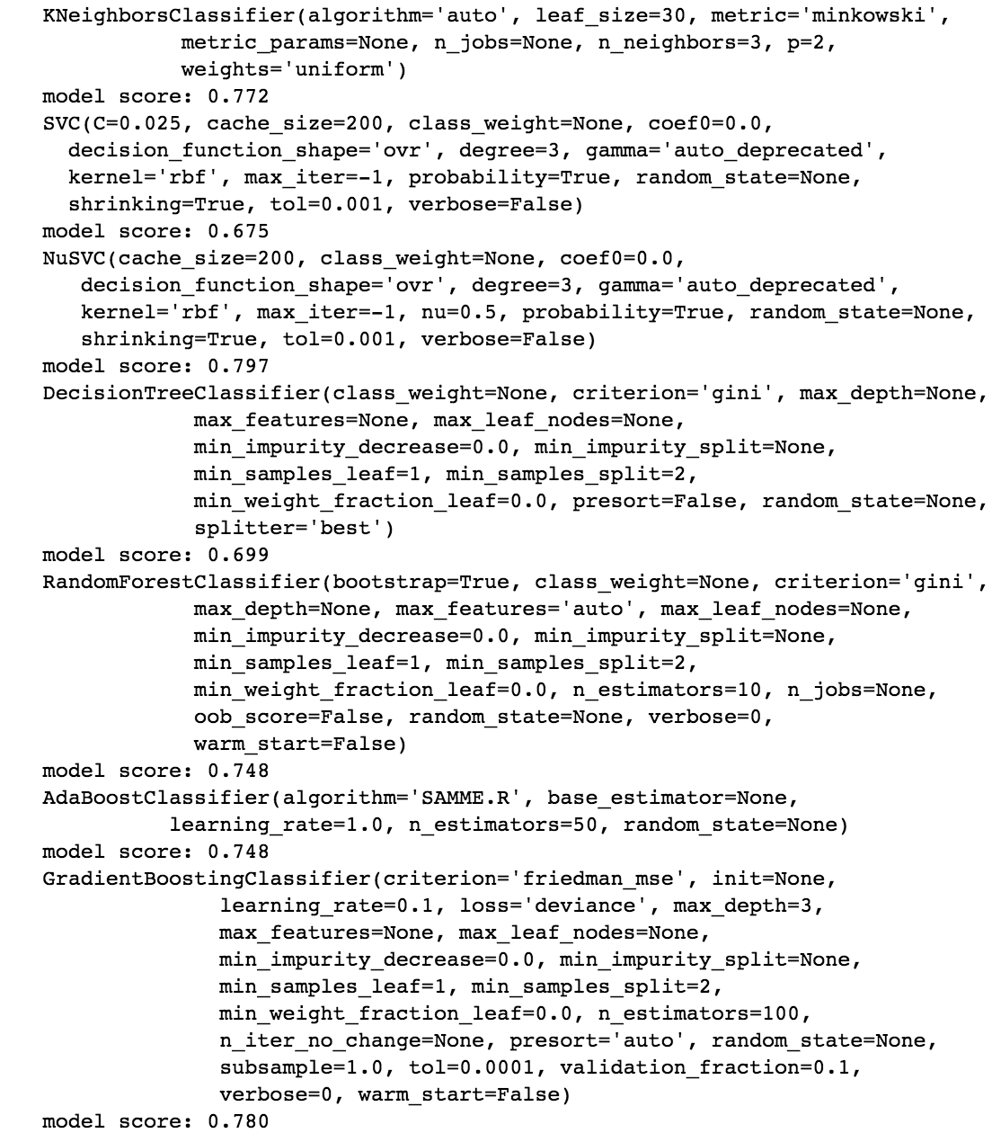

The pipeline can also be used in grid search to find the best performing parameters. To do this you first need to create a parameter grid for your chosen model. One important thing to note is that you need to append the name that you have given the classifier part of your pipeline to each parameter name. In my code above I have called this ‘classifier’ so I have added classifier\_\_ to each parameter. Next I created a grid search object which includes the original pipeline. When I then call fit, the transformations are applied to the data, before a cross-validated grid-search is performed over the parameter grid.

param\_grid = {   
 'classifier\_\_n\_estimators': [200, 500],  
 'classifier\_\_max\_features': ['auto', 'sqrt', 'log2'],  
 'classifier\_\_max\_depth' : [4,5,6,7,8],  
 'classifier\_\_criterion' :['gini', 'entropy']}from sklearn.model\_selection import GridSearchCVCV = GridSearchCV(rf, param\_grid, n\_jobs= 1)  
   
CV.fit(X\_train, y\_train)   
print(CV.best\_params\_)   
print(CV.best\_score\_)

I am working quite a lot with scikit-learn machine learning projects at the moment. Before I started to use pipelines I would find that when I went back to a project to work on it again even after only a short time I would have trouble following the workflow again. Pipelines have really helped me to put together projects that are both easily repeatable and extensible. I hope that this guide helps others who are interested in learning how to use them.

# Cluster Sampling and Stratified Sampling

Cluster Sampling and Stratified Sampling [probability sampling](https://www.questionpro.com/blog/probability-sampling/) techniques with different approaches to create and analyze samples.

[Cluster Sampling](https://www.questionpro.com/blog/cluster-sampling/) is a method where the target population is divided into multiple clusters. Some of these clusters are selected randomly for sampling or a second stage or multiple stage sampling is carried out to form the target sample. Depending on the number of steps followed to create the desired sample, cluster sampling is divided using a single-stage, two-stage or multiple stage sampling techniques. This sampling method is extremely cost-effective as it requires minimum efforts in sample creation and also convenient to execute.

[Stratified Sampling](https://www.questionpro.com/blog/stratified-random-sampling/) is a probability sampling method, also called random quota sampling, where a large population is divided into unique, homogeneous strata and further, members from these strata are randomly selected to form a sample. Elements of each of the samples will be distinct which will give the entire population an equal opportunity to be a part of these samples. Segregation on the basis of age, religion, nationality, socioeconomic backgrounds, qualifications etc. can be done using this sampling technique.

|  |  |  |
| --- | --- | --- |
| **Factors for Comparison** | **Cluster Sampling** | **Stratified Sampling** |
| Definition | Members of this sample are chosen from naturally divided groups called clusters, by randomly selecting elements to be a part of the sample. | Members of this sample are randomly chosen from non-overlapping, homogeneous strata. |
| Purpose | Cost reduction and increased efficiency. | Enhanced precision and population depiction. |
| Sample selection | Selection of the sample is done by randomly selected clusters and including all the members from these clusters. | Selection of the sample is done by randomly selecting members from various formed strata. |
| Selection of elements that form a Sample | Conjointly | Distinctively |
| Division type | Naturally formed | Depends on the researcher |
| Heterogeneity | Internally, with the clusters | Externally, between various strata |
| Homogeneity | Externally, between various clusters | Internally, with the strata |

**Cluster Sampling – Key Points:**

* + Naturally existing groups are chosen to be a part of the final sample set.
  + Mainly used in [market research](https://www.questionpro.com/market-research.html), in this technique, a population is divided into clusters and these clusters are randomly chosen to be a part of the sample.
  + Information can also be collected from elements selected from each of the sub-clusters.
  + This method is usually applied in groups where there is diversity within the groups and not between clusters.
  + The only prerequisite is that all the clusters should be distinctive and non-overlapping. **Stratified Sampling – Key Points:**
* A population is divided into strata by random selection.
* The simplest explanation of strata is a group of members of a population.
* [Simple random sampling](https://www.questionpro.com/blog/simple-random-sampling/) is then performed on these strata to form samples.
* One similarity that stratified sampling has with cluster sampling is that the strat formed should also be distinctive and non-overlapping.
* By making sure each stratum is distinctive, the errors in results are drastically reduced.

# Simplifying the ROC and AUC metrics

ROC and AUC curves are important evaluation metrics for calculating the performance of any classification model. These definitions and jargons are pretty common in the Machine learning community and are encountered by each one of us when we start to learn about classification models. However, most of the times they are not completely understood or rather misunderstood and their real essence cannot be utilized. Under the hood, these are very simple calculation parameters which just needs a little demystification.

*The concept of ROC and AUC builds upon the knowledge of Confusion Matrix, Specificity and Sensitivity. Also, the example that I will use in this article is based on Logisitic Regression algorithm, however, it is important to keep in mind that the concept of ROC and AUC can apply to more than just Logistic Regression.*

Consider a **hypothetical example** containing a group of people. The y-axis has two categories i.e **Has Heart Disease** represented by red people and **does not have Heart Disease**represented by green circles.**A**long the x-axis, we have **cholesterol** levels and the classifier tries to classify people into two categories depending upon their cholesterol levels.

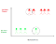

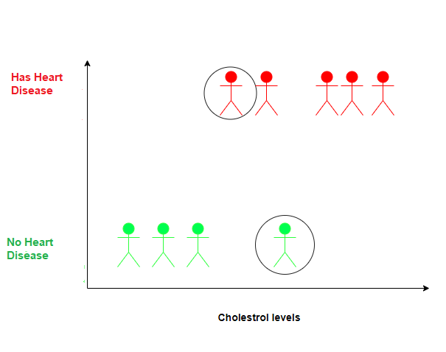

## Something to notice:

* Circled Green person has a high level of cholesterol but does not have heart disease. This may be due to the reason that now the person is observing a better lifestyle and exercising regularly.
* Circled Red person has low cholesterol levels still had a heart attack. This may be due to the reason that he has other heart-related issues.

This is a hypothetical example so the reasons are also hypothetical 😃

## Logistic Regression

Now if we fit a Logistic Regression curve to the data, the Y-axis will be converted to the **Probability** of a person having a heart disease based on the Cholesterol levels.

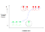

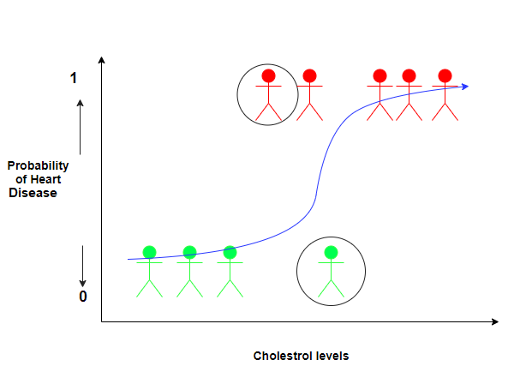

The white dot represents a person having a lower heart disease probability than the person represented by the black dot.

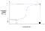

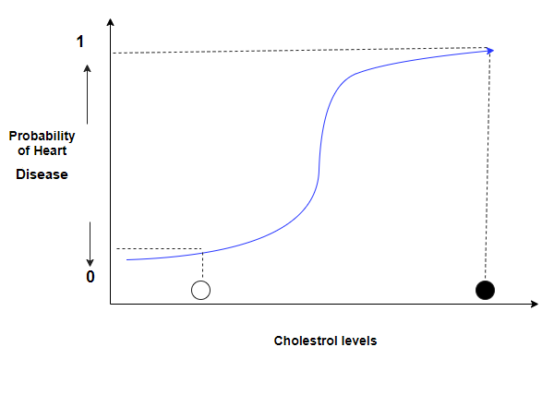

However, if we want to classify the people in the two categories, we need a way to turn probabilities into classifications. One way is to set a threshold at 0.5. Next, classify the people who have a probability of heart disease > 0.5 as “**having a heart disease**” and classify the people who have a probability of heart disease < 0.5 as “**not having a heart disease**”.

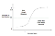

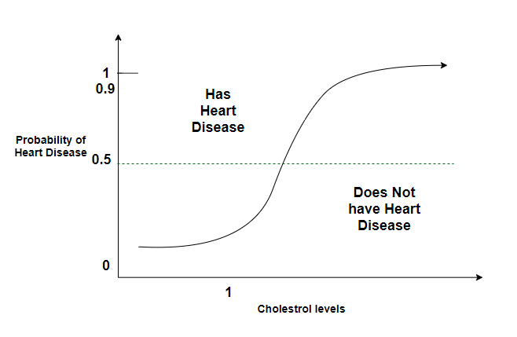

Let us now evaluate the effectiveness of this logistic regression with the classification threshold set to 0.5, with some new people about whom we already know if they have heart disease or not.



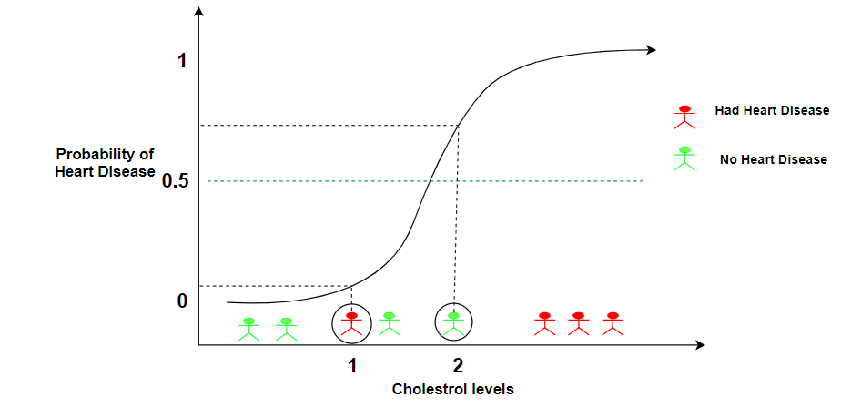

Our Logistic Regression model correctly classifies all people except the persons 1 and 2.

* We know Person 1 has heart disease but our model classifies it as otherwise.
* We also know person 2 doesn’t have heart disease but again our model classifies it incorrectly.

## Confusion Matrix

Let’s create a Confusion Matrix to summarize the classifications.

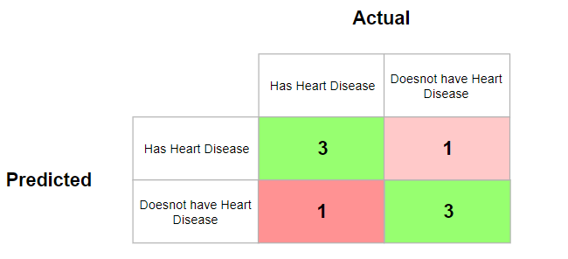

Once the confusion matrix is filled in, we can calculate the **Sensitivity** and the **Specificity** to evaluate this logistic regression at 0.5 threshold.

## Specificity and Sensitivity

In the above confusion matrix, let’s replace the numbers with what they actually represent.

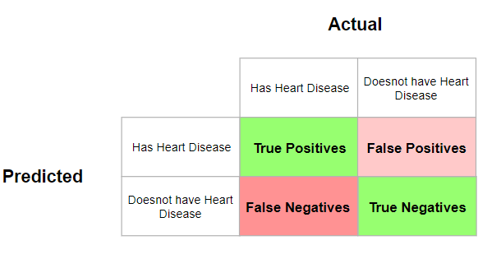

* **True Positives (TP):** People who had heart disease and were also predicted to have heart disease.
* **True negatives (TN):** People who did not have heart disease and were also predicted to not have heart disease.
* **False negatives (FN):** People who have heart disease but the prediction says they don’t.
* **False positives (FP):** People who did not have heart disease but the prediction says they do.

We can now calculate two useful metrics based upon the confusion matrix:

## Sensitivity

Sensitivity tells us what percentage of people with heart disease were actually correctly identified.



This turns out to be: 3/3+1 = 0.75

This tells us that **75%** of people with heart disease were correctly identified by our model.

## Specificity

Specificity tells us what percentage of people without heart disease were actually correctly identified.

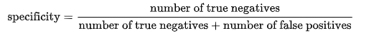

This turns out to be: 3/3+1 = 0.75

This tells us that again **75%** of people without heart disease were correctly identified by our model.

**If correctly identifying positives is important for us, then we should choose a model with higher Sensitivity. However, if correctly identifying negatives is more important, then we should choose specificity as the measurement metric.**

## Identifying the Correct Thresholds

Now, let’s talk about what happens when we use a different threshold for deciding if a person has heart disease or not.

* **Setting the Threshold to 0.1**

This would correctly identify all people who have heart disease. The person labeled 1 is also correctly classified to be a heart patient.

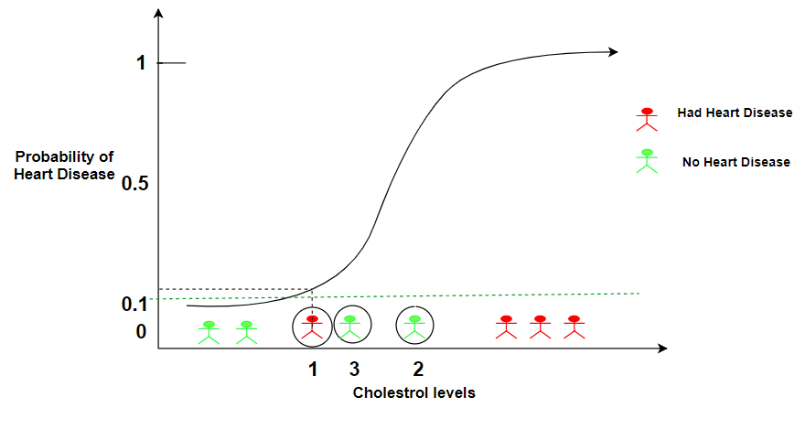

However, it would also increase the number of False Positives since now person 2 and 3 will be wrongly classified as having heart disease.

Therefore a lower threshold:

* Increases the number of False Positives
* Decreases the number of False Negatives.

Recalculating the confusion matrix:

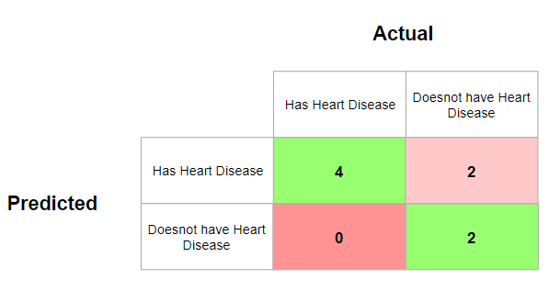

In this case, it becomes important to identify people having a heart disease correctly so that the corrective measures can be taken else heart disease can lead to serious complications. This means lowering the threshold is a good idea even if it results in more False Positive cases.

* **Setting the Threshold to 0.9**

This would now correctly identify all people who do not have heart disease. The person labeled, however, person 1, would be incorrectly classified having no heart disease.

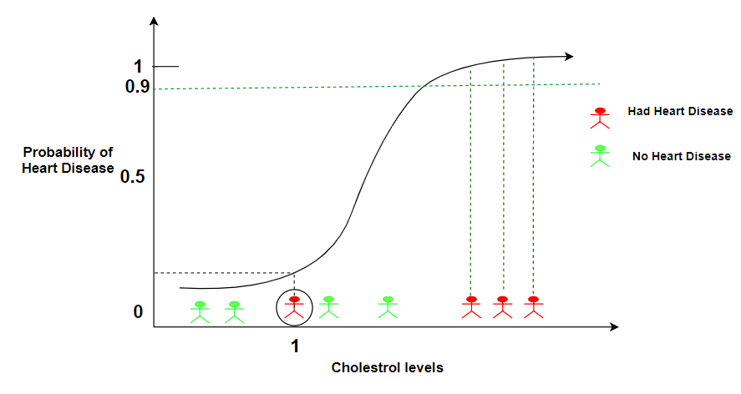

Therefore a lower threshold:

* Decreases the number of False Positives
* Increases the number of False Negatives.

Recalculating the confusion matri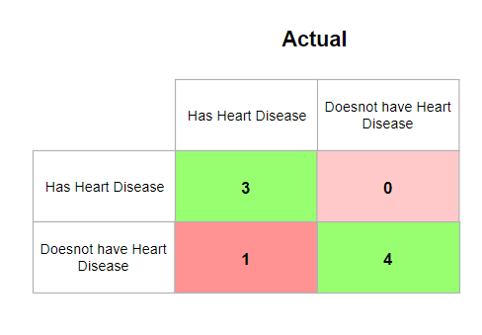

The threshold could be set to any value between 0 and 1. So how do we determine which threshold is the best? Do we need to experiment with all the threshold values? Every threshold results in a different confusion matrix and a number of thresholds will result in a large number of confusion matrices which is not the best way to work.

## ROC Graphs

ROC(Receiver Operator Characteristic Curve) can help in deciding the best threshold value. It is generated by plotting the True Positive Rate (y-axis) against the False Positive Rate (x-axis).

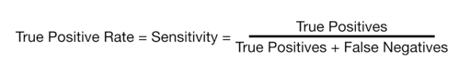

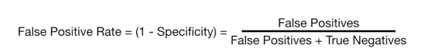

*True Positive Rate indicates what proportion of people ‘****with heart diseas****e’ were correctly classified.*

*False Positive Rate indicates the proportion of people classified as ‘****not having heart disease****’, that are False Positives.*

To get to know the ROC better, let’s draw one from scratch.

* **Threshold classifying all people as having heart disease.**

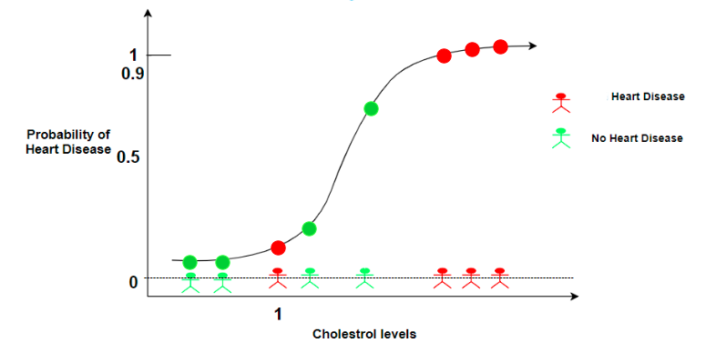

The confusion matrix will be:

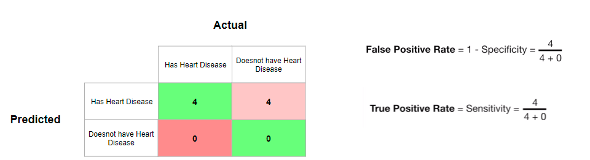

This means the True Positive Rate when the threshold is so low that every single person is classified as having heart disease, is 1. This means that every single person with heart disease was correctly classified.

Also, the False Positive Rate when the threshold is so low that every single person is classified as having heart disease, is also 1. This means that every single person without heart disease was wrongly classified.

Plotting this point on the ROC graph:

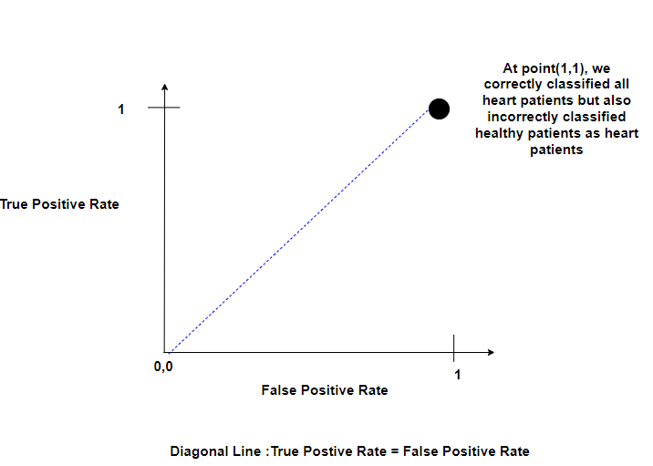

Any point on the Blue Diagonal Lines means that the proportion of correctly classified samples is equal to the proportion of incorrectly classified samples.

* **Increasing the Threshold slightly so that only the two people with the least cholesterol value are below the threshold.**

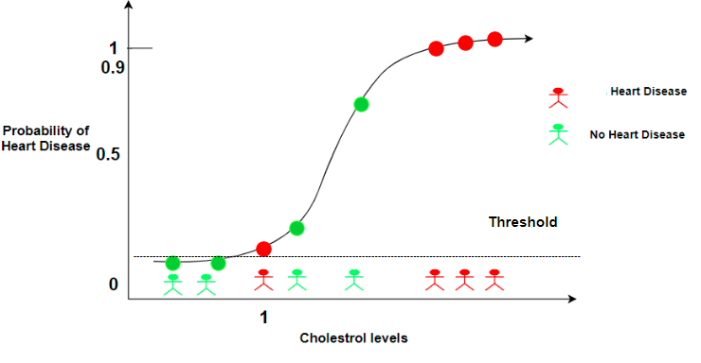

The confusion matrix will be:

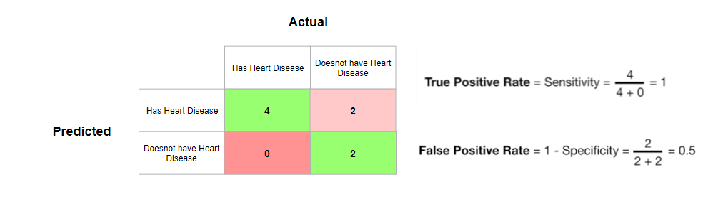

Let’s plot this point (0.5,1) on the ROC graph.

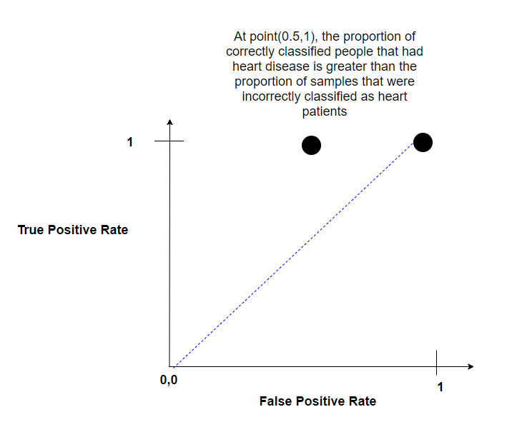

This means this threshold is better than the previous one.

* **Now if go on increasing the threshold values, and reach a point where we get the following confusion matrix:**

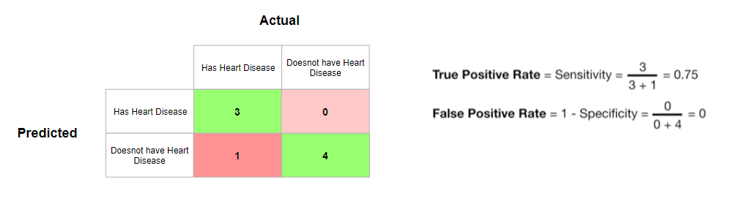

Let’s plot this point (0,0.75) on the ROC graph.

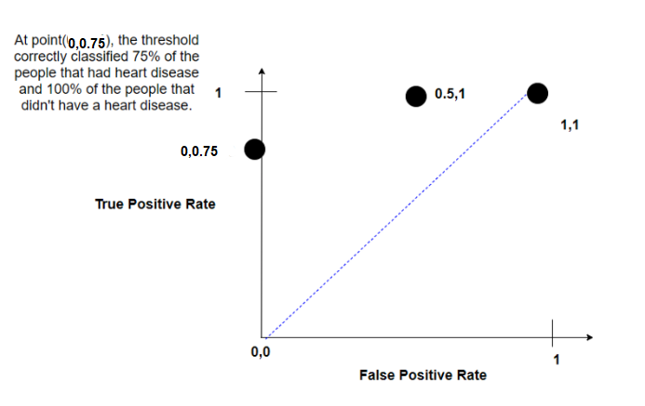

By far this is the best threshold that we have got since it predicted no false positives.

* **Lastly, we choose a threshold where we classify all people as not having a heart disease i.e Threshold of 1.**

The graph, in this case, would be at (0,0):

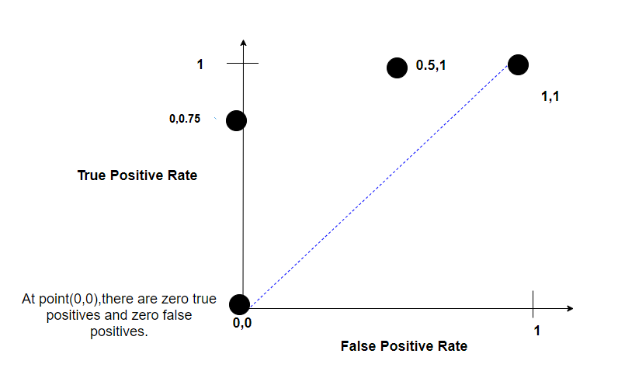

We can then connect the dots which gives us a ROC graph. The ROC graph summarises the confusion matrices produced for each threshold without having to actually calculate them.

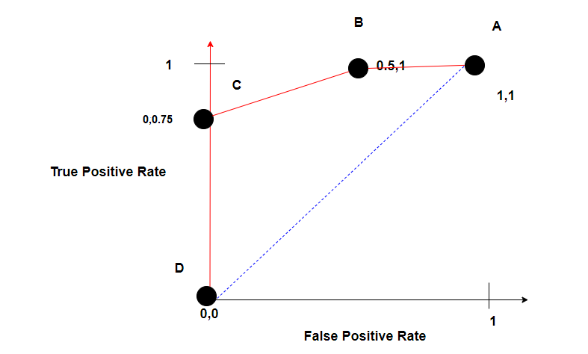

Just by glancing over the graph, we can conclude that threshold C is better than threshold B and depending on how many False Positives that we are willing to accept, we can choose the optimal threshold.

## AUC

AUC stands for **Area under the curve**. AUC gives the rate of successful classification by the logistic model. The AUC makes it easy to compare the ROC curve of one model to another.

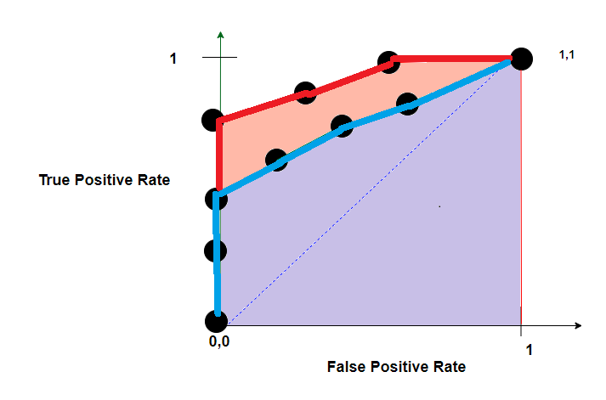

The**AUC** for the red **ROC** curve is greater than the **AUC** for the blue **RO**C curve. This means that the Red curve is better. If the Red ROC curve was generated by say, a Random Forest and the Blue ROC by Logistic Regression we could conclude that the Random classifier did a better job in classifying the patients.